

BIRZEIT UNIVERSITY
Physics Department

Physics 111

Experiment No. 2

Conservation of linear momentum
………………………………………………………………………………………

Student’s Name: Lara Sami . Student’s No.: 1120139

Partner’s Name: Weam Mikkawi Partners’ No. : 1120442

Instructor: Ziad Sa'eed Section No.: 4 M

Date: 8 /10/2012

- Abstract:

- The aim of the experiment:
- To verify the law of conservation of linear momentum

- The method used:
By making collision between two different balls and taking the data that we need to calculate the momentum of each ball before and after the collision; such as the mass of each ball and the distance before and after the collision in order to find the velocity and then the momentum.

- The main results are:

R = 1.05 ± 0.03
- Theory:
Linear momentum, p is a vector quantity defined as the product of mass and velocity. For a body mass, m and velocity, v; its momentum is given as
p = mv. In the absence of external force, that is, in an isolated system, the total momentum of the system is constant. In other words, the total momentum is conserved. This is known as the Law of Conservation of Linear Momentum.
Applying the law of Conservation of Linear Momentum in collision, the total momentum of the colliding bodies remains the same before and after the collision. Let m1 and m2 be the masses of two colliding bodies
(i.e ball 1 and ball 2) and v1_{b}, v2_{b}, v1_{a} and v2_{a} are the velocities before and after the collision of the ball 1 and ball 2 respectively.
We may write this as: M1 v1_{b} + m2 v2_{b} = m1 v1_{a} + m2 v2_{a}
In this experiment the two balls are constrained to move in one dimension , so there is no need to use vector notation.
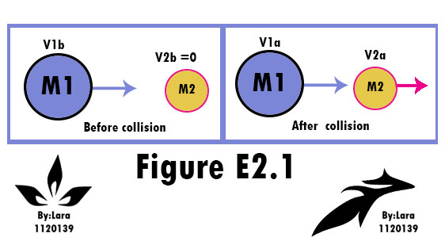
If we define The ratio R as $R=\frac{Pa}{\text{pb}}$
P_{a}= m1 v1_{a} + m2 v2_{a} and p _{b}= M1 v1b (since the speed of ball 2 before =0)
Then by theory the ratio R should be equal = 1
And to prove this practically:
The ratio (R) could be found using the equation
$R=\frac{m1v1a+m2v2a}{m1v1b}$
And because we are studying the collision between two balls on a curved track. The first ball is released from the top of the track so that it gains momentum m1v1_{b} before it hits the second ball which is stationary at the horizontal end of the track.
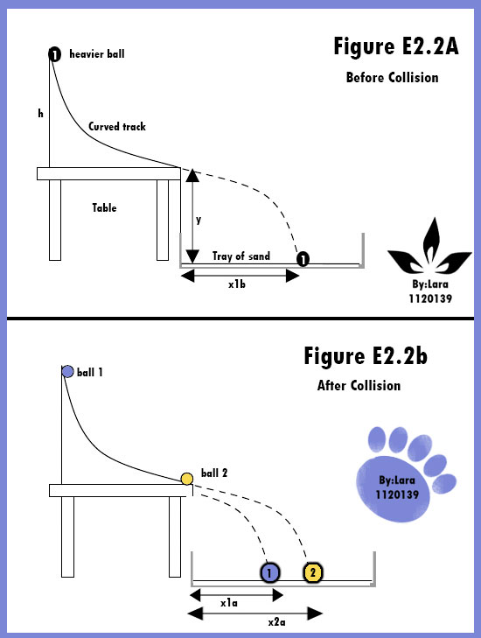

Let y be the height of the ball 1 from the falling point to the ground when it starts to fall freely and x1b is its horizontal displacement. If t is the time of flight, then from the kinematics equation, we may write:
-y = 0 + ½ (-g) t²
So the time of flight
$t=\sqrt{\frac{2y}{g}}$
Since the initial y-component of velocity is zero for both balls at the point of collision and since they fall down the same distance y, then time of flight will be the same for both balls

Now the horizontal speeds and momentum of two balls are constant after collision and are given by:

$$V1a=\frac{X1a}{t}⇒P1a=\frac{m1x1a}{\sqrt{2y/g}}$$
$$V2a=\frac{X2a}{t}⇒P2a=\frac{m2x2a}{\sqrt{2y/g}}$$

$$\text{SO}:R=\frac{Pa}{\text{pb}}=\frac{m_{1}{\overline{X}}_{1a}+m_{2}{\overline{X}}_{2a}}{m_{1}{\overline{X}}_{1b}}$$
To find the uncertainty in R , if we neglect the uncertainty in the height of the table(y)
Since the ratio is given by $R=\frac{Pa}{\text{pb}}=\frac{m_{1}{\overline{X}}_{1a}+m_{2}{\overline{X}}_{2a}}{m_{1}{\overline{X}}_{1b}}=\frac{A}{B}$
Where :
A=$m_{1}{\overline{X}}_{1a}+m_{2}{\overline{X}}_{2a}$ B=$m_{1}{\overline{X}}_{1b}$
$$⇒\frac{ΔR}{R}=\frac{ΔA}{A}+\frac{ΔB}{B}$$
Where:
$$ΔA=m_{1}Δ{\overline{X}}_{1a}+{\overline{X}}_{1a}{Δm}_{1}+m_{2}Δ{\overline{X}}_{2a}+{\overline{X}}_{2a}{Δm}_{2}$$
$ΔB=m_{1}Δ{\overline{X}}_{1b}+{\overline{X}}_{1b}{Δm}_{1}$
- Procedure:

The track was adjusted by placing the end of the track at the edge of the table. Then we measured m1 and m2 using balance scale, then the sand tray was placed directly below the collision point using a plumb-bob .then we located a good starting point for the heavier ball by trying several times, so that the ball could fall inside the tray .then we measured x1b by setting the heavy ball free from the release point on track and measuring the distance it crossed six times. Then we measured x1a and x2a six times after making collision between the two balls .Finally we wrote our measurements in the tables.

- Data:
m₁ =16.40 ± 0.05 gm, m₂ = 4.55 ± 0.05 gm

No. | 1. | 2. | 3. | 4. | 5. | 6. | Average
(cm) | 44.6 | 45 | 45.5 | 43.5 | 43.8 | 44.2 | 44.4
(cm) | 28.6 | 28.4 | 26.9 | 28.1 | 29.5 | 26.8 | 28.1
(cm) | 66.6 | 66.5 | 65.7 | 64.9 | 67.5 | 65.7 | 66.2

- Calculation:

$$R=\frac{Pa}{\text{pb}}=\frac{m_{1}{\overline{X}}_{1a}+m_{2}{\overline{X}}_{2a}}{m_{1}{\overline{X}}_{1b}}=\frac{(\text{16}\text{.}\text{40}×\text{28}\text{.}1)+(4\text{.}\text{55}×\text{66}\text{.}2)}{\text{16}\text{.}\text{40}×\text{44}\text{.}4}=1\text{.}\text{0465}$$

0.4 cm
0.4 cm
0.3 cm
A=$m_{1}{\overline{X}}_{1a}+m_{2}{\overline{X}}_{2a}$=$\text{16}\text{.}\text{40}×\text{28}\text{.}1+4\text{.}\text{55}×\text{66}\text{.}2$
=762.05
B=$m_{1}{\overline{X}}_{1b}$=$\text{16}\text{.}\text{40}×\text{44}\text{.}4=\text{728}\text{.}\text{16}$
$$ΔA=m_{1}Δ{\overline{X}}_{1a}+{\overline{X}}_{1a}{Δm}_{1}+m_{2}Δ{\overline{X}}_{2a}+{\overline{X}}_{2a}{Δm}_{2}$$
$$\begin{aligned}ΔA=(\text{16}\text{.}\text{40}×0\text{.}4)+(\text{28}\text{.}1×0\text{.}\text{05})+(4\text{.}\text{55}×0\text{.}4)+(\text{66}\text{.}2×0\text{.}\text{05}) \\ =\text{13}\text{.}\text{095}\end{aligned}$$
$$ΔB=m_{1}Δ{\overline{X}}_{1b}+{\overline{X}}_{1b}{Δm}_{1}$$
$$ΔB=(\text{16}\text{.}\text{40}×0\text{.}3)+(\text{44}\text{.}4×0\text{.}\text{05})=7\text{.}\text{14}$$
$$⇒\frac{ΔR}{R}=\frac{ΔA}{A}+\frac{ΔB}{B}$$
$⇒\frac{ΔR}{R}=\frac{\text{13}\text{.}\text{095}}{\text{762}\text{.}\text{05}}+\frac{7\text{.}\text{14}}{\text{728}\text{.}\text{16}}$=0.02698
0.02698×$1\text{.}\text{0465}$=0.03

1.05 ± 0.03

- Results and Conclusion:

R = 1.05 ± 0.03

- Discrepancy = |my result – true value | ➔
|1.05-1| = 0.05< 2 error ➔ 0.05 < 0.06
My result is accepted

- My experimental value nearly agrees with the theory ,it doesn't exactly the same because in this experiment many errors can be occurred.
- If the lower end of the track is not horizontal this may change the track of the balls. The heavier one might stay on the track and go back ,while the lighter may go higher before landing so the distances won't be measured accurately and this would affect the results. Also it would add more distance between balls and the edge of the track and this would affect the distance we measure ,because we must add the radius of each ball to the measured distance.

- The systematic could be related to many different reasons such as the height of the sand wasn't in the same level in all the tries so the taken measurements differ in each try ,also the edge of the sand tray may not be located accurately below the end of the truck

