

BIRZEIT UNIVERSITY
Physics Department

Physics 111

Experiment No. 3

Density of a Liquid
………………………………………………………………………………………

Student’s Name: Lara Sami . Student’s No.: 1120139

Partner’s Name: Weam Mikkawi Partners’ No. : 1120442

Instructor: Ziad Sa'eed Section No.: 4 M

Date: 15 /10/2012

- Abstract:

- The aim of the experiment:

To calculate the density of an unknown liquid and then identify the liquid using the result.

- The method used :
Is the U-tube Method .(By adding colored water into the U-tube and then add an unknown liquid to one of its sides six times and then take the measurements (L1, L2) after waiting few moments).

- The main results are:

ρ = 0.86 ± 0.04 gm/cm³

- Theory:
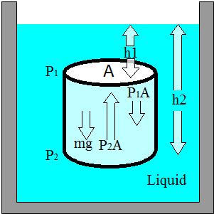

It's known that the pressure of the fluid on a surface is the force exerted by the fluid per unit area :
Pressure$(P)=\frac{\text{force}}{\text{area}}=\frac{F}{A}$ As figure shows :

A part of liquid in shape of a cylinder was considered with area (A) and height (h₂-h₁). P1, P2 pressures as the liquid is in static equilibrium and the net force acting on it is zero.

➔ +P₂A – mg – P₁A = 0.
Since m = densityVolume = ρV.
Since V = A(h₂-h₁). ➔ P₂ – P₁ = ρA(h₂-h₁).
And this will be used in the experiment to identify the unknown liquid. And for finding the error in ρ we use $ρ=\frac{L_{1}}{L_{2}}$ ➔$Δρ=\frac{{ΔL}_{1}}{L_{1}}+\frac{L_{1}{ΔL}_{2}}{L^{2_{2}}}$➔$\frac{Δρ}{ρ}=\frac{{ΔL}_{1}}{L_{1}}+\frac{{ΔL}_{2}}{L_{2}}$.
In the experiment there was two liquids with different densities ρ₁, ρ₂. Where ρ₁ > ρ₂ ➔ P_{B} – P_{A} = ρ₂gL₂ and P_{D} – P_{C} = ρ₁gL₁.
PB = PD as the two points are on the same level (same vertical height). P_{A} = P_{C} = P_{a} affected only by the atmospheric pressure (P_{a} = atmospheric pressure). And by solving the two equations ➔ ρ₁L₁ = ρ₂L₂. And because in this experiment Liquid1 is water and the density of water = 1 gm\cm³.Thus L₁ = ρ₂L₂.
L₁ vs. L₂ is a straight line with a slope equal to ρ.
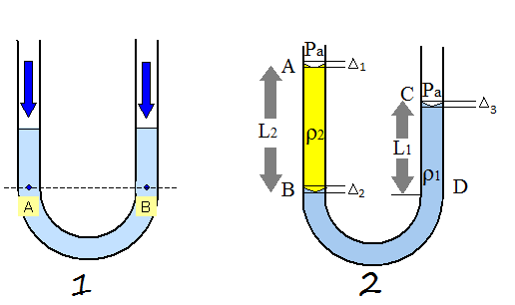

Before adding the after adding the liquid
unknown liquid
- Procedure:
At first we cleaned the U-tube using acetone by shaking it and pouring it away. Then we added colored water until it reached the height of 20 cm nearly 1/3 of the U-tube. Then we started adding the unknown liquid to one of the tube sides nearly 3 cm each time, and before the measurements were taken we waited for few moments until the liquid settled down. After that we estimated $Δ_{1},Δ_{2}$and$Δ_{3}$. And at the end measurements were taken six times and written down.

- Data:

No | 1 | 2 | 3 | 4 | 5 | 6 | Average
L₁(cm) | 2.6 | 5.4 | 7.6 | 10.7 | 13.4 | 16.5 | 9.4
L₂(cm) | 3.4 | 6.4 | 9.2 | 13.1 | 15.9 | 19.6 | 11.3

ΔL₁= Δ₃₊Δ₂ = 0.1 +0.1=0.2cm (By estimation, see Manual)

ΔL₂=Δ₁ +Δ₂ =0.2+0.1=0.3cm

- Calculations:

Centroid ($\overline{L_{1}}$,$\overline{L_{2}}$) = ( 9.4 , 11.3 )

From the graph:

slope = $=\frac{ΔL1}{ΔL2}=\frac{9\text{.}4−2\text{.}6}{\text{11}\text{.}3−3\text{.}4}=\frac{6\text{.}8}{7\text{.}9}=0\text{.}\text{86}\text{gm}{\text{cm}}^{3}$
$\frac{Δρ}{ρ}=\frac{{ΔL}_{1}}{{\bar{L}}_{1}}+\frac{{ΔL}_{2}}{{\bar{L}}_{2}}=$$\frac{0\text{.}2}{9\text{.}4}+\frac{0\text{.}3}{\text{11}\text{.}3}=0\text{.}\text{05}$
$Δρ=$0.05× 0.86=0.04

- Results and Conclusion:

ρ = 0.86 ± 0.04 gm/cm³

- Discrepancy : | true value – result| = | 0.82 – 0.86 | = 0.04
0.04 < 20.04.
- My result is accepted because D < 2$Δρ$.

- Systematic errors:
At first there were some dirt in the tube ,we have tried to use acetone to clean the tube but there still little dirt in it which affects the result ,Also the two meters which were fixed in the two side of the tube were not exactly on the same level so the data wasn't accurate as it should be the right side was higher than the lift side by 0.2 cm and this also affect the estimation of $Δ$1 , $Δ$2, $Δ$3 .

- Questions:
Q1 : The unknown liquid is Paraffin

Q2 : the measurements will be wrong because (L1,L2) will be higher so we will get wrong result for the density of the unknown liquid and the unknown liquid won't be identified .
The equation ρ₁L₁ = ρ₂L₂ won't give us an accurate result.

Q3 : So that all the added liquid settles down to get correct measurements.

