

BIRZEIT UNIVERSITY
Physics Department

Physics 111

Experiment No. 4

D.C. Circuit
………………………………………………………………………………………

Student’s Name: Lara Sami . Student’s No.: 1120139

Partner’s Name: Weam Mikkawi Partners’ No. : 1120442

Instructor: Ziad Sa'eed Section No.: 4 M

Date: 22/10/2012

- Abstract:

- The aim of the experiment:

- To test the material and find out if the material is Ohmic or non-Ohmic.
- To find the value of R_{s} , R_{p} practically
where:
R_{s} is equivalent resistance for two resistors connected in series
R_{p} is the equivalent resistance for two resistors connected in parallel
- The method used:
A)By plotting a graph of the potential difference V across the material against the current through it and keeping the temperature of the material constant. If the graph is linear then the material is Ohmic.
B) by connecting two resistors at first In series and one more time in parallel and measure( V_{s}, I_{s}),( V_{p}, I_{p})
- The main results are:

R = 75 ± 8 Ω
R_{s} = 214 ± 20Ω
R_{p} =49 ±4Ω

- Theory:
(*) One of the fundamental laws describing how electrical circuits behave is Ohm’s law. According to Ohm’s law, there is a linear relationship between the voltage drop across a circuit element and the current flowing through it. Therefore the resistance R is viewed as a constant independent of the voltage and the current. In equation form, Ohm’s law is:
V = IR.
Here, V is the voltage applied across the circuit in volts (V), I is the current flowing through the circuit in units of amperes (A), and R is the resistance of the circuit with units of ohms (Ω).
$R=\frac{V(\text{Voltage})}{I(\text{Current})}$R : resistance. R doesn't depend on (I) or (V).
(*) Materials that obey Ohm's law are called Ohmic materials. Materials that don't obey Ohm's law are called non-Ohmic materials. Testing the material to decide if it's Ohmic or non-Ohmic could be done by plotting the graph of the voltage (V) on the x-axis vs. the current (I) on the y-axis and if the graph is linear then the material is Ohmic, and if it's not linear then the material is non-Ohmic.
(*)Two or more resistors can be connected in series, connected one after another (Fig. (a)), or in parallel, typically shown connected so that they are parallel to one another (Fig. (b)). As long as the current must split, go through the resistors and then coalesce, they are in parallel.
When two resistors R1 and R2 are connected in series, the equivalent
resistance RS is given by RS = R1 + R2. Thus, the circuit in Fig. (a)
behaves as if it contained a single resistor with resistance RS — that is,
it draws current from a given applied voltage like such a resistor. When
those resistors are connected in parallel instead, we use a different formula for finding the equivalent resistance.
Fig.(a) Fig.(b)
R₁,R₂ on Series : R₁,R₂ on Parallel :
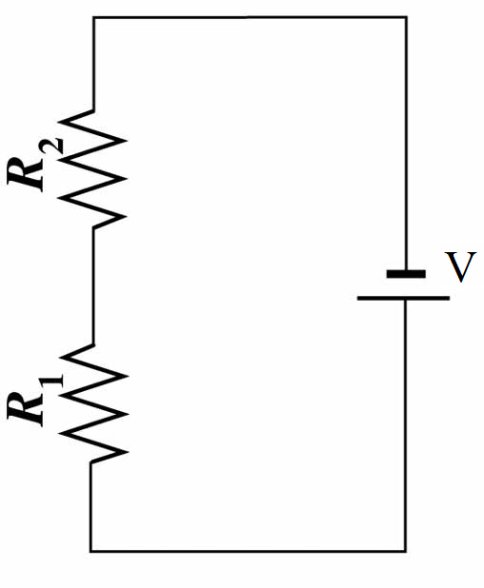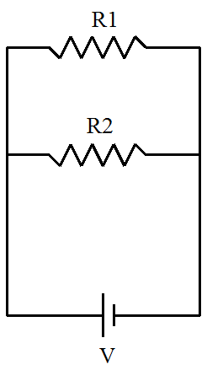
- Procedure:
At first, a resistance was connected with another variable resistance to a circuit with a 3 volt power supply and. Then the uncertainty in the current ΔI and the uncertainty in the voltage ΔV was estimated. Then we measured the current (I) and the potential difference (V) across the resistance. After that the current and the potential difference were measured, but after adjusting the variable resistance and this was repeated six times. Then we disconnected the variable resistance and connected another resistance (R₂) in series instead. And after estimating ΔI and ΔV we wrote down the reading of I_{s} and V_{s}. Then the second resistance was connected in parallel and ΔI and ΔV were estimated and the I_{p} and V_{p} were written down. Finally the values of R₁ and R₂ were written down using the color codes on the back of the resistances.
- Data:
Part A (one resistance used in the circuit, either R₁ or R₂):

_{V =0.1} _{I= 1mA}
No | 1 | 2 | 3 | 4 | 5 | 6 | Average
I(mA) | 7 | 13 | 20 | 26 | 34 | 41 | 23.5
V(volt) | 0.5 | 1 | 1.5 | 2 | 2.5 | 3 | 1.75

Part B (R₁ and R₂ in series):

V_{s} = 3 volt ΔV_{s} = 0.1 volt

I_{s} = 14 mA ΔI_{s} =1mA

Part C (R₁ and R₂ in parallel):

V_{p} = 2 volt ΔV_{p} = 0.1 volt

I_{p} = 41 mA ΔI_{p}= 1mA
- Calculations:
R = from the slope = $\frac{ΔV}{ΔI}=\frac{0\text{.}\text{75}−0}{\text{10}−0}=0\text{.}\text{075}KΩ=\text{75}Ω$

ΔR = $R(\frac{ΔV}{V}+\frac{ΔI}{I})=\text{75}(\frac{0\text{.}1}{1\text{.}\text{75}}+\frac{1×{\text{10}}^{−3}}{\text{23}\text{.}5×{\text{10}}^{−3}})=8Ω$

Resistance R₁ from color code = 75 ± 4 $Ω$
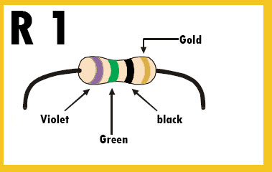

Resistance R₂ from color code = 150 ± 8 $Ω$
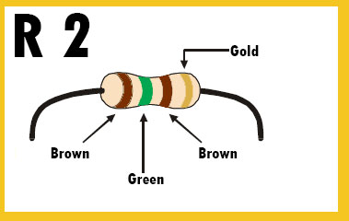

R₁ and R₂ in series:

A)Practically(By experiment):
R_{s} = $\frac{V_{S}}{I_{S}}=\frac{3}{\text{14}×{\text{10}}^{−3}}=\text{214}Ω$
ΔR_{s} = $R_{S}(\frac{{ΔV}_{S}}{V_{S}}+\frac{{ΔI}_{S}}{I_{S}})=\text{214}(\frac{0\text{.}1}{3}+\frac{1×{\text{10}}^{−3}}{\text{14}×{\text{10}}^{−3}})=\text{20}Ω$
B) theoretically:
R₁ from color code = 75 ± 4 $Ω$
R₂ from color code = 150 ± 8 $Ω$
R_{S} = R₁+R₂= 75+150=225
$${ΔR}_{s}={ΔR}_{1}+{ΔR}_{2}=4+8=\text{12}$$
Rs= 225 ± 12 Ω

R₁ and R₂ in parallel:
A)Practically(By experiment):
R_{p} = $\frac{V_{P}}{I_{P}}=\frac{2}{\text{41}×{\text{10}}^{−3}}=\text{49}Ω$
ΔR_{p} = $R_{P}(\frac{{ΔV}_{P}}{V_{P}}+\frac{{ΔI}_{P}}{I_{P}})=\text{49}(\frac{0\text{.}1}{2}+\frac{1×{\text{10}}^{−3}}{\text{41}×{\text{10}}^{−3}})=4Ω$
B) theoretically:
R₁ from color code = 75 ± 4 $Ω$
R₂ from color code = 150 ± 8 $Ω$
$R_{p}=\frac{R_{1}R_{2}}{R_{1}+R_{2}}=\frac{\text{75}Χ\text{150}}{\text{75}+\text{150}}=\text{50}Ω$
To find ΔR_{p} Assume that
$$R_{p}=\frac{A}{B}→\text{then}→{ΔR}_{p}=(\frac{ΔA}{A}+\frac{ΔB}{B})R_{p}$$
Where A= R₁R₂= 75× 150=11250
$\text{ΔΑ}=\frac{{ΔR}_{1}}{R_{1}}+\frac{{ΔR}_{2}}{R_{2}}=\frac{4}{\text{75}}+\frac{8}{\text{150}}=0\text{.}\text{11}Ω$
B= R1+R2=75+150=225
$ΔB={ΔR}_{1}+{ΔR}_{2}=\text{12}$
So
${ΔR}_{p}=(\frac{ΔA}{A}+\frac{ΔB}{B})R_{p}=(\frac{0\text{.}\text{11}}{\text{11250}}+\frac{\text{12}}{\text{225}})\text{50}=3Ω$
ΔR_{p} =3Ω
- Results and Conclusion:
- Part A (one resistance used in the circuit, either R₁ or R₂):
- My result from the slope of the graph is
R1= 75 ± 8 Ω
- The true value of the resistor R1 from color code is
R1= 75 ± 4 $Ω$
Discrepancy : | true value – result| = | 75 – 75 | = 0
0 < 28 → 0<16
My result is accepted because D < 2$ΔR$.

- Part B(R₁ and R₂ in series):
My result is
Rs= 214 ± 20 Ω
The true value of the equivalent resistance for two resistors
connected in series theoretical is :
Rs= 225 ± 12 Ω

- Discrepancy : | true value – result| = | 225– 214 | = 11
11 < 220 → 11<40
My result is accepted because D < 2${ΔR}_{s}$.

Part C(R₁ and R₂ in parallel):
My result is
Rp= 49 ± 4 Ω
The true value of the equivalent resistance for two resistors
connected in parallel theoretical is :
Rp= 50± 3Ω

- Discrepancy : | true value – result| = | 50– 49 | = 1
1 < 24 → 1<8
My result is accepted because D < 2${ΔR}_{p}$.
systematic errors
A wire is actually a resistor with very low resistance compared to the resistors we typically use in class. Therefore, we neglected (ignored) any resistance that it has. Also the ammeter and the voltmeter have a resistance that we neglected.

When we take the measurements we must look straight at the pointer to have a correct reading and if we don't our reading will not be accurate.

The answer of the Question:
My measured values of R₁, R_{s} , and R_{p} are consistent with the values that I obtained from color codes.

