
BIRZEIT UNIVERSITY
Physics Department

Physics 111

Experiment No. 7

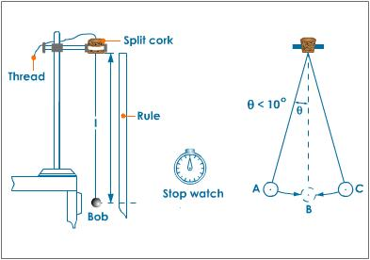

Measurement of g at BZU
………………………………………………………………………………………
Student’s Name: Lara Sami . Student’s No.: 1120139

Partner’s Name: Weam Mikkawi Partners’ No. : 1120442

Instructor: Ziad Sa'eed Section No.: 4 M

Date:19/11/2012
- Abstract:

- The aim of the experiment:
To measure the value of (g) at BZU .
- The method used:
By using Simple pendulum method.
- The main results are:

g = 9.1 ± 0.4 m/s²

- Theory:
The following graph is about an ideal simple pendulum which consists of a point mass particle of mass (m) connected to a massless string of length (L) swinging back and forth. We need to find the period of the pendulum (T) where T is the time the pendulum needs to complete one oscillation from point A to point B then back to point A. By Newton's second law, we can find the forces acting on the mass into two parts. Radial part and Tangential part :
Radial part :
Tension –mg cos θ = 0
Tangential part :
f₁ - mg sin θ
And we know that the angle(θ) is small thus sin θ(θ in radians) so : f_{t} = $\frac{{\text{md}}^{2}b}{{\text{dt}}^{2}}≈−\text{mg}θ$
And we know that the length of the arc at any time (t) is b = L θ which means that $θ=\text{bl}$ as a result : $m\frac{d^{2}b}{{\text{dt}}^{2}}≈−\text{mg}θ\frac{b}{l}→\frac{d^{2}b}{{\text{dt}}^{2}}=−\frac{g}{l}b$
From this form : b (t) = bsin (ω t + δ), (where b and δ are constants) we can find the value of (ω) :
-bω²sin θ(ω t + δ) + $\frac{g}{l}$ bsin (ω t + δ) = 0 ➔ ω²=$\frac{g}{l}$.
Also, we can find the period of the pendulum since :
$$T=\frac{2π}{ω}=\frac{2π}{\sqrt{g/L}}=2π\sqrt{g/L}→T^{2}=\frac{4π^{2}}{g}l$$
We can find the uncertainty in g using $\frac{Δg}{g}=\frac{Δm}{m}$ (where m is the slope).
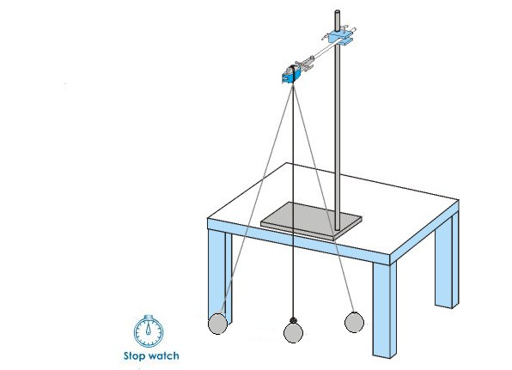
- Procedure:
Before the experiment was done the following was kept in mind : The max angle of displacement must not exceed 15 degrees.
- The mass of the string is neglected, then the length L is the distance from the support to the centre of the ball that is $L=S+\frac{d}{2}$ where S is the length of the string and d is the diameter of the ball which can be measured using the caliper.
A length of 42 cm was started with, and the time needed to do 10 periods was measured using a stop watch. Then, step 1 was repeated 2 times for all 6 different values of (L) from 42 to 144 cm . finally for each value of (L) the average value of time for 10 periods was found, and then the result was divided by 10 to find the average value of a single period (T), also T² was found. And finally all the data were written down in the table.

- Data:

r = $\frac{d}{2}$= $\frac{2}{2}=1$cm

No. | S  (cm) | L=  s + r  (cm) | t₁(sec)  10 periods | t₂ (sec)  10 periods | t (sec)  average | T (sec)  One Period | T²  (Sec²)
1 | 1 | 42.00 | 13.19 | 13.16 | 13.18 | 1.318 | 1.736
2 | 1 | 58.00 | 15.34 | 15.26 | 15.30 | 1.530 | 2.341
3 | 1 | 79.00 | 17.86 | 17.68 | 17.70 | 1.770 | 3.158
4 | 1 | 102.0 | 20.37 | 20.18 | 20.28 | 2.028 | 4.111
5 | 1 | 125.0 | 23.38 | 23.54 | 23.46 | 2.346 | 5.504
6 | 1 | 144.0 | 24.31 | 24.64 | 24.48 | 2.448 | 5.990

- Calculations:

Use the computer (Excel Sheets) to calculate the slope and the intercept of the line representing T² vs. L.

Slope = 0.0433± 0.0019

Intercept = -0.16519

To find g:
Slope = 0.0433 = $\frac{4π^{2}}{g}$ ➔
g = $\frac{4π^{2}}{0\text{.}\text{0433 }}=\text{910}\text{.}8{\text{cm}}/{s^{2}}=9\text{.}\text{108}≈9\text{.}1m/{s^{2}}$

Δ g =$\frac{Δm}{m}g=$ $\frac{0\text{.}\text{0019}}{0\text{.}\text{0433 }}×9\text{.}1=0\text{.}4m/{s^{2}}$
the graph made by Excel:
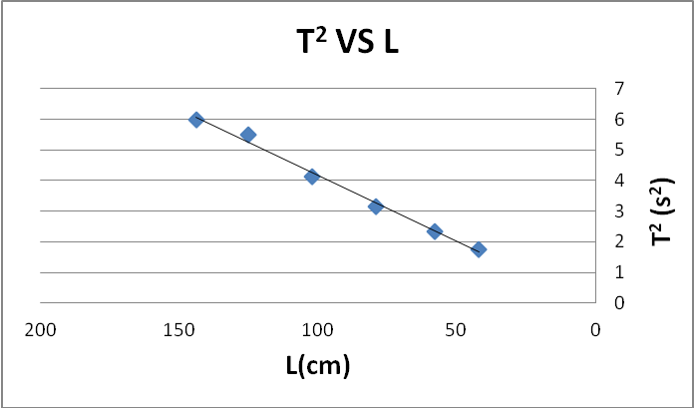
- Results and conclusion:
g = 9.1 ± 0.4 m/s²
 the true value of the gravity = 9.8 m\s²,
 but my calculated value = 9.1 ± 0.4 m\s².
The discrepancy = |9.1 – 9.8| ≤ 2×0.4 ➔ 0.7 < 0.8
So my result is accepted .
In this experiment there were many errors all of these may affect our result :
1. At first, we may not looked at the protractor and the meter stick perpendicularly when we measured the length of the string.
2.Also the length of the string it is not measured by very accurate instruments. Since meter ruler has a large percentage error.
3.In addition to that , each time we tried to measure the period (T) of a specific length of the string, The max angle of displacement must not exceed 15 degrees and may be one or two of the angles that we made where bigger than 15 .
4.when we used the stop watch our reflexes. And how quick we're able to press the stop button affected the result may be we didn't press the button exactly on time in some of our tries.
5. when we take the bob to a height and realize it we tried to keep it straight but sometimes it revolves around .
Questions :
The plotted from the calculation nearly fit our data .
The equation of this line is:
Y= 0.0433x-0.16512

The centroid is (92,3.8)
And the line nearly pass through it

Y= (0.0433) (92)-0.16512=3.81848 3.8

