

BIRZEIT UNIVERSITY
Physics Department

Physics 111

Experiment No. 9
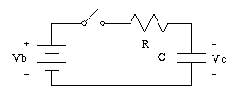
RC Circuit
………………………………………………………………………………………

Student’s Name: Lara Sami . Student’s No.: 1120139

Partner’s Name: Weam Mikkawi Partners’ No. : 1120442

Instructor: Ziad Sa'eed Section No.: 4 M

Date:3/12/2012

- Abstract:

- The aim of the experiment:

…………………………………………………………………………………………
…………………………………………………………………………………………
- The method used: …………………………………………………………
…………………………………………………………………………………………
…………………………………………………………………………………………

- The main results are:

C = ±

- Theory:
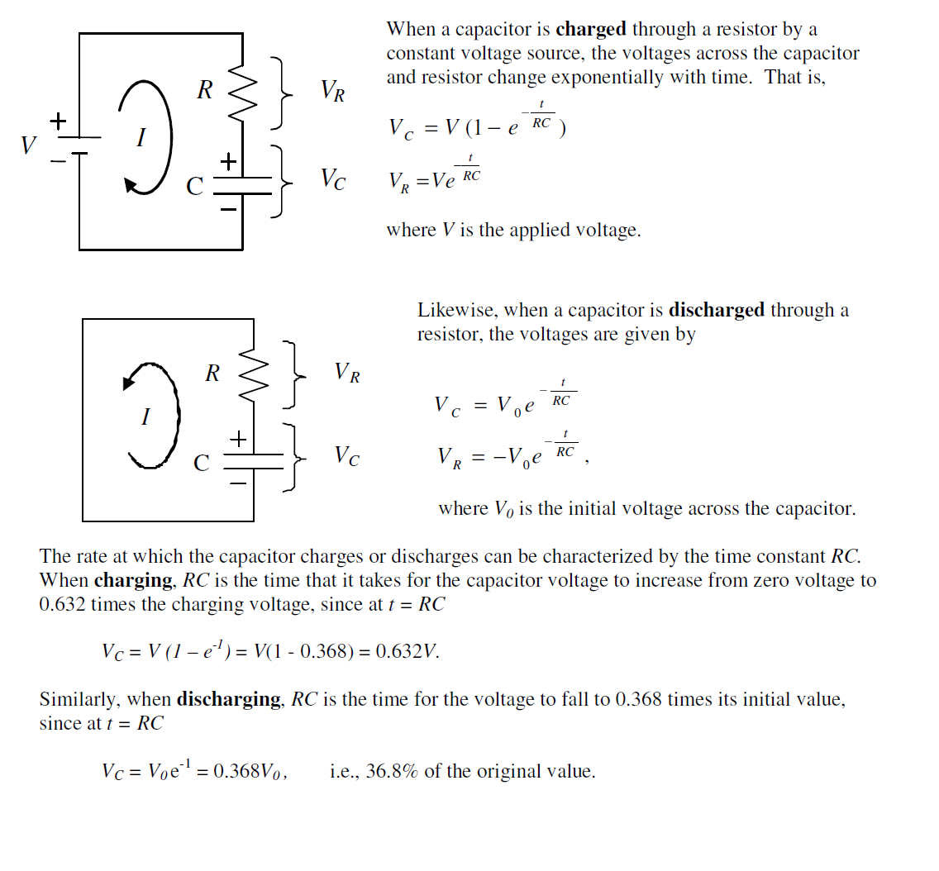
- Procedure:
…………………………………………………………………………………………………
…………………………………………………………………………………………………
…………………………………………………………………………………………………
…………………………………………………………………………………………………
…………………………………………………………………………………………………
…………………………………………………………………………………………………
…………………………………………………………………………………………………
…………………………………………………………………………………………………
…………………………………………………………………………………………………
…………………………………………………………………………………………………
…………………………………………………………………………………………………
…………………………………………………………………………………………………
…………………………………………………………………………………………………

- Data:
R = (1.00± 0.01) mega Ω

Charging |  |  |  | Discharging
Time  (sec.) | V_{c}  (volts) | Time  (sec.) | V_{c}  (volts) | Time  (sec.) | V_{c}  (volts) | Time  (sec.) | V_{c}  (volts)
0 | 0.00 | 70 | 4.93 | 0 | 5.46 | 70 | 0.53
5 | 0.78 | 80 | 5.09 | 5 | 4.51 | 80 | 0.40
10 | 1.46 | 90 | 5.27 | 10 | 3.80 | 90 | 0.30
15 | 2.23 | 100 | 5.32 | 15 | 3.30 | 100 | 0.21
20 | 2.75 | 110 | 5.37 | 20 | 2.74 | 110 | 0.17
25 | 3.40 | 120 | 5.40 | 25 | 2.33 | 120 | 0.13
30 | 3.65 | 130 | 5.42 | 30 | 2.05 | 130 | 0.10
35 | 3.79 | 140 | 5.43 | 35 | 1.51 | 140 | 0.07
40 | 4.01 | 150 | 5.45 | 40 | 1.29 | 150 | 0.06
45 | 4.31 | 160 | 5.45 | 45 | 1.15 | 160 | 0.04
50 | 4.49 | 170 | 5.45 | 50 | 0.96 | 170 | 0.03
55 | 4.66 | 180 | 5.46 | 55 | 0.82 | 180 | 0.02
60 | 4.77 | 190 | 5.46 | 60 | 0.76 | 190 | 0.01
65 | 4.86 | 200 | 5.46 | 65 | 0.62 | 200 | 0.01

- Calculation:

- Charging-Discharging graph

τ_{c} (Charging) =26 sec

τ_{d} (Discharging) = 29 sec

- Semi-log graph

Slope= -0.03267 τ_{s} (Slope) =30.6 sec

$\overline{τ}=$ 28.5 ± 1.4 sec

$\frac{ΔC}{C}=\frac{ΔR}{R}+\frac{Δτ}{τ}=$0.06

C =(28.5 ± 1,7) μf

- Results and Conclusion:

…………………………………………………………………………………………………
…………………………………………………………………………………………………
…………………………………………………………………………………………………
…………………………………………………………………………………………………
…………………………………………………………………………………………………
…………………………………………………………………………………………………
…………………………………………………………………………………………………
…………………………………………………………………………………………………
…………………………………………………………………………………………………
…………………………………………………………………………………………………
…………………………………………………………………………………………………
…………………………………………………………………………………………………
…………………………………………………………………………………………………
…………………………………………………………………………………………………
…………………………………………………………………………………………………
…………………………………………………………………………………………………
…………………………………………………………………………………………………
…………………………………………………………………………………………………
…………………………………………………………………………………………………
…………………………………………………………………………………………………
…………………………………………………………………………………………………
…………………………………………………………………………………………………

