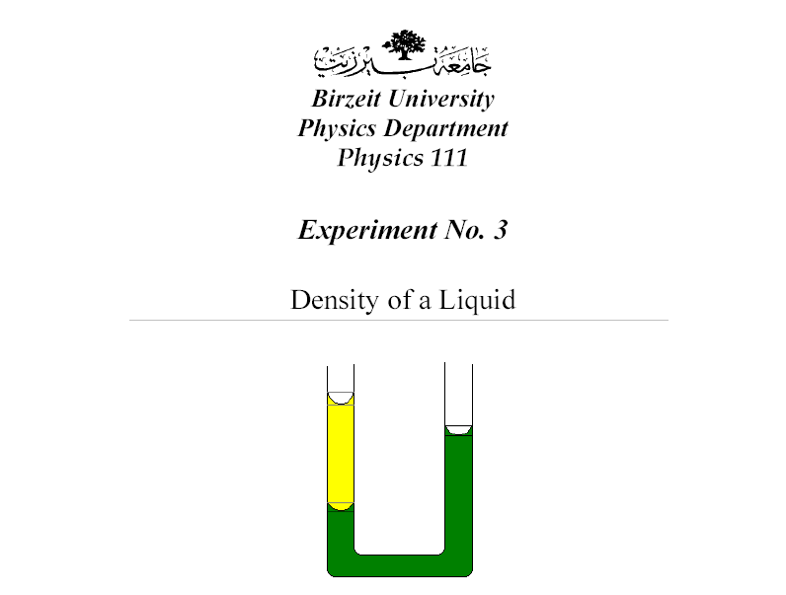

Student's name : Ahmad Abufarha
Student's NO. : 1050562

Partner's name: Rasha Bakir
Partner's NO. : 1050137

Instructor : Dr. Yaqub Anini .
Section NO. : 3

Date : 8\10\2005

Abstract :

1) The aim of the experiment is to find the density of an
unknown liquid .

2) The method used is by using a U-tube method .

3) The main results are:

ρ(liquid) = 0.86 ± 0.03 g\cm3

Theory :
Let's look at the following figure that
Shows a container filled with liquid of
Density (ρ). Consider portion of the
Liquid as shown in the figure . Note that
The portion is affected by three forces ;
The liquid above push down with force
(p1A) where p1 is the pressure of the top
Surface , A is the area . Liquid below
Pushes the portion up with force (p2A)
Where p2 is the pressure at the bottom
Surface . and the weight of the portion acts down with force equal (mg) . Hence,
P2A – P1A = mg as the portion of the liquid in static equilibrium. But ,
M = density (ρ)× Volum (V) = ρA(h2-h1)

P2 – P1 = ρ(h2 – h1 )g

SO the difrences in pressure depends only on the difrence vertical height .

Let's take a U-tube shown in the figure contains two liquids with the density (ρ1) , (ρ1) where ρ1 ≥ ρ2 .

ρL1 = ρL2
But , ρ1 = 1 g\cm3 as it's the density of water

So ρ2 = L1\L2

The error in ρ is given by the equation
∆ ρ = ρ(∆L1\L1 + ∆L2\L2)

Procedure:

1) A colored water was added to the U-tube until it reaches a suitable height .
2) Unknown liquid was added to one side of the tube .
3) After we wait a minute we read the measurements L1 , L2 .
4) The 3rd process was repeated six times.
5) ∆1, ∆2, and ∆3 were estimated experimentally.

Calculations:
__ __
L1 = 15.033 cm L2 = 17.566 cm

From the graph slope = ∆L1\∆L2 = 24-12\27-14 = 12\14 = 0.857 ≈0.86

ρ= slope = 0.857 g\cm3

__ __
∆ρ = (∆L1\L1 + ∆L2\L2) ρ = (0.3\15 + 0.3\17.6) × 0.857 = 0.032 g\cm3

Ρ = 0.857 ± 0.032 g\cm3

(Note: The result is very close to the real density, but there is an error that has occurred during cleaning the tube and has affected the result.)

Results and conclusion:

Ρ= 0.86 ± 0.03

1) I think that the liquid is paraffin wax.
2) If the tube were dirty , then it may affect the height of water and paraffin , so we ought to clean the tube with acetone .
3) I waited for a minute in order to be sure that the liquid static equilibrium.

