Student’s Name: Mohammad Na’em Mohammad Al Khatib.
Student’s No.: 1051104.

Partner’s Name: Ra’fat Nihad yousef
Partner’s No.: 1050675

Instructor: Tayseer Arouri

Section number: (8)

Date: 1/12/2005


- The aim of the experiment is:
  - To measure the decay constant and the half-life of a draining column of water.
- The method used is: the Burette method.
- The main result is :
(h vs. t graph)
$t_{1/2}=\text{23}±2\text{sec}$ (Ln(h) vs. t graph)



We consider a tube having water in it of a height () at time (). When we open the valve water drains from it at some rate.

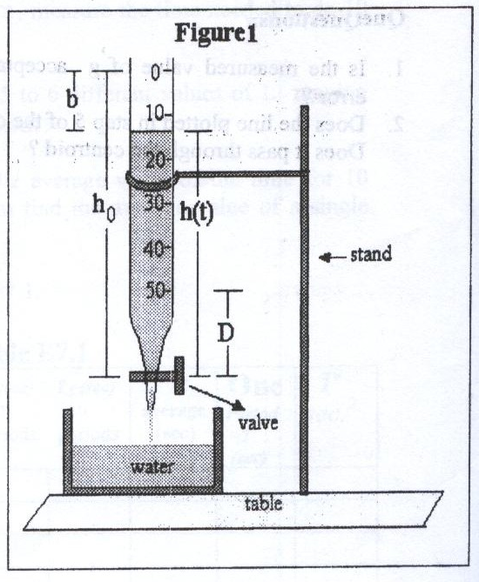

The rate of the decay of the water column is proportional to its height (h) that is:
$$\frac{−\text{dh}}{\text{dt}}∝h(t)$$
$$\frac{−\text{dh}}{\text{dt}}=λh(t)$$

Where$λ$is the a constant,
$$\frac{\text{dh}}{\text{dt}}=−λh(t)$$
$$\int{\frac{\text{dh}}{h}}=\int{−λ\text{dt}}$$
$$\text{ln}h−\text{ln}h_{0}=−λt$$
$$\text{ln}\frac{h}{h_{0}}=−λt$$
$$h=h_{0}e^{−λt}$$
So that $λ$is the decay constant.
When h = then:
$$\frac{h_{0}}{2}=h_{0}e^{−λt}$$
$$\frac{1}{2}=e^{−λt}$$
$$−{λt}_{1/2}=−\text{ln}2$$
$$t_{1/2}=\frac{\text{ln}2}{λ}=\frac{0\text{.}\text{693}}{λ}$$

When $λ$is greater then is smaller:
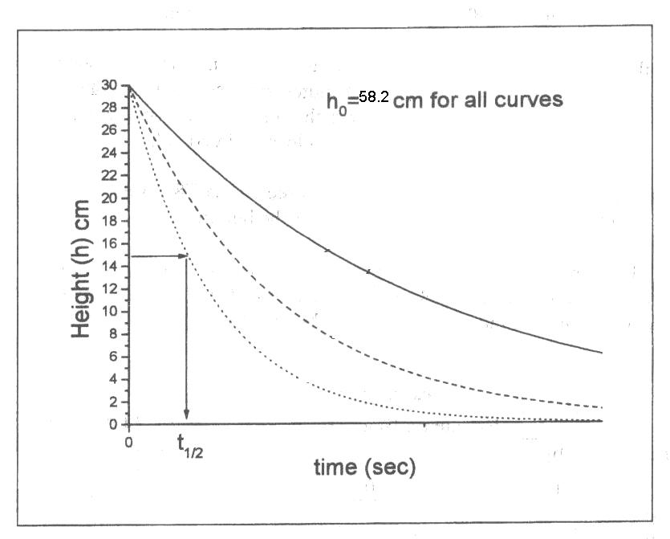


First we cleaned the tube in case there will be any dirty which can close the way of water going out of the tube.

After that we started to add little quantities of water in order to calibrate the hole from which water would go out so that the whole quantity of water after that would be emptied within about a minute and this is related to the quality of the burette we used.

After we calibrated the hole we started to add the whole quantity needed to fill the burette



Total burette length L=58.2 u (u is the burette units)

Time (sec) | Burette reading (u) |  |  | $$\overline{b}$$  (u) | $$h=L−\overline{b}$$  (u)
Time (sec) | $$b_{1}$$ | $$b_{2}$$ | $$b_{3}$$ | $$\overline{b}$$  (u) | $$h=L−\overline{b}$$  (u)
0 | 0.0 | 0.0 | 0.0 | 0.00 | 58.20
10 | 6.1 | 6.0 | 5.7 | 5.93 | 52.27
20 | 11.4 | 11.4 | 11.5 | 11.43 | 46.77
30 | 16.6 | 16.8 | 16.3 | 16.57 | 41.63
40 | 22.0 | 22.0 | 21.9 | 21.97 | 36.23
50 | 26.6 | 26.9 | 26.5 | 26.67 | 31.53
60 | 31.5 | 31.2 | 31.2 | 31.30 | 26.90
70 | 36.6 | 36.0 | 36.4 | 36.33 | 21.87
80 | 40.5 | 40.7 | 40.7 | 40.63 | 17.57
90 | 44.3 | 44.5 | 44.2 | 44.33 | 13.87



h vs. t graph
(the best fitting curve was found by the computer, it has the equation $\text{y = 63}\text{.}{\text{5e}}^{\text{-0}\text{.}\text{0304t}}$:

Table of measurements for the half-time from the plot

$$t_{1/2}(\text{sec})$$ | 23.08 | 22.31 | 23.08 | 23.08 | 22.69 | 25

The average value of $t_{1/2}$is:
${\overline{t}}_{1/2}$= 23.20513 sec
The error in ${\overline{t}}_{1/2}$is:

ln(h) vs. t Graph

The best fitting line to the data was find by the computer (On least square fit method), its equation is:
$$\text{ln}(h)=−0\text{.}\text{0304}t+4\text{.}\text{1517}$$

The slope =$−λ=−0\text{.}\text{0304}{\text{sec}}^{−1}$
The uncertainty in the slope, which also was found by the computer, is:

$$\begin{aligned}Δm=−Δλ=0\text{.}\text{002}{\text{sec}}^{−1} \\ Δλ=0\text{.}\text{002}{\text{sec}}^{−1}\end{aligned}$$

$$t_{1/2}=\frac{\text{Ln}2}{λ}=\frac{0\text{.}\text{693}}{0\text{.}\text{0304}}=\text{22}\text{.}8\text{sec}$$
The uncertainty in $t_{1/2}$is:

(h vs. t graph)

(ln(h) vs. t graph)


(h vs. t graph)
$t_{1/2}=\text{23}±2\text{sec}$ (Ln(h) vs. t graph)

First we see that the ${\overline{t}}_{1/2}$with its range of error intersects with the range of error for $t_{1/2}$ so that we see that our results is accepted within the rang of error we have.

As every experiment we expect some error to occur in it. One expected one is that the water as we noticed haven’t had the wanted continuity while the water exactly runs out especially at the end of the interval of time we achieved.

Another expected error is the difference (in time ) between stopping or starting the timer watch and closing the hole of the valve as a result of the delay in our brains signals. And that causes a quantity of water to be gone out or perhaps stopping the watch before stopping the flow of water.

Lastly, We can guess another error which is commonly expected while using any kind of instruments. It is that the burette we used with that short interval of time would affect our accuracy in finding equations or even having good fitting lines and that could be solved by getting a burette with a good quality which will make the time interval longer , and so , the lines and calculations will be more and more accurate .

