Birzeit University

Physics Department
Physics 111

Experiment No.8

Half-Life of a Draining Water Column

Student’s Name: Walid Hasan Abu Salah
Student’s No. : 1050193

Partner’s Name : Anas Neda Mousa
Partner’s No. : 1050018

Section : 8

Date : Dec. 6 , 2005

Instructor : Dr. Tayseer Arouri

Procedure:

1. We measured the total burette length in burette unit , this distance represents initial value ( h0 ) .
2. We filled the burette with water using the funnel .
3. The period that water drained was estimated .
4. We measured the burette reading every period of time relating to the estimated value ( which is 10 seconds in my case ) .
5. The burette was filled again with water to the same initial height , and step 4 was repeated twice .
Hint ; the setting of the valve must not be changed during the experiment .

Data:

Total burette length h0 = 65.5 in burette units ( u ).

Ln(h) | .h= h0-b | b | Burette reading ( u ) |  |  | Time  ( sec )
Ln(h) | .h= h0-b | b | .b3 | .b2 | .b1 | Time  ( sec )
4.18 | 65.5 | 0 | 0 | 0 | 0 | 0
4.09 | 60.0 | 5.5 | 5.5 | 5.6 | 5.5 | 10
4.00 | 54.8 | 10.7 | 10,8 | 10.6 | 10.6 | 20
3.91 | 50.0 | 18.4 | 15.5 | 15.5 | 15.6 | 30
3.81 | 45.3 | 20.2 | 20.3 | 20.1 | 20.3 | 40
3.71 | 40.9 | 24.6 | 24.7 | 24.4 | 24.6 | 50
3.61 | 36.8 | 28.7 | 28.8 | 28.6 | 28.8 | 60
3.49 | 32.9 | 32.6 | 32.7 | 32.5 | 32.6 | 70
3.38 | 29.4 | 36.1 | 36.0 | 36.2 | 36.2 | 80
3.26 | 26.0 | 39.5 | 39.5 | 39.5 | 39.5 | 90
3.14 | 23.0 | 42.5 | 42.5 | 42.5 | 42.6 | 100
3.00 | 20.1 | 45.4 | 45.4 | 45.4 | 45.4 | 110
2.86 | 17.5 | 48.0 | 48.0 | 48.1 | 48.0 | 120

Abstract:

1. The aim of the experiment is to find the constant of decay ( λ) , and the half-life ( t_{1/2}) of draining water column .

2. The method used is by using burette method .

3. The main redults are :

. t_{1/2} = ( 64 ± 2 ) sec. ( from h vs t graph )

. t_{1/2} = 63 sec. ( from Ln(h) vs t graph )

Theory :
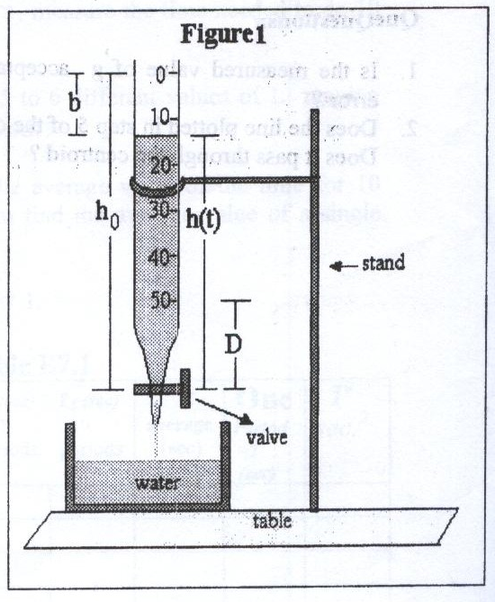 Consider a burette along a glass tube . At t = 0 , the tube contains water to a height of h0 , but when one opens the valve ,then the water will start draining out of the tube , this process called decayingof the water column , hence ;
-dh/dt α h(t) ,but we can recast this equation as ;
dh/dt = -λh(t) ,where λ is a constant .
One can multiply this equation by dt/h to get the following equation : dh/h =-λdt
By taking integration to both sides of the equation we get;

∫ dh/h = - ∫ λh(t) → lnh(t) -lnh0 = -λt or

ln [h(t)/ h0] =-λt → h(t) = h0℮^{-λt}

Note that the constant λ is called the deay constant .

One can obtain a relation between t_{1/2} and λ , notice that when h(t) = h0/2 the time t is equal to t_{1/2 ,} substituting this
. in the previous equation we get ,

h0/2 = h0℮^{-λt1/2} → -ln(2) = -λ t_{1/2} → t_{1/2 =} ln(2)/ λ

0.693 / λ ▪▪▪▪▪= ▪▪▪▪▪ t_{1/2}

So, we sketsh two graphs ;

The first: ( h vs t ) which gives different values of t_{1/2} of average t_{1/2} .
Then the uncertainity can be easily found as :
The uncertainity = σ_{m} (t_{1/2})

The second : is a linear graph ( ln(h) vs t )which has slope equals ( - λ ) .

Calculations:

1. From ( h vs t ) graph paper
( obtain 7 values for t_{1/2} )

58 | 61 | 63 | 63 | 65 | 68 | 72 | t_{1/2}  Sec))

The average value of t_{1/2} is :

t_{1/2} = ( 72+68+65+63+63+61+58 ) /7 =450 /7=64.2857 = 64 sec

The error in t_{1/2} is :

∆ t_{1/2} = σ_{m} (t_{1/2}) =1.7418 = 2 sec

2. From ( ln(h) vs t ) graph paper :

the slope = - λ = - 0.011

t_{1/2} = ln(2) / λ = 0.693 /0.011 = 63 = 63 sec

. t_{1/2} = ( 64 ± 2 ) sec. ( from h vs t graph )

. t_{1/2} = 63 sec. ( from Ln(h) vs t graph )

Results and Conclusion :

. t_{1/2} = ( 64 ± 2 ) sec. ( from h vs t graph )

. t_{1/2} = 63 sec. ( from Ln(h) vs t graph )

We find the values of (t_{1/2}) from two graphs , first graph
( h vs t ) that gives us (64 ± 2 sec ) , from the second linear graph ( ln(h) vs t ) we have a value of t_{1/2} which is 63 sec , since 63 є ( 62, 66) → there is similarity between the values of t_{1/2} from the two graphs → my result is accurate .

Though we got an accurate result ,we might make some systematic errors .

One of these systematic errors the unaccuracy in stoping the stop watch , sometimes it may be less or more 10 sec.

Another systematic error the non coincidence in letting water drain from the tube and the starting of the watch , for example , I may open the valve of the tube and after or before a short time I let the watch to start .

Another matter that may cause a systematic error is the dirts in the tube , that is , it may not be clean enough . So we can clean it to get more accurate results .

