

BIRZEIT UNIVERSITY
Physics Department

Physics 111

Experiment No. 6

Index of Refraction
………………………………………………………………………………………

Student’s Name: Osaid Ayasa Student’s No.: 1101634

Partner’s Name: Maryam Irbash Partners’ No. : 1100027

Instructor: Dr. Tayseer Arouri Section No.: 14

Date: October 14, 2010

Abstract :
- The aim of the experiment: is to measure the index of refraction for a kind material ( glass or plastic ).

- The method used: is by measuring the angles of incidence and refraction and using Snell's law and least square fit method to calculate the index of refraction .
- The main results are: µ = 1.47 ± 0.13

Theory :

When a ray of light passes from a medium into another then the speed of light changes through that change. The change of the speed of light between the two mediums causes the bending of the ray. The bending of light is called “refraction”.

Each medium has its own behavior of light in it which causes the difference in speed in that medium. This property is called “ index of refraction” of that medium. We would symbolize that index as (n) which equals the ratio of speed of light in vacuum and the speed of light in that medium.

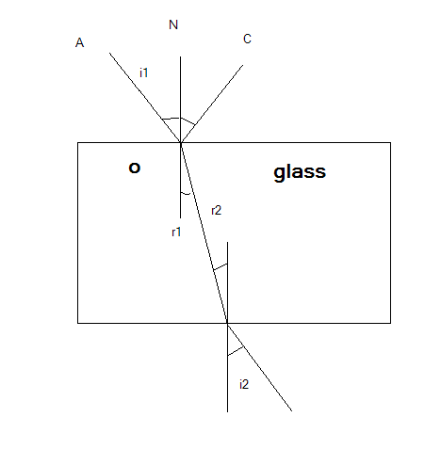

Figure 1.0

As Snell’s law shows , assuming the angle of incidence to (i) and the angle of refraction to (r) , that:
is the index of refraction of air which is near that of the vacuum () and is the index of refraction of the glass.
Then:
Then we can find from using least square fit method .
The error in is founded by:
Procedure
First , the block was placed on a piece of white paper , then
the borders of block were drawn on the paper. After that, the angles of incidence were marked as shown in figure 2.0

Figure 2.0

The first angle of incidence was chosen near 10 , and the second angle of incidence near 20 , the third near 30 and so on .
After that , shine a narrow beam of light such that the beam is exactly on path 1 in figure 2.0 , then the path of the outgoing beam was marked and labeled .
Note : This procedure was repeated six more times for the other angles from 20 degrees to 60 degrees .

** The block was removed . For each outgoing beam , a perpendicular line was drown to the block boundary at each exit point .
For each incident and outgoing beam , the incident point was connected with the exit point .
***For each incident and outing beam , the angles ( i , i ) and ( r , r )
were measured ( Note that theory (, then the measurements were written down in the table .
From the divergence of the beam , the uncertainty was estimated in the measurements of i and r , ∆i and ∆r ( see figure 3.0 ) . in radians.
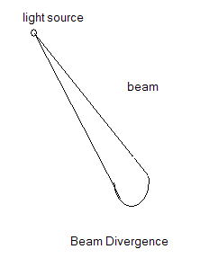

Figure 3.0

Data :

No. | Angle i degree |  | i  average |  | Anlge r  degree |  | r  average
1 | 10 | 8 | 9 | 0.15 | 7 | 5 | 6.0 | 0.105
2 | 20 | 15 | 17.5 | 0.30 | 13 | 11 | 12.0 | 0.208
3 | 30 | 26 | 28.0 | 0.47 | 18 | 16 | 17.0 | 0.292
4 | 40 | 34 | 37.0 | 0.60 | 24 | 23 | 23.0 | 0.391
5 | 50 | 44 | 47.0 | 0.73 | 29 | 29 | 29.0 | 0.485
6 | 60 | 53 | 56.5 | 0.83 | 36 | 34 | 35.0 | 0.574

Calculations :
(Using Least Square Fit method )

x_{i} | y_{i} | x_{i}y_{i} | x_{i}² | y_{i}-mx_{i}-b | (y_{i}-mx_{i}-b)²
0.105 | 0.156 | 0.016 | 0.11 | -0.0467 | 0.0022
0.208 | 0.301 | 0.063 | 0.043 | -0.0142 | 0.0020
0.292 | 0.470 | 0.137 | 0.085 | 0.0531 | 0.0028
0.391 | 0.602 | 0.235 | 0.153 | -0.0451 | 0.0020
0.485 | 0.731 | 0.354 | 0.235 | -0.0453 | 0.0021
0.574 | 0.834 | 0.479 | 0.329 | -0.0444 | 0.00197
∑x_{i}= | ∑y_{i}= | ∑x_{i}y_{i}= | ∑x_{i}²= |  | ∑( y_{i}-mx_{i}-b)²=
2.06 | 3.09 | 1.284 | 0.856 |  | 0.0113

Let x= Sin ( $\overset{−}{r}$), y= Sin ($\overset{−}{i}$)
$D=N\sum{{x_{i}}^{2}}−(\sum{x_{i}})^{2}$= 6(0.86) - (2.06) = 0.892
$m=(N\sum{x_{i}}y_{i}−\sum{x_{i}}\sum{y_{i}})/D$=
(6 1.284 – 2.06 3.09) \ 0.892 = 1.47

$b=(\sum{x_{i^{2}}}\sum{y_{i}}−\sum{x_{i}}\sum{x_{i}y_{i}})/D=$
(0.99 3.24 – 2.23 1.447)\ 0.96 = 0.05

Calculation of errors:
$σ_{y^{2}}=\frac{1}{N−2}\sum{(y_{i}−{\text{mx}}_{i}−b})^{2}=$ 2.83 10
$Δμ=σ_{m}=\sqrt{\frac{{Nσ}_{y^{2}}}{D}}=$ 0.132
$Δb=σ_{b}=σ_{y}\sqrt{\frac{\sum{x_{i^{2}}}}{D}}=$ 0.054
- Results and conclusion:
µ = 1.47 ± 0.13

The calculation of the index of refraction is within the range of the real one, the test range is but with a little accuracy and that is of course caused by systematic errors occurred while doing the experiment.
One expected error is the measurement of the angles with a non précised tool which not suitable for such use. Another expected error is the divergence of the which makes deciding where the real line and angle for refraction impossible because of its wideness. We can reduce such an error by using more precise light like that of a laser one . which makes the wideness of the beam of light less and less and so the reading of the angles would be more precise.

