

BIRZEIT UNIVERSITY
Physics Department

Physics 111

Experiment No. 8

half-life of a draining column of water.
………………………………………………………………………………………

Student’s Name: Osaid Ayasa Student’s No.: 1101634

Partner’s Name: Maryam Irbash Partners’ No. : 1100027

Instructor: Dr. Tayseer Arouri Section No.: 14

Date: October 28, 2010

Abstract:

- The aim of the experiment is: to measure the decay constant and the half-life of a draining column of water.
- The method used is: the Burette method.
- The main result is :
(h vs. t graph)
$t_{1/2}=\text{23}±2\text{sec}$ (Ln(h) vs. t graph)

Theory:

We consider a tube having water in it of a height () at time (). When we open the valve water drains from it at some rate.

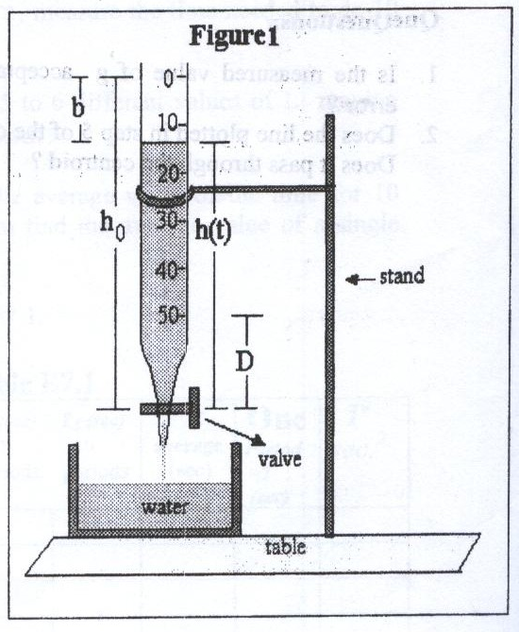

The rate of the decay of the water column is proportional to its height (h) that is:
$\frac{−∂h}{∂t}∝h(t)$➔$\frac{−∂h}{∂t}=λh(t)$ E 1
where $λ$ is a constant.
Multiplying E2 by -$∂t$ and dividing it by h(t) we obtain :
$$\frac{−∂h}{h}=λ∂t$$
Integrating both sides:
$\int_{h_{0}}^{h(t)}{\frac{∂h}{h}=−\int_{0}^{t}{λ∂t}}$➔$\text{Lnh}|\begin{matrix}h(t) \\ h_{0}\end{matrix}=−λt|\begin{matrix}t \\ 0\end{matrix}$

➔$\text{Lnh}(t)−{\text{Lnh}}_{0}=−λt$➔$\text{Ln}\frac{h(t)}{h_{0}}=−λt$
Exponentiating both sides :
$e^{\text{Ln}\frac{h(t)}{h_{0}}}=e^{−λt}$➔$\frac{h(t)}{h_{0}}=e^{−λt}$➔$h(t)=h_{0}e^{−λt}$ E2
To find the half-life , (when $h(t)=\frac{h_{0}}{2}$):

$\frac{h_{0}}{2}=h_{0}e^{−{λt}_{1/2}}$➔$\frac{1}{2}=−{λt}_{1/2}$
taking the natural logarithm for both sides :

$\text{Ln}2^{−1}={\text{Lne}}^{−{λt}_{1/2}}$➔$−\text{Ln}2=−{λt}_{1/2}$➔$t_{1/2}=\frac{\text{Ln}2}{λ}=\frac{0\text{.}\text{693}}{λ}$
The uncertainty in $t_{1/2}$is found as the following :
$${Δt}_{1/2}=\left|\frac{−\text{Ln}2Δλ}{λ^{2}}\right|=t_{1/2}\frac{Δλ}{λ}$$

When is greater then is smaller:
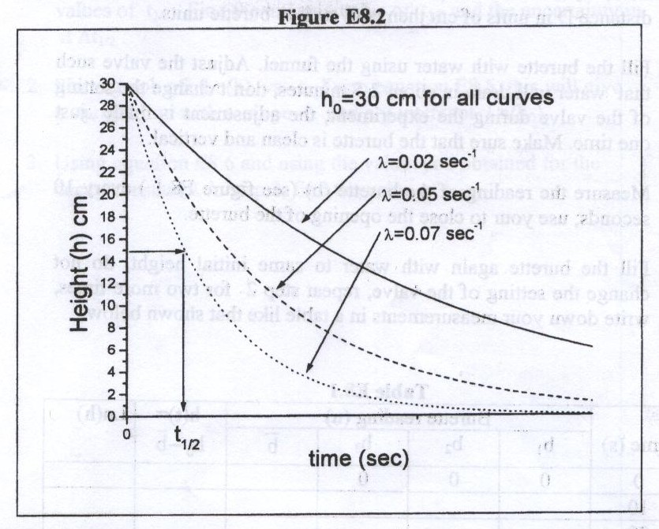

Procedure:

First we cleaned the tube lest there will be any dirty which can close the way of water going out of the tube.

After that we started to add little quantities of water in order to calibrate the hole from which water would go out so that the whole quantity of water after that would be emptied within about a minute and this is related to the quality of the burette we used.

After we calibrated the hole we started to add the whole quantity needed to fill the burette

Data:

Total burette length L=60.13 u (u is the burette units)

Time (sec) | Burette reading (u) |  |  | $\overline{b}$(u) | $h=L−\overline{b}$(u) | In (u)
 | $$b_{1}$$ | $$b_{2}$$ | $$b_{3}$$ | $\overline{b}$(u) |  | In (u)
0 | 0.0 | 0.0 | 0.0 | 0.00 | 60.13 | 4.10
5 | 5.0 | 4.8 | 5.1 | 4.97 | 55.16 | 4.01
10 | 10.0 | 9.6 | 9.7 | 9.77 | 50.36 | 3.92
15 | 14.9 | 14.5 | 14.5 | 14.63 | 45.50 | 3.82
20 | 18.7 | 19.0 | 18.7 | 18.80 | 41.33 | 3.72
25 | 22.9 | 23.5 | 23.0 | 23.13 | 37.00 | 3.61
30 | 27.5 | 27.3 | 27.3 | 27.37 | 32.76 | 3.49
35 | 31.5 | 31.0 | 31.1 | 31.20 | 28.93 | 3.36
40 | 35.1 | 35.1 | 34.9 | 35.03 | 25.10 | 3.22
45 | 38.3 | 38.4 | 38.2 | 38.30 | 21.83 | 3.08
50 | 41.2 | 40.9 | 41.1 | 41.07 | 19.06 | 2.95
55 | 44.1 | 44.0 | 44.1 | 44.07 | 16.06 | 2.78

Calculations:

1) From h vs. t graph ( the best fitting curve was found by the computer , it has the equation $\text{y = 61}\text{.}{\text{5e}}^{\text{-0}\text{.}\text{0304t}}$:
Table of measurements for the half-time from the plot

$$t_{1/2}(\text{sec})$$ | 23.07 | 22.45 | 23.06 | 23.08 | 22.70 | 24.87

The average value of $t_{1/2}$is :
${\overline{t}}_{1/2}$= 23.205 sec
The error in ${\overline{t}}_{1/2}$is :
2) Ln(h) vs. t :
The best fitting line to the data was find by the computer (On least square fit method), its equation is :
$$\text{ln}(h)=−0\text{.}\text{0304}t+4\text{.}\text{1517}$$
The slope =$−λ=−0\text{.}\text{0304}{\text{sec}}^{−1}$

The uncertainty in the slope , which also was found by the computer , is :
$$\begin{aligned}Δm=−Δλ=0\text{.}\text{002}{\text{sec}}^{−1} \\ Δλ=0\text{.}\text{002}{\text{sec}}^{−1}\end{aligned}$$

$$t_{1/2}=\frac{\text{Ln}2}{λ}=\frac{0\text{.}\text{693}}{0\text{.}\text{0304}}=\text{22}\text{.}8\text{sec}$$
The uncertainty in $t_{1/2}$is :

D${\overline{t}}_{1/2}$= ${\overline{t}}_{1/2}$ D1= 22.8 $\frac{0\text{.}\text{002}}{0\text{.}\text{03}}=1\text{.}5$ sec

(h vs. t graph)
(Ln(h) vs. t graph)

Results and Conclusion:

(h vs. t graph)
$t_{1/2}=\text{23}±2\text{sec}$ (Ln(h) vs. t graph)
First we see that the ${\overline{t}}_{1/2}$with its range of error intersects with the range of error for $t_{1/2}$ so that we see that our results is accepted within the rang of error we have.

As every experiment we expect some error to occur in it. One expected one is that the water as we noticed haven’t had the wanted continuity while the water exactly runs out especially at the end of the interval of time we achieved.

Another expected error is the difference (in time ) between stopping or starting the timer watch and closing the hole of the valve as a result of the delay in our brains signals. And that causes a quantity of water to be gone out or perhaps stopping the watch before stopping the flow of water.

Lastly, We can guess another error which is commonly expected while using any kind of instruments. It is that the burette we used with that short interval of time would affect our accuracy in finding equations or even having good fitting lines and that could be solved by getting a burette with a good quality which will make the time interval longer , and so , the lines and calculations will be more and more accurate .

