

BIRZEIT UNIVERSITY
Physics Department

Physics 111

Experiment No. 9

RC circuit
………………………………………………………………………………………

Student’s Name: Osaid Ayasa Student’s No.: 1101634

Partner’s Name: Maryam Irbash Partners’ No. : 1100027

Instructor: Dr. Tayseer Arouri Section No.: 14

Date: November. 4. 2010

Abstract:
1)The aim of the experiment is to find the time constant $τ$ of an RC circuit and the value of its capacitor.
2)The method used is by measuring the voltage on the capacitor at certain moments in a charging and a discharging circuits.
3)The main result is: $C=\text{21}±1μF$
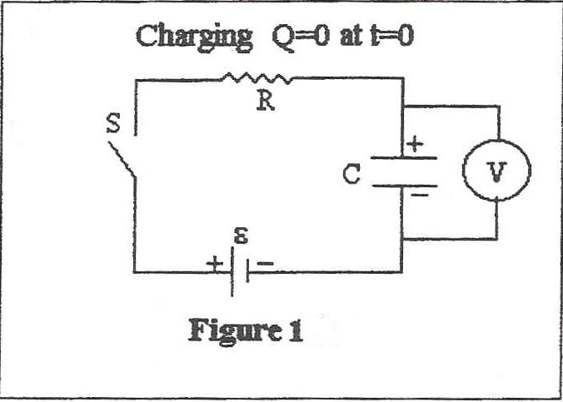
Theory:
Lets consider the series RC
circuit shown in figure1,
consisting of a capacitor C
and a resistance R connected in
series to a voltage source $ε$,
at t=0 the capacitor is uncharged ,
that is, $Q_{0}=0$, when the circuit
is closed then the capacitor will
start charging.
Here are the two states , charging
and discharging , we will treat at this experiment:
A. Charging:
From Kirchhoff’s second rule , which implies that the sum of all voltage drops over a closed group is zero ($\sum_{i=1}^{n}{V_{i}=\text{Zero}}$) we find that ,in our circuit, :
$ε−\text{IR}−\frac{Q}{C}=0$ $I=\frac{ε}{R}−\frac{Q}{\text{RC}}$ $\frac{∂Q}{∂t}=\frac{ε}{R}−\frac{Q}{\text{RC}}$
$\frac{∂Q}{\frac{ε}{R}−\frac{Q}{\text{RC}}}=∂t$ ;(as $I=\frac{∂Q}{∂t}$)
Integrating both sides:
$\int_{Q=0}^{Q(t)}{\frac{1}{\frac{ε}{R}−\frac{Q}{\text{RC}}}∂Q=\int_{0}^{t}{∂t}}$ $−\text{RCLn}(\frac{(ε/R)−(Q/{\text{RC}})}{ε/R})=t$
$$\text{Ln}(\frac{(ε/R)−(Q/{\text{RC}})}{ε/R})=\frac{−t}{\text{RC}}$$
Exponentiating both sides , we get :
$\frac{(ε/R)−(Q/{\text{RC}})}{ε/R}=e^{\frac{−t}{\text{RC}}}$ $1−\frac{Q}{εC}=e^{\frac{−t}{\text{RC}}}$
$$Q(t)=εC(1−e^{\frac{−t}{\text{RC}}})$$
and as the voltage on the capacitor has the relation (V=Q/C) with the charge on it , thus:
$V(t)=ε(1−e^{\frac{−1}{\text{RC}}})$
At the time t=RC ,which is known as the time constant $τ$of the circuit the voltage on the capacitor is:
$V(t=\text{RC})=ε(1−e^{−1})=ε(1−\frac{1}{e})=0\text{.}\text{63}ε$
We see from equation E1 that the time constant$τ$is the time needed for the potential difference on the capacitor V(t) to reach 0.63 of the maximum voltage $ε$.
Note : $τ$can be found from the graph of the charging curve as that of figure , by drawing a parallel line to the t-axis passes through 0.63$ε$volts on the v-axis , then by drawing a parallel line to the v-axis , from the point where the first line cuts the curve of V vs. t , and the point where it cuts the t-axis is$τ$ as shown in figure 2.

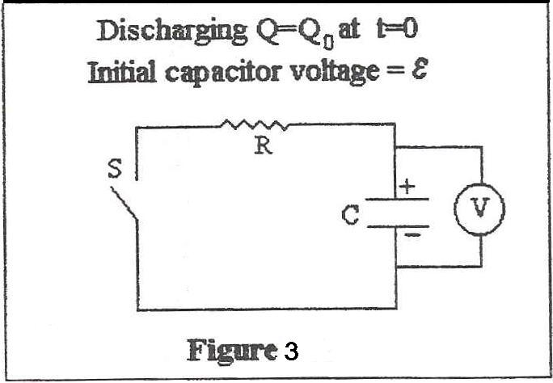
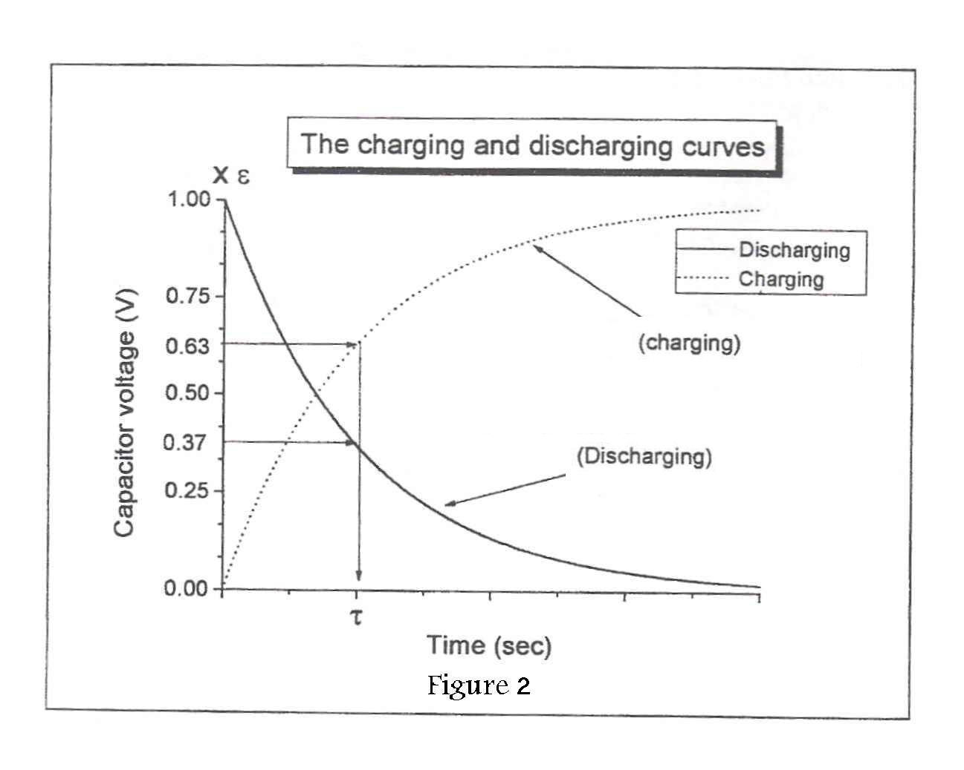

B. Dicharging:

After the capacitor has been charged ,
and if we removed the power supply ,
and a resistance R is connected ,by
series, to this circuit as shown in
figure 3 , the capacitor has an initial
potential difference of $ε$and an initial
charge of $Q_{0}=Cε$.Then the capacitor
will start discharging through the resistance . Back again to Kirchhoff’s second rule ;
$−\text{IR}−\frac{Q}{C}=0$ $−\frac{∂Q}{∂t}R−\frac{Q}{C}=0$ $R\frac{∂Q}{∂t}=−\frac{Q}{C}$
Dividing both sides by RQ;
$$\frac{∂Q}{Q}=−\frac{1}{\text{RC}}∂t$$
Integrating both sides;
$\int_{Q=0}^{Q(t)}{\frac{∂Q}{Q}=−\frac{1}{\text{RC}}\int_{0}^{t}{∂t}}$ $\text{LnQ}(t)−{\text{LnQ}}_{0}=−\frac{1}{\text{RC}}t$
$$\text{Ln}(\frac{Q(t)}{Q_{0}})=−\frac{1}{\text{RC}}t$$
$\frac{Q(t)}{Q_{0}}=e^{−\frac{1}{\text{RC}}t}$ $Q(t)=Q_{0}e^{−\frac{1}{\text{RC}}t}$ $Q(t)=ε{\text{Ce}}^{−\frac{1}{\text{RC}}t}$

And as the voltage on the capacitor V =Q/C ;
$$V(t)=\frac{Q(t)}{C}={εe}^{−\frac{t}{\text{RC}}}$$
And at time t=$τ$;
$V(t=\text{RC})={εe}^{−1}=\frac{ε}{e}=0\text{.}\text{37}ε$
From the discharging curve as that shown in figure 2 we can find $τ$, but this time the first line cuts the v-axis at v=0.37$ε$ volts

A third way for finding $τ$is from the linear equation we get from taking the natural logarithm of both sides of equation E2 ;
$\text{Ln}\left\{v(t)\right\}=\text{Ln}{εe}^{−\frac{t}{\text{RC}}}$ $\text{Ln}\left\{v(t)\right\}=\text{Ln}ε−\frac{t}{\text{RC}}$
Equation E3 gives a linear equation with the y-intercept Ln($ε$) and with a slope $m={−1}/{\text{RC}}={−1}/τ$ .
So $τ={−1}/m$
The value of the unknown capacitor can be found using this equation :
$$C=\frac{\overline{τ}}{R}$$
The uncertainty in C $ΔC$is found by taking the partial derivative of the later equation , thus;
$ΔC=\left|\frac{Δ\overline{τ}}{R}\right|+\left|−\frac{\overline{τ}ΔR}{R^{2}}\right|$ $ΔC=C(\frac{Δ\overline{τ}}{\overline{τ}}+\frac{ΔR}{R})$
The uncertainty in $\overline{τ}$,$Δ\overline{τ}=σ_{m}(τ)$,the standard deviation of the mean value of the measurements of $τ$.The resistance R is measured either by the ohmmeter or using the color code on it, and $ΔR$, the uncertainty in R, is to be estimated from the multi-meter (switched to as an ohmmeter) or from the color code.

Procedure:
First, the circuit was setup as shown in figure 1,volts was provided from the main power supply . ( Note : the voltmeter which was used was a digital voltmeter and it was adjusted to read DC volts and also the appropriate scale was selected ) .
Then , before doing the experiment , the capacitor had no charge on it , this was done by shortening the terminals of the capacitor by a wire .
After that , the wire was removed and the circuit was closed . At the same instant the stop watch was started and the reading of the digital voltmeter for the time values were written down in the table of data .
The circuit was disconnected from the voltage source and it was replaced by a short at the same instant the stop watch was started . this was the circuit as shown in figure3. before closing the circuit , the voltage on the capacitor was the maximum , and the voltage on the capacitor was started decreasing as a function of time , and the capacitor voltage for the time were written down below in the table of data .

Data:
$C=\text{22}μF$ 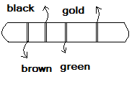
$R=\text{10}×{\text{10}}^{5}±5\text{\%}$$Ω$
$R={\text{10}}^{6}±1$ $Ω$
(From the color code)

Time  (sec) | Charging  $V_{\text{Capacitor}}$(volts) | Discharging  $V_{\text{Capacitor}}$(volts)
0 | 0.00 | 5.64
5 | 1.72 | 5.03
10 | 2.43 | 4.36
15 | 3.09 | 3.57
20 | 3.49 | 2.88
25 | 3.88 | 2.40
30 | 4.14 | 2.00
35 | 4.44 | 1.71
40 | 4.65 | 1.40
45 | 4.80 | 1.14
50 | 4.95 | 0.92
55 | 5.07 | 0.77
60 | 5.17 | 0.66
65 | 5.26 | 0.52
70 | 5.34 | 0.44
75 | 5.40 | 0.37
80 | 5.44 | 0.30
85 | 5.48 | 0.24
90 | 5.51 | 0.20
95 | 5.54 | 0.17
100 | 5.54 | 0.14
105 | 5.57 | 0.12
110 | 5.59 | 0.10
115 | 5.60 | 0.08
120 | 5.61 | 0.06
125 | 5.62 | 0.05
130 | 5.63 | 0.04
135 | 5.64 | 0.03
140 | 5.64 | 0.03
145 | 5.64 | 0.02
150 | 5.64 | 0.02
155 | 5.64 | 0.01
160 | 5.64 | 0.01
165 | 5.64 | 0.01

Calculations:
1)From the linear graph paper:
a) The time constant from the charging curve $(τ_{c}):$
$τ_{c}=\text{20}\text{.}5$Sec
b) The time constant from the discharging curve ($τ_{d}$) :
$τ_{d}=\text{21}\text{.}5$Sec
2)From the semi-log graph ;
$\text{Slope}=\frac{\text{Ln}0\text{.}5−\text{Ln}4\text{.}\text{36}}{\text{65}−\text{10}}=−0\text{.}\text{040}$${\text{Sec}}^{−1}$
$τ_{s}=\text{21}\text{.}\text{60}$Sec $\overline{τ}=\text{21}\text{.}\text{20}$Sec
$$Δτ=\frac{σ_{s}}{\sqrt{N}}=\frac{0\text{.}\text{57}}{\sqrt{3}}=0\text{.}\text{33}\text{Sec}$$
Resistance
$R={\text{10}}^{6}±1$$Ω$
$$C=\frac{τ}{R}=\frac{\text{21}\text{.}2}{{\text{10}}^{6}}=\text{21}\text{.}2×{\text{10}}^{−6}F$$
$$ΔC=C(\frac{Δ\overline{τ}}{\overline{τ}}+\frac{ΔR}{R})$$
$$\begin{aligned}ΔC=C(\frac{Δ\overline{τ}}{\overline{τ}}+\frac{ΔR}{R})=\text{21}\text{.}2×{\text{10}}^{−6}(\frac{0\text{.}\text{33}}{\text{21}\text{.}2}+\frac{5×{\text{10}}^{4}}{{\text{10}}^{6}}) \\ \text{21}\text{.}2×{\text{10}}^{−6}(0\text{.}\text{016}+0\text{.}\text{05})=1\text{.}\text{39}×{\text{10}}^{−6}F\end{aligned}$$
$$C=\text{21}±1μF$$

Results & conclusion:
$$C=\text{21}±1μF$$
The range of measured value of C is from 20 to 22 $μF$and so the manufacturer’s stated value of C written on the capacitor lies within the range.
Increasing the resistance R affects both the charging and discharging processes by increasing the time needed for charging and discharging. Notice that $τ=\text{RC}$
The unit of $τ=\text{RC}$is seconds :
$$[τ]=[\text{RC}]=Ω×F=\frac{\text{Votls}}{A}×\frac{\text{colom}}{\text{Volts}}=\frac{\text{colom}}{\text{colom}\text{/sec}}=\text{sec}$$
Notice that:
* $R=\frac{V}{I}$ *$C=\frac{Q}{V}$ *$I=\frac{∂Q}{∂t}$
A systematic error I expect in this experiment is that when my partner finished his periodic counting and I read the value of the voltage it was not the certain value , as sometimes the value changed after its ,relatively, long steady just after he began a new counting. Much more digits are to be taken for the voltage.

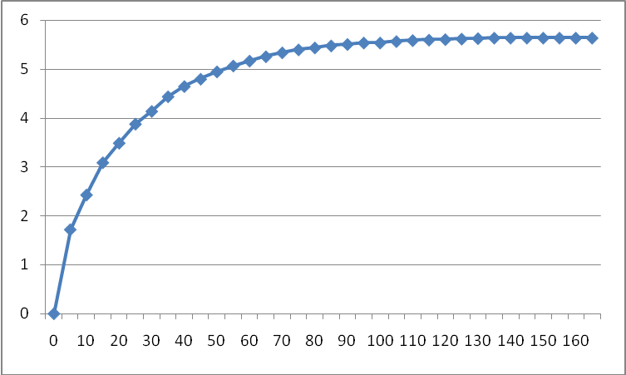
Charging

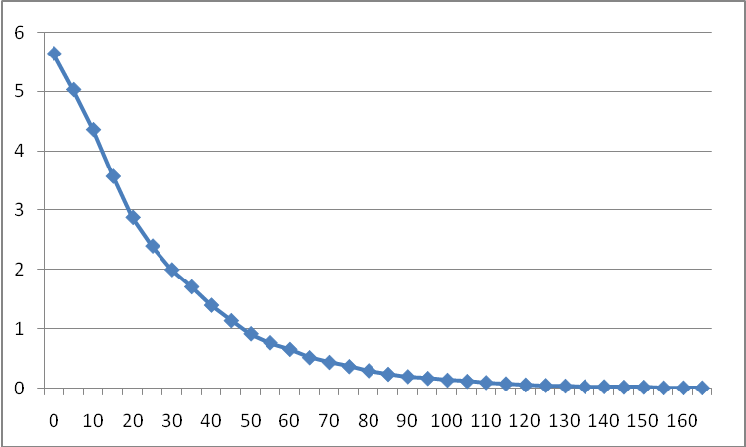
Discharging

