

Physics Department

Physics 112

Experiment No.10

Resonance

Student’s Name: Almutasem bellah Omar

Student’s No.: 1090349

Partner’s Name: Jihad Abdullah

Partner’s No.: 1090349

Section: 5

Date: 29\3\2010

Instructor: Dr. Ghassan Andoni

Abstract:

1)The aim of the experiment :is to find the resonance frequency and the quality factor.
2)The method used : by measuring the voltage as a function of frequency, and using it to plot the current as a function of the frequency.

3)The main results are:

………………………………………………………………………………………………………………………………………………………………………………………………………………………………………………………………………………………………………………………………………………………………………………………………………………………………………………………………………………

Theory:

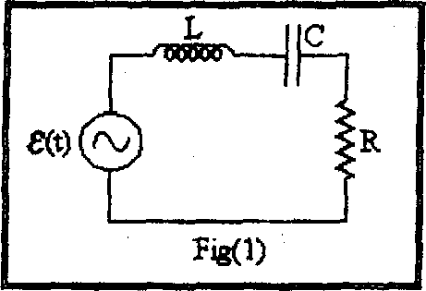
The amplitude of the current passing through the circuit shown in is given by, $I_{o}=\frac{V_{o}}{\sqrt{R^{2}+{\left(ωL−\frac{1}{ωC}\right)}^{2}}}$.

As we can see, we can get a maximum value of $I_{o}$ when
$$ωL=\frac{1}{ωC}$$
$⇒ω_{o}=\frac{1}{\sqrt{\text{LC}}}$ Under such a condition ω is the natural angular frequency of the circuit.
The resonance is that the current assumes its maximum value when the deriving voltage frequency equals the natural frequency of the RLC circuit.
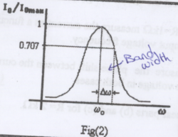
Fig.2 shows a plot of the value of $I_{o}$as a function of ω. At resonance $I_{o}=\frac{V_{o}}{R}$ and the value of the current is only limited by the resistance of the circuit.

The quality factor:
A measure of the sharpness of the resonance curve is a quantity called the quality factor (Q), which is defined as $Q=\frac{ωL}{R}$
At resonance $Q=\frac{1}{R}\sqrt{\frac{L}{C}}$
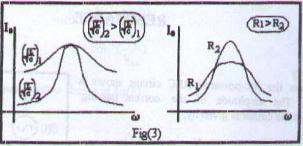
Fig.3 shows a plot of resonance curve for different combinations of R, L, and C.
The band width (∆ω) is a practical value that measures the sharpness of the resonance curve. The band width (∆ω) is the frequency range between the maximum value of $I_{o}$and the value $\frac{I_{o}}{\sqrt{2}}$, see fig.2.

The quality factor is related to the band width as follows:
$Q=\frac{ω_{o}}{2\left|Δω\right|}$.

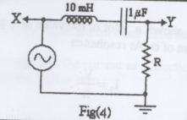
Procedure:

1-we connected the circuit of figure 4.
2- For R=1 kΩ ,we measured the current as a function of the input voltage frequency.
3-we measured the phase shift between the current and the voltage in both cases.
4-we repeated the previous step for R=2 kΩ.

Data:

L=10mH; C=0.1µF; R=1k$Ω$

f (kHz) | ω (rad/s) | R = 1 k$Ω$ |  | R = 2 k$Ω$
f (kHz) | ω (rad/s) | $$V_{0}(\text{volt})$$ | $$I_{0}(\text{mA})$$ | $$V_{0}(\text{volt})$$ |  | $$I_{0}(\text{mA})$$
0.2
0.3
0.5
0.6
0.8
1.0
2.0
3.0
5.0
5.5
6.0
8.0

Calculations:

Theoretically:

$ω_{0}=\frac{1}{\sqrt{\text{LC}}}=$

For R = 1kΩ
$$Q=\frac{\text{ω L}}{R}=\frac{1}{R}\sqrt{\frac{L}{C}}=$$

For R = 2kΩ
$Q=\frac{\text{ω L}}{R}=\frac{1}{R}\sqrt{\frac{L}{C}}=$

Experimentally:

From the graphs
$$f_{o}=\text{.}\text{.}\text{.}\text{.}\text{.}\text{.}\text{.}\text{.}\text{.}\text{.}\text{.}\text{.}\text{.}\text{kHz}$$
$ω_{o}=2{πf}_{o}=\text{.}\text{.}\text{.}\text{.}\text{.}\text{.}\text{.}\text{.}\text{.}\text{.}\text{.}\text{.}\text{.}\text{.}\text{.}\text{.}\text{.}\text{.}\text{.}\text{.}\text{.}\text{.}\text{.}\text{.}\text{.}\text{.}\text{.}\text{.}\text{.}\text{.}\text{.}\text{.}\text{.}\text{.}\text{.}\text{.}\text{.}\text{.}\text{.}\text{.}\text{.}\text{.}\text{.}\text{.}\text{.}$

For R = 1kΩ
$I_{0}$ =
${I_{0}}/{\sqrt{2}}$ =
$2\left|Δω\right|$=
$$Q=\frac{ω_{o}}{2\left|Δω\right|}=$$
For R = 2kΩ
$I_{0}$ =
${I_{0}}/{\sqrt{2}}$ =
$2\left|Δω\right|$=
$Q=\frac{ω_{o}}{2\left|Δω\right|}=$

Results and conclusions:
R = 1 KΩ R = 2 KΩ

………………………………………………………………………………………………………………………………………………………………………………………………………………………………………………………………………………………………………………………………………………………………………………………………………………………………………………………………………………………………………………………………………………………………………………………………………………………………………………………………………………………………………………………………………………………
………………………………………………………………………………………………………………………………………………………………………………………………………………………………………………………………………………………………………………………………………………………………………………………………………………………………………………………………………………………………………………………………………………………………………………………………………………………………………………………………………………………………………………………………………………………
………………………………………………………………………………………………………………………………………………………………………………………………………………………………………………………………………………………………………………………………………………………………………………………………………………………………………………………………………………………………………………………………………………………………………………………………………………………………………………………………………………………………………………………………………………………
………………………………………………………………………………………………………………………………………………………………………………………………………………………………………………………………………………………………………………………………………………………………………………………………………………………………

Question :
