**Physics 112**

**Exp.#2: Source internal resistance, loading problems and circuit impedance matching**

**Preliminary Laboratory Questions**

1. 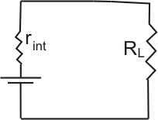Define the electromotive force (emf)
2. For the simple series circuit shown
3. At what conditions the source delivers most of its emf as a voltage difference across its terminals?

ε

1. At what conditions the source is loaded?
2. How we can avoid source loading?
3. Show that the power P developed across a resistance R is given by P=I2R, where I is the current flowing across the resistance.
4. In this experiment you do not measure the actual internal resistance of the source. Why. Explain in detail.
5. 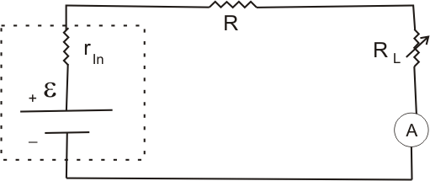For the circuit shown find an expression for the power developed across the load resistance.
6. If you vary the load resistance, when the power developed across the load resistance is maximum? Verify by using elementary calculus.
7. If one take the reading of the ammeter while changing the value of RL. Then plot 1/I versus RL data as shown in the graph below:



RL ,KΩ

1/I A

1. Find the value of ε,
2. Find the value of Rin= R+rin