**Physics 112 Data Sheet 2**

**Exp.#3: Network analysis 1: The spp and Kirchhoff’s laws**

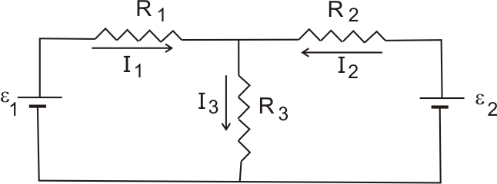

**1) Kirchhoff’s Laws**

Connect the circuit shown:

R1= 2 kΩ,

R2= 3.3 kΩ,

R3= 6.2 kΩ,

ε1= 10 V,

ε2= 12 V.

Measure the currents:

|  |  |  |
| --- | --- | --- |
|  | experiment | calculation |
| I1 (mA) |  |  |
| I2 (mA) |  |  |
| I3 (mA) |  |  |

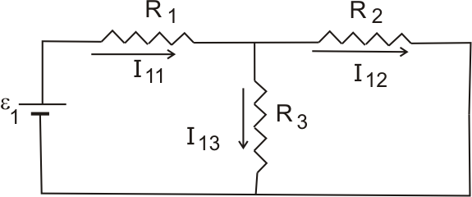

**2) Superposition Principle**

A) Connect the circuit shown:

Measure the currents:

|  |  |  |
| --- | --- | --- |
|  | experiment | calculation |
| I11 (mA) |  |  |
| I12 (mA) |  |  |
| I13 (mA) |  |  |

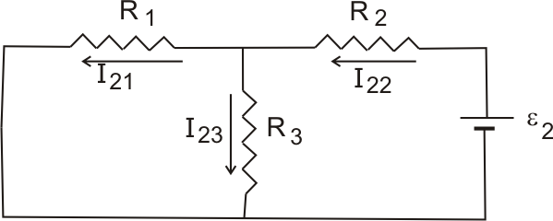

B) Connect the circuit shown:

Measure the currents:

|  |  |  |
| --- | --- | --- |
|  | experiment | calculation |
| I21 (mA) |  |  |
| I22 (mA) |  |  |
| I23 (mA) |  |  |

C) Find the currents using SPP:

I1= mA I2= mA I3= mA