**Physics 112**

**Exp.#3: Network Analysis 1: The superposition principle and Kirchhoff’s laws**

**Preliminary Laboratory Questions**

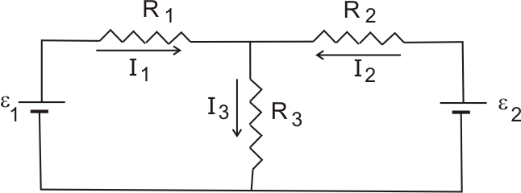

In the next two experiments you will work with the network shown in figure:

R1= 2 kΩ,

R2= 3.3 kΩ,

R3= 6.2 kΩ,

ε1= 10 V, and

ε2= 12 V.

Fig.1

1) Use Kirchhoff’s laws to find the currents: I1, I2, and I3 in the circuit shown in fig.1.

2) Find the currents I11, I12, and I13 in the circuit shown in fig.2.

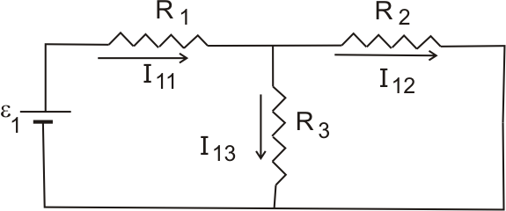

Fig.2

3) Find the currents I21, I22, and I23 in the circuit shown in fig.3.

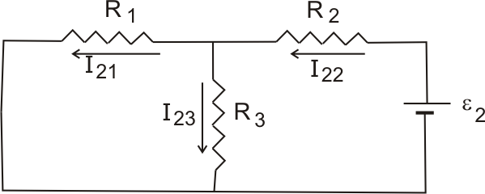

Fig.3

4) Using superposition principle and the results of q2 and q3 find the currents I1, I2, and I3.

(Be careful with signs). Then compare your answer with the answer of q1.