

Physics Department

Physics 112

Experiment No.5

Capacitors And Conductors

Student’s Name: Mudar Abed Rabbo

Student’s No.: 1041433

Partner’s Name: Khairallah

Partner’s No.: 1040132

Section: 6

Date: 13/11/2005

Instructor: Dr. Ziyad Izzat
Abstract:

The aim of the experiment: is to find out the time constant in RC, RL , and LC circuits.
The method used: is by using the CRO to measure the voltage in the RC and RL circuits and to measure the frequency in the LC circuit.
The main result:
$\overline{τ}≈τ_{\text{th}}$ (RC circuit)
$\overline{τ}≈τ_{\text{th}}$ (RL circuit)

$\begin{aligned}f_{o}≈f_{\text{th}} \\ ω_{o}≈ω_{\text{th}}\end{aligned}$ (LC circuit)

Theory:

RC circuits:
Charging a capacitor:
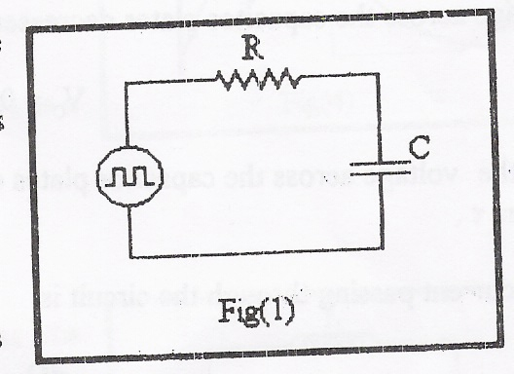
The voltage across the capacitor’s plates is defined by $V_{C}=\frac{Q}{C}$, and while $Q(t)=Cε\left(1−e^{−\frac{t}{\text{RC}}}\right)$ (when we are talking about the positive half period of the square wave), then $V_{C}=ε\left(1−e^{−\frac{t}{\text{RC}}}\right)$.The value of RC is usually called the time constant (τ) of the RC circuit like the one shown in fig.1. τ is a measure of how fast the voltage across the capacitor rises. When $t=τ$, $V_{C}=0\text{.}\text{63}ε$.
The current passing through the circuit is given by: $I(t)=\frac{\text{dQ}}{\text{dt}}=\frac{ε}{R}e^{−\frac{t}{\text{RC}}}$, and while the voltage across the resistor is $V_{R}=I(t)R={εe}^{−\frac{t}{\text{RC}}}$.

Discharging a capacitor:
Now, during the negative period of the square wave, the capacitor, the capacitor discharges according to the following formula:
$$Q(t)={Cεe}^{−\frac{t}{\text{RC}}}$$
And so the voltage across the capacitor’s plates is:
$$V_{C}=0\text{.}\text{37}ε$$
In this case the voltage decays to 0.37 of its maximum value within a time τ, which equals RC (the time constant).
The current passing through the circuit is:
$I(t)=\frac{\text{dQ}}{\text{dt}}=−\frac{ε}{R}e^{−\frac{t}{\text{RC}}}$
and so, the voltage is given by:
$$V_{R}=I(t)R=−{εe}^{−\frac{t}{\text{RC}}}$$

RL circuits:
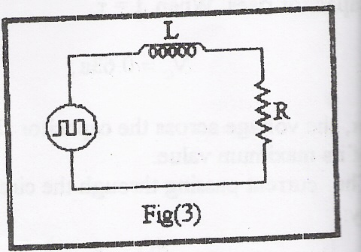
The current passing through the RL circuit shown in fig.3 rises with time accordi

ng to the following equation:
$$I=\frac{ε}{R}\left(1−e^{−\frac{\text{Rt}}{L}}\right)$$
The voltage across the resistor is $V_{R}=\text{IR}=ε\left(1−e^{−\frac{\text{Rt}}{L}}\right)$ and across the inductor is $V_{L}=L\frac{\text{dI}}{\text{dt}}={εe}^{−\frac{\text{Rt}}{L}}$.
In this case the time constant equals $\frac{L}{R}$. When $t=τ$,
$V_{R}=0\text{.}\text{63}ε$ and $V_{L}=0\text{.}\text{37}ε$.
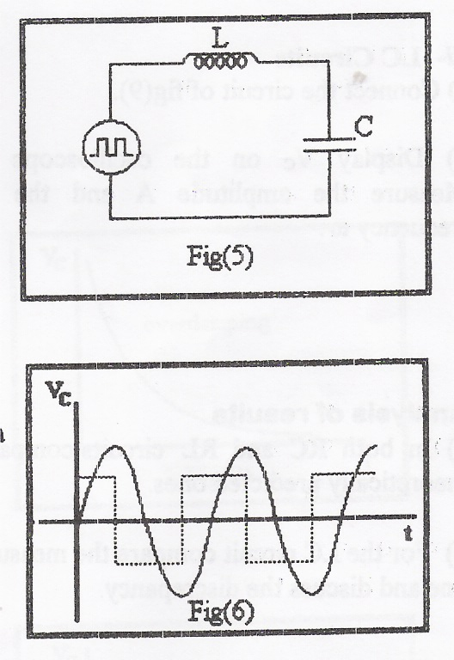
LC circuits:
The following equation describes the voltage across the capacitor’s plates of the one in the circuit shown in fig.5,
$V_{C}=V_{\text{Co}}\text{cos}\left(ωt+Φ\right)$
where $V_{\text{CO}}$ is the amplitude (constant) and$ω=\frac{1}{\sqrt{\text{LC}}}$.
Fig.6 shows the voltage across the capacitor as a function of time.
Data:

R = 1 kΩ
C = 0.1 μF
L = 10 mH

RC circuit:
V_{max}= 8 v
V_{C} : τ ₁ =0.8 × 10⁻⁴ sec
V_{R} : τ₂ = 1× 10⁻⁴ sec

RL circuit:
V_{max}= 7.6 v
V_{R} : τ ₁ = 0.8 × 10⁻⁵ sec
V_{L} : τ₂ =1× 10⁻⁵ sec

LC circuit:
The value of frequency as we read from the signal generator is 5 × 10³ Hz.
The value of frequency theoretically is 5033 Hz.
The value of frequency practically is 5 × 10³ Hz.
Calculations:

RC circuit:
$τ=R×C=\text{1000}×0\text{.}1×{\text{10}}^{−6}=\text{10}×{\text{10}}^{−5}\text{sec}$. (Theoretically, in the two cases; charging and discharging).
$\begin{aligned}τ_{1}=8×{\text{10}}^{−5}\text{sec} \\ τ_{2}=\text{10}×{\text{10}}^{−5}\text{sec}\end{aligned}$. (The practical values of time constant that we obtained by measuring the voltage across the capacitor and the resistance).

RL circuit:
$τ=\frac{L}{R}=\frac{\text{10}×{\text{10}}^{−3}}{\text{1000}}=\text{10}×{\text{10}}^{−6}\text{sec}$. (Theoretically)
$\begin{aligned}τ_{1}=8×{\text{10}}^{−6}\text{sec} \\ τ_{2}=\text{10}×{\text{10}}^{−6}\text{sec}\end{aligned}$. (The practical values of time constant that we obtained by measuring the voltage across the resistance and the inductor e).

LC circuit:
The value of frequency as we read from the signal generator is 5 × 10³ Hz.
$ω_{o}=2{πf}_{o}=2×\frac{\text{22}}{7}×\text{5000}=\text{31428}\text{.}6\text{Hz}$
Theoretically:
$$\begin{aligned}ω_{o}=2{πf}_{o}=\frac{1}{\sqrt{\text{LC}}}=\frac{1}{\sqrt{\text{10}×{\text{10}}^{−3}×0\text{.}1×{\text{10}}^{−6}}}=\frac{1}{\sqrt{{\text{10}}^{−9}}}=\text{31622}\text{.}\text{7766}\text{Hz} \\ f_{o}=\frac{\text{31622}\text{.}\text{7766}}{2π}≈\text{5033}\text{Hz}\end{aligned}$$
Analysis of results:

As we saw from the results of the three circuits the values were somehow close to those of the theoretical ones, the small difference may be because of the visual inaccuracy while looking on the CRO.

Q1) $τ→0$
$$\begin{aligned}\text{ch}\text{arg}\text{ing}⇒V_{C}=ε(1−e^{−\frac{t}{\text{RC}}})=ε(1−e^{0})=0 \\ \text{disch}\text{arg}\text{ing}⇒V_{C}={εe}^{−\frac{t}{\text{RC}}}=ε\end{aligned}$$

$$\begin{aligned}\text{ch}\text{arg}\text{ing}⇒V_{C}=ε(1−e^{−\frac{t}{\text{RC}}})=ε \\ \text{disch}\text{arg}\text{ing}⇒V_{C}={εe}^{−\frac{t}{\text{RC}}}=0\end{aligned}$$

Q2) We can only do so if we use large values of R,L, and C.

