**Physics 112**

**Exp.#5: Electric Field and Equipotential Lines**

**Preliminary Laboratory Questions**

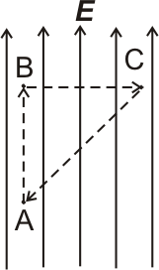**1)** A particle with a positive charge of magnitude *q* is moved in an electric field ***E*** from point A to point B then to point C, which is at the same distance from B as point A, and then back to point A.

a) In which of the three paths AB, BC, or CA the work done by the electric field is greatest? Explain.

b) What is the total work done by the field?

c) Draw 4-5 equipotential lines on the same figure and discuss a) and b) using your equipotential lines.

**2)** Draw at least four electric field lines and four equipotential lines for the configurations

