Damped Oscillation

Purpose

Abstract:

In this experiment we are going to deal with the ( CRO ) and the signal generator in making damping for an inductor changing it with the resistor , and see the results on the screen of the oscilloscope .

Main results:

1- Over damping:
t_{1/2} = 8 ms
λ₊ = 1.55*10⁵ s⁻¹
λ₋ = -6.45*10⁵ s⁻¹

2- Critical damping:
t_{1/2} = 6 ms
λ₊ = λ₋ = 1*10⁵

3- Under damping:
R=1600Ω
t_{1/2} = 0.9*10⁻⁵ sec. (Experimental value)
t_{1/2} = 0.966*10⁻⁵ sec. (Theoretical value)

Theory

In this type of experiments the charge on the capacitor and hence is given by the formula:

Q (t) = A₁ e^{λ+t} + A₂ e^{λ+t}

Where A₁ & A₂ are constants

λ+ = ( -R/2L ) + { (R/2L)² – ( 1/LC )}^{1/2}
λ - = ( -R/2L ) - { (R/2L)² – ( 1/LC )}^{1/2}

For this type of solutions there is three cases emerge

1) Over damping:

(R/2L)²>(1/LC)

So as a result the both terms decay exponentially with time and voltage across the capacitor is said to be over damped.
As the following figure:

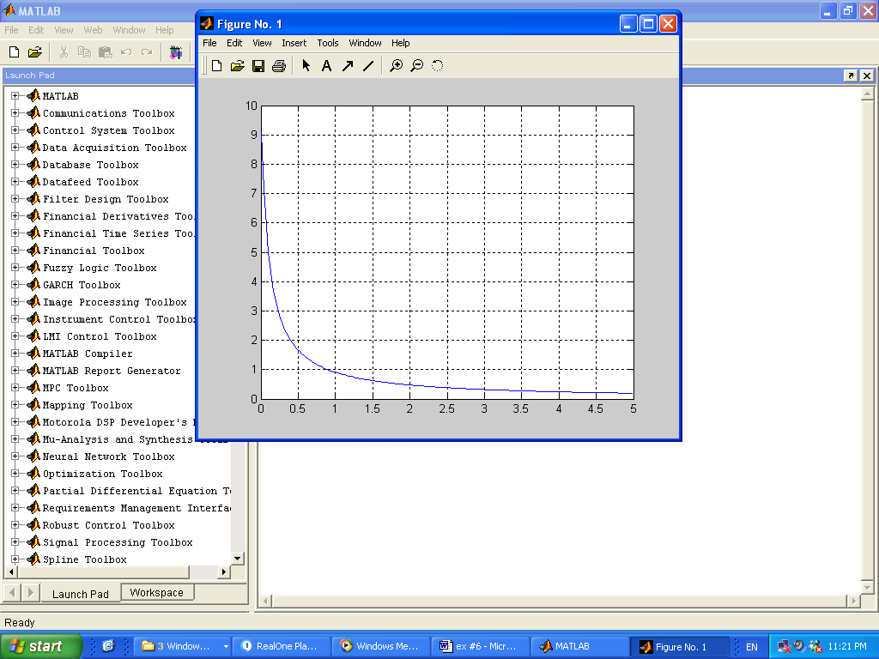

Figure 1

2) Critical damping:
(R/2L)² = (1/LC)

Then the term under the square in the equation vanishes therefore the charge on the capacitor plates take the following form:

Q(t) = Ae^{(R/2L)t} + Bte^{(-R/2L)t}

Where B & A are constants

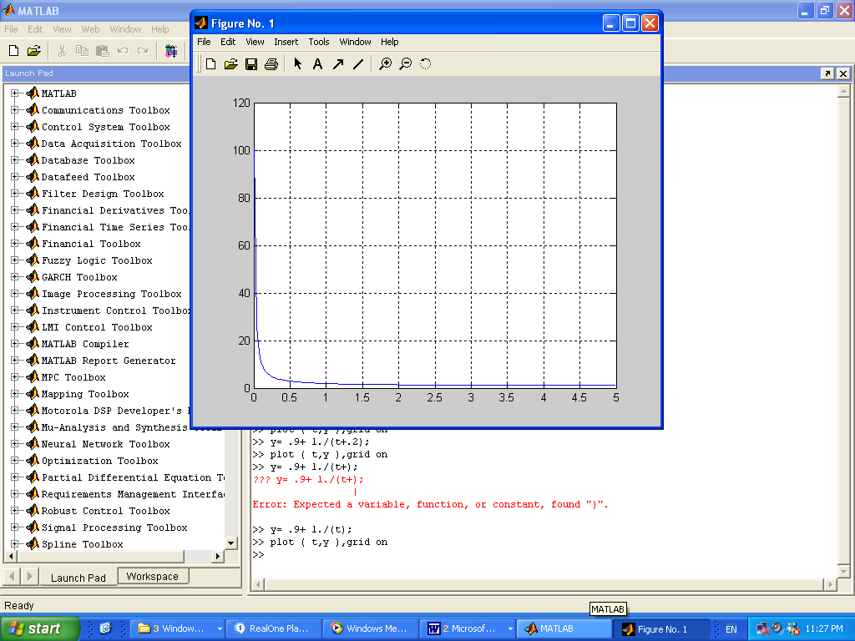
Figure 2
3) Under damping:

This case would happen if:
(R/2L)²<(1/LC)
Then the term of the square root becomes negative so the solution which is introduced:
Q(t) = Q₀e^{-δt} cos (ωt + Φ₀ )
Where δ = R / 2L

ω = {(1/LC) – (R/2L)²}^{1/2}
There is a quantity which is the time ½ t after which the amplitude (evolve) Q₀e^{δt ½}
Q0/2 = Q0eδt ½
T_{1/2} = {(2L) Ln (2)} / R
Vc = Q(t)/C
Apparatus:

1- Resistance decade box.
2- Inductor ( 10 mH )
3- Capacitor (0.01 μF )
4- Signal generator.
5- Oscilloscope

Procedure:

1- We connected the circuit shown in the figure.

2- We displayed the voltage across the capacitor on the CRO.

3- We changed the value of R to obtain the three damping cases.

Conclusion:

In this experiment, we did a three cases for damped oscillation … in the first case, we notice that the over damping happens for R greater than 2 KΩ. and in the second case which was the critical damping, we notice that it happens at approximately 2 KΩ.
Finally, in the under damping case... we notice that it happens for a value of R less than 2 KΩ. And it was in our experiment 454Ω. For the value of t_{1/2} measured in this case (0.9*10⁻⁵sec), it was near the theoretical value (calculated) which was( 0.966*10⁻⁵ sec.)

