If an experiment works, something has gone wrong.

Birzeit University
Physics Department
Physics 112

Experiment No.7

Impedance & Reactance

Student’s Name: Ammar T. Ammar
Student’s No.: 1040385

Section: 7

Date: 28/4/2005
Instructor: Dr. Ziyad Izzat

 2005
Copy left reversed

Abstract:
1)The aim of the experiment is to find the phase shift between each pair of the voltage difference of the capacitor the resistance & the inductor and to measure the frequency at which the phase shift between the current and the driving voltage is zero.
2)The method used is by displaying the voltage difference of the capacitor the inductor , the resistance and the driving voltage on the oscilloscope's screen .
3)The main results are

$$\begin{aligned}f=\text{11}\text{KHZ}ϕ_{\text{CR}}=1\text{.}\text{52} \text{rad} \\ ϕ_{\text{LR}}=1\text{.}\text{63} \text{rad}ϕ_{\text{LC}}=3\text{.}\text{15} \text{rad}\end{aligned}$$

Theory:

In the RLC circuit shown in figure1 the current is :
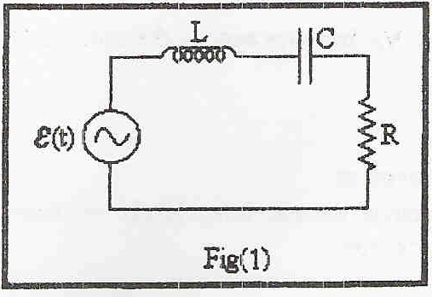
$$I(t)=\frac{ε(t)}{Z_{\text{eq}}}$$
Where
$$\begin{aligned}Z_{\text{eq}}=Z_{R}+Z_{C}+Z_{L} \\ Z_{R}=R (\text{the} \text{resistive} \text{impedance}) \\ Z_{C}=−\frac{j}{ωC} (\text{the} \text{capaci}\text{tan}\text{ce} \text{impedance}) \\ Z_{L}=jωL (\text{the} \text{inductive} \text{impedance})\end{aligned}$$
While:
$\frac{1}{ωC}$ is the capacitance reactance and $ωL$ is the inductive reactance.
We Solve the equation of the current :
$$ε(t)=ε_{0}\text{Cos}(ωt)$$
$$\begin{aligned}I(t)=\frac{ε_{0}e^{jωL}}{R+j(ωL−1/{ωC})})(\frac{R−j(ωL−1/{ωC})}{R−j(ωL−1/{ωC})}=\frac{R−j(ωL−1/{ωC})ε_{0}e^{jωL}}{R^{2}+(ωL−1/{ωC})^{2}} \\ \frac{\sqrt{R^{2}+(ωL−1/{ωC})}ε_{0}e^{j(ωL+ϕ)}}{R^{2}+(ωL−1/{ωC})^{2}}=\frac{ε_{0}}{\sqrt{R^{2}+(ωL−1/{ωC})}}e^{j(ωL+ϕ)}\end{aligned}$$
=$\frac{ε_{0}}{\sqrt{R^{2}+(ωL−1/{ωC})}}\text{Cos}(ωt+ϕ)=I_{0}\text{Cos}(ωt+ϕ)$
Where:
$$ϕ={\text{tan}}^{−1}(\frac{1/{ωC}−ωL}{R})$$
$$I_{0}=\frac{ε_{0}}{\sqrt{R^{2}+(ωL−1/{ωC})}}$$

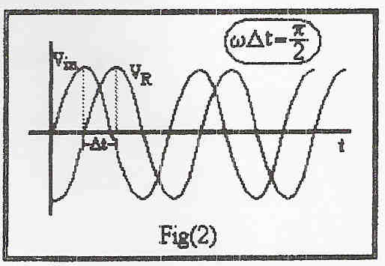
The phase shift between the current and the voltage is given by $φ=ωΔt$ see fig 2.

The voltage a cross the inductor is given by:
$$V_{L}=L\frac{\text{dI}(t)}{\text{dt}}=−ω{\text{LI}}_{0}\text{Sin}(ωt+φ)$$
This equation shows that the voltage of the
inductor is just the inductive impedance
multiplied by the current with a phase shift=$Π/2$ .
The voltage across the capacitor is given by :
$$V_{R}=\text{RI}(t)={\text{RI}}_{0}\text{Cos}(ωt+φ)$$
And here $V_{R}$is the current multiplied by the resistance..
According to the voltage across the capacitor :
$$V_{C}=\frac{1}{C}\int{I(t)\text{dt}=\frac{1}{C}\int{I_{0}\text{Cos}(ωt+φ)\text{dt}=\frac{I_{0}}{ωC}\text{Sin}(ωt+φ)}}$$
Which is the current multiplied by the capacitive reactance with a phase shift of $Π/2$ introduced.
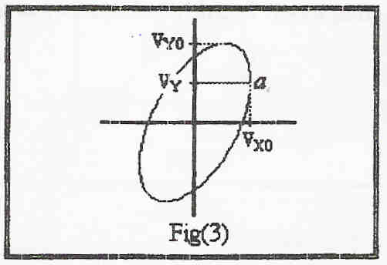
To find the phase shift between two
harmonic functions using the oscilloscope
we set the oscilloscope to the x-y mode
and connect the functions to the X-channel
and Y-Channel , to have a shape like that
shown in fig 3 .
Let $V_{x}=V_{x0}\text{Cos}(ωt)$ and $V_{y}=V_{y0}\text{Cos}(ωt+φ)$where $φ$is the phase shift between the two functions .
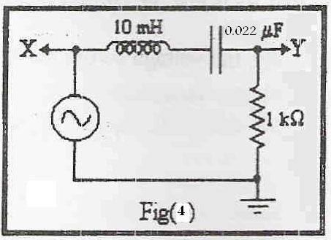
$ωt=0$at point a shown in fig3 where Vx has its maximum value ,hence:
$V_{Y}=V_{Y0}\text{Cos}(φ)$➔$φ={\text{Cos}}^{−1}(\frac{V_{Y}}{V_{Y0}})$
Procedure:
1. We connected the circuit shown in figure 4.
2. We found the phase shift between the driving
Voltage and the the current for different frequencies.
3. We displayed each pair pf VR, VC & VL oscilloscope screen. And measured the phase shift between each pair of them.

Data & Calculations:
1)
Frequency KHZ | a (unit) | b (unit) | a/b | Phase shift (rad)
0.5 | 1.4 | 1.4 | 1.000 | 1.57
1 | 3.3 | 3.4 | 0.971 | 1.33
3 | 3.4 | 3.8 | 0.895 | 1.11
5 | 4.8 | 6.4 | 0.750 | 0.85
7 | 2.2 | 4 | 0.550 | 0.58
9 | 1.2 | 4.6 | 0.261 | 0.26
10 | 0.5 | 4.7 | 0.106 | 0.11
11 | 0.1 | 4.8 | 0.021 | 0.02
15 | 1.7 | 4.4 | -0.386 | - 0.40
30 | 2.3 | 2.8 | -0.821 | -0.96
50 | 1.6 | 1.7 | -0.941 | -1.23
70 | 1.2 | 1.2 | -1.000 | -1.57
100 | 0.8 | 0.8 | -1.000 | -1.57

From the graph we found can see that the value of frequency that makes the phase equal to zero is 11 KHZ.
Theoretical value:
$f=\frac{ω}{2Π}=\frac{1}{2Π\sqrt{\text{LC}}}=\text{10}\text{.}7\text{KHZ}$

2)
Experimental values:
**Phase shift between VC & VR ($ϕ_{1}$):
$ϕ=ωΔt=2ΠfΔt=\text{11}X{\text{10}}^{3}X\text{22}X{\text{10}}^{−6}X2Π=1\text{.}\text{52} \text{rad}$

**Phase shift between VL & VR($ϕ_{2}$) :
$ϕ=ωΔt=2ΠfΔt=\text{11}X{\text{10}}^{3}X\text{24}X{\text{10}}^{−6}X2Π=1\text{.}\text{63} \text{rad}$
**Phase shift between VL & VC($ϕ_{3}$):
$ϕ_{3}=ϕ_{1}+ϕ_{2}=1\text{.}\text{63}+1\text{.}\text{52}=3\text{.}\text{15}$ rad
Theoretical value of:
$ϕ_{1}$=$ϕ_{2}$=1.57 rad
$ϕ_{3}$=3.14 rad

Results & conclusions:

$$\begin{aligned}f=\text{11}\text{KHZ}ϕ_{\text{CR}}=1\text{.}\text{52} \text{rad} \\ ϕ_{\text{LR}}=1\text{.}\text{63} \text{rad}ϕ_{\text{LC}}=3\text{.}\text{15} \text{rad}\end{aligned}$$
From the experimental & theoretical values we have we conclude the following:
- The value of the frequency we have (11 KHZ) is almost equal to the theoretical one (10.7KHZ) and the discrepancy lies within the experimental error.
- The value of the phase between the voltage of the capacitor and the voltage of the resistance (1.52) is near to the real value , and the discrepancy can be attributed to the value of frequency at which we made the measurements which was (11 KHZ) a little bit more than (10.7KHZ) and that caused a little shift to the phase from the expected value.
- The value of the phase shift between the voltage of the inductor and that of the resistance is 1.63 which has a little discrepancy which we can attribute to the value of frequency at which we take the measurements which was 11KHZ (more than 10.7KHZ)
- The value of the phase shift between the voltage on the capacitor and that on the inductor(3.15 rad) has a little discrepancy from the theoretical value(3.14 rad) , such a discrepancy is expected as the experimental value is the algebraic sum of the two first phase shifts (which have a discrepancy from their theoretical values )
- We can measure the phase shifts using the external mode and compare them with the values of the internal mode, then with the theoretical values to have results almost identical with the theoretical ones.

AC-powered
As Sin(x)=cos(x+$Π/2)$
The phase shifts between the current and the voltages across the circuit elements is related to $φ$ which is a function of $ω$
look at the attached graph
which is the theoretical value of the frequency at which the phase shift between the current and the driving voltage is zero.

