If an experiment works, something has gone wrong.

Birzeit University
Physics Department
Physics 112

Experiment No.8

Resonance

Student’s Name: Qasim Salhab
Student’s No.: 1041078

Section: (2-5)T

Date: 12/12/2005
Instructor: Dr. Jamal Suliman

Abstract:
1)The aim of the experiment is to find the resonance frequency and the quality factor.
2)The method used is by measuring the voltage as a function of frequency, and using it to plot the current as a function of the frequency.

3)The main results are

Theory:
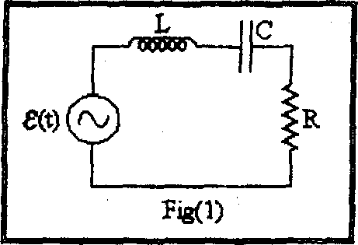
In the circuit shown in figure 1, the current passing through the circuit is given by:
$$I_{0}=\frac{V_{0}}{\sqrt{R^{2}+(\text{ω L}−\frac{1}{\text{ωC}})^{2}}}$$
It is obvious that I0 assumes a maximum when L = 1 / C, and so $ω=\frac{1}{\sqrt{\text{LC}}}$, which equals the natural angular frequency.

In other words, the current in the circuit assumes its maximum value when the driving voltage frequency equals the natural frequency of the RLC circuit. This phenomenon is called resonance.

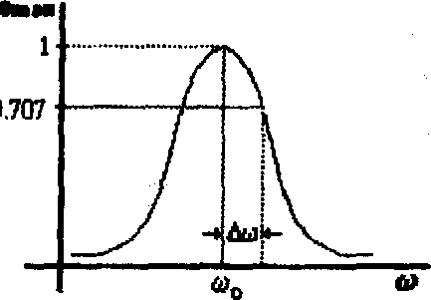
The figure on the right shows a plot of the value of $I_{0}$ as a function of $ω$ . At resonance

$$I_{0}=\frac{V_{0}}{R}$$
and the value of the current is only limited by the resistance of the circuit.

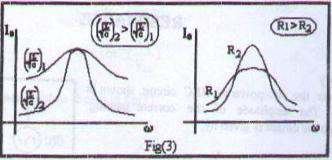
The quality factor is a measure of the sharpness of the resonance curve, and is defined as following $Q=\frac{\text{ω L}}{R}=\frac{1}{R}\sqrt{\frac{L}{C}}=\frac{ω_{0}}{|\text{Δω}|}$ where ∆ is the band width which is the frequency range between the maximum value of I0 and the value ${I_{0}}/{\sqrt{2}}$.

Procedure:
1- Connect the circuit of figure 2.
2- For R=1k, measure the current as a function of the frequency.
3- Repeat the previous step for R=2k.

Data:
After performing the experiment the following data were obtained:

Theoretically:
f (kHz) | ω (rad/s) | R = 1k |  | R = 2k
f (kHz) | ω (rad/s) | V_{P}(Volts) | Ip(mA) | V_{P}(Volts) | Ip(mA)
$ω_{0}=\frac{1}{\sqrt{\text{LC}}}=\frac{1}{\sqrt{\text{10}×{\text{10}}^{−3}×0\text{.}\text{011}×{\text{10}}^{−6}}}=\text{95}\text{.}\text{.}\text{3 rad/s}$

For R = 1k.
$$Q=\frac{\text{ω L}}{R}=\frac{1}{R}\sqrt{\frac{L}{C}}=\frac{1}{\text{1000}}\sqrt{\frac{\text{10}×{\text{10}}^{−3}}{0\text{.}\text{011}×{\text{10}}^{−6}}}=0\text{.}9$$

For R = 2k.
$Q=\frac{\text{ω L}}{R}=\frac{1}{R}\sqrt{\frac{L}{C}}=\frac{1}{\text{2000}}\sqrt{\frac{\text{10}×{\text{10}}^{−3}}{0\text{.}\text{011}×{\text{10}}^{−6}}}=0\text{.}0\text{.}\text{45}$

Experimentally:

From the graph
f 0 =.
0 =

For R = 1k.
I0 =.
${I_{0}}/{\sqrt{2}}$ =
2 =
Q = 0 / |2| =

For R = 2k.
I0 =.
${I_{0}}/{\sqrt{2}}$ =
2 =
Q = 0 / |2| =

Results and conclusions:
For R = 1k, the experimental values for the resonance frequency and the quality factor equal =94rad/s, Q = 0.5 respectively, and the theoretical values for the resonance frequency and the quality factor equal  = 95.3 rad/s, Q=0.9 respectively. For R = 2k, the experimental values for the resonance frequency and the quality factor equal =94rad/s, Q = 0.43 respectively, and the theoretical values for the resonance frequency and the quality factor equal =95.3rad/s, Q=0.45 respectively.

To show that Q = (1/R) $\sqrt{\text{L/C}}$
Q = $\frac{\text{ω L}}{R}$ , but $ω$ = $\frac{1}{\sqrt{\text{LC}}}$
Q =$\frac{1}{\sqrt{\text{LC}}}$.$\frac{L}{R}$= $\frac{1}{R}$.$\sqrt{L}$.$\frac{1}{\sqrt{C}}$= $\frac{1}{R}\sqrt{\frac{L}{C}}$

For R=2k
We noticed that the experimental and the theoretical values are very close, but there is a small difference between them, and this refers to some errors like not evaluating the readings from the oscilloscope very well.
However, For (R=1k) we can easily notice the huge discrepancy , a fact that leads us to revise the whole experiment in order to find the where the error lies. I think that the error lies in the fact that we may have changed the capacitance during the experiment and there fore changed all the theoretical values.

