

Physics Department

Physics 112

Experiment No.9

Filters

Student’s Name: MOEZ ZABEN

Student’s No.: 1061287

Partner’s Name: MOHAMMAD MURAD

Partner’s No.: 1061230

Section: 8

Date: 13/12/2007

Instructor: Dr. Ziyad Izzat
Abstract:

The aim of the experiment: is to find the attenuation factor for both cases of low and high pass filters.
The method used: is by using the CRO to see the plot of the capacitance’s voltage vs. time and get the value of the voltage.
The main results:
A (high) vs. f:

$$⇒ω_{−3\text{dB}}=\text{11000}{\text{rad}}/s$$
A (low) vs. f:

$$⇒ω_{−3\text{dB}}=\text{10000}{\text{rad}}/s$$

Theory:

A filter is an electrical circuit that allows certain frequencies to flow while preventing others.
There are three types of filters: high pass filters, low pass filters, and band pass filters.

Low-pass RC filters:
If we took the circuit shown in fig.1a, using the generalized ohm’s law we can obtain the output voltage $V_{\text{out}}$as a function of the input voltage, $V_{\text{in}}$as follows:
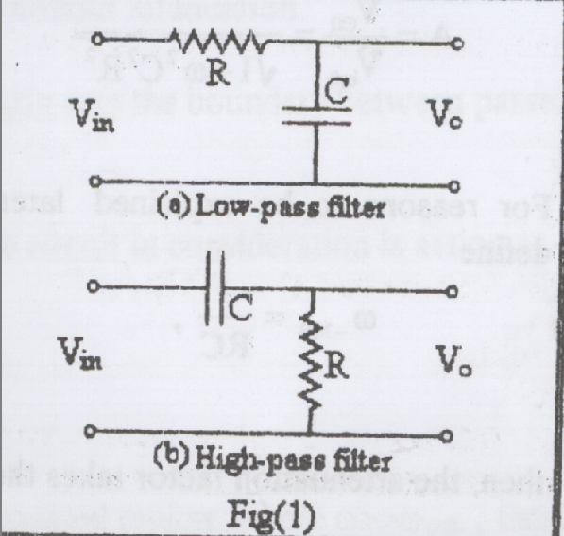
$$\begin{aligned}\text{equivalent}\underset{}{}\text{impedance}⇒Z_{\text{eq}}=R−\frac{j}{ωC} \\ \text{current}⇒I(t)=\frac{V_{\text{in}}(t)}{Z_{\text{eq}}} \\ \text{output}\underset{}{}\text{voltage}⇒V_{\text{out}}(t)=V_{C}(t)=\frac{V_{\text{in}}(t)}{R−\frac{j}{ωC}}\left(\frac{−j}{ωC}\right) \\ ⇒V_{\text{out}}(t)=\frac{V_{\text{in}}(t)}{1+jω\text{RC}} \\ V_{\text{co}}(ω)=\frac{V_{\text{ino}}}{\sqrt{1+ω^{2}C^{2}R^{2}}}\end{aligned}$$
$\begin{aligned} \\ \text{attenuation}\overset{}{}\text{factor}\underset{}{}(A):A=\frac{V_{\text{Co}}}{V_{\text{ino}}}=\frac{1}{\sqrt{1+ω^{2}C^{2}R^{2}}} \\ \\ ω_{−3\text{dB}}=\frac{1}{\text{RC}} \\ ⇒A=\frac{1}{\sqrt{1+{\left(\frac{ω}{ω_{−3\text{dB}}}\right)}^{2}}}\end{aligned}$Due to the last equation we get three cases:
If we defined:
- If $ω\text{>>}ω_{−3\text{dB}}$ then A is extremely small and the output signal is highly attenuated.
- If $ω\text{<<}ω_{−3\text{dB}}$ then A ≈ 1 and the amplitude of the out put signal is equal to that of the input signal, in other words the signal is passed without attenuation.
- If $ω=ω_{−3\text{dB}}$ then$A=1/{\sqrt{2}}=0\text{.}\text{707}$ and the amplitude of the output signal is 0.707 of the amplitude of the input amplitude. This value sets a practical boundary between passed signals and highly attenuated ones.

It is obvious from here that the circuit we are talking about, shown in fig.2a, acts as a low-pass filter.

High-pass RC filters:
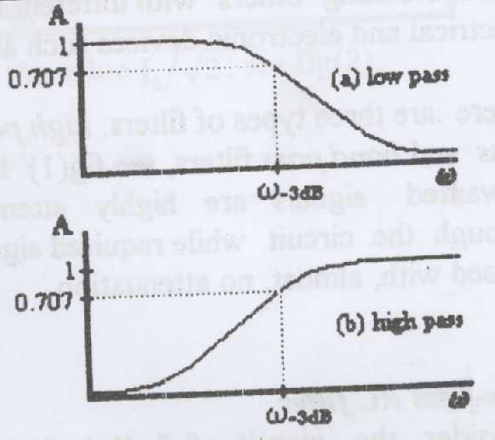
This RC filter looks like the one shown in fig.1b, and we can get the attenuation factor in the same way of the low pass filter. And this gives:
$$A=\frac{1}{\sqrt{1+{\left(\frac{ω_{−3\text{dB}}}{ω}\right)}^{2}}}$$
In the same way:
- If $ω\text{<<}ω_{−3\text{dB}}$ then A is extremely small and the output signal is highly attenuated.
- If $ω\text{>>}ω_{−3\text{dB}}$ then A ≈ 1 and the signal is passed without attenuation.
- If $ω=ω_{−3\text{dB}}$ then $A=1/{\sqrt{2}}=0\text{.}\text{707}$ this again sets the boundary between passed signals and highly attenuated ones.

It is obvious from the discussion above that the circuit in consideration is acting as a high-pass filter.

Differentiators and Integrators:
If a low-pass filter is functioning in the highly attenuated region, where$ω\text{>>}ω_{−3\text{db}}$, then, $V_{\text{out}}(t)$is extremely small and
$$V_{R}(t)=V_{\text{in}}(t)−V_{\text{out}}(t)≈V_{\text{in}}(t)$$
On the other hand,
$$\begin{aligned}I(t)=\frac{\text{dQ}(t)}{\text{dt}}=C\frac{{\text{dV}}_{C}(t)}{\text{dt}}=C\frac{{\text{dV}}_{\text{out}}(t)}{\text{dt}} \\ V_{\text{in}}(t)≈V_{R}(t)=\text{RI}(t)=\text{RC}\frac{{\text{dV}}_{\text{out}}}{\text{dt}} \\ V_{\text{out}}(t)=\frac{1}{\text{RC}}\int{V_{\text{in}}(t)\text{dt}}\end{aligned}$$
The out put voltage is just integral of the input voltage. Under such conditions this circuit acts as integrator.
If an RC high-pass filter is functioning in the highly attenuated region where$ω\text{<<}ω_{−3\text{db}}$, then, $V_{\text{out}}(t)$is extremely small and
$V_{C}(t)=V_{\text{in}}(t)−V_{\text{out}}(t)≈V_{\text{in}}(t)$
On the other hand,
$$\begin{aligned}I(t)=\frac{\text{dQ}(t)}{\text{dt}}=C\frac{{\text{dV}}_{C}(t)}{\text{dt}}=C\frac{{\text{dV}}_{\text{in}}(t)}{\text{dt}} \\ V_{\text{out}}(t)=\text{RI}(t)=\text{RC}\frac{{\text{dV}}_{\text{in}}(t)}{\text{dt}}\end{aligned}$$
The output voltage is just the derivative of the input voltage. Under such conditions this circuit acts as a differentiator.
Data:

 |  |  | Low |  |  |  | High
f kHz | ω_{o} kHz |  | V_{out} Volt |  | A |  | V_{out} Volt |  | A
0.2 | 1.256636 |  | 6.00 |  | 1 |  | 0.68 |  | 0.11
0.4 | 2.513272 |  | 5.80 |  | 0.966667 |  | 1.50 |  | 0.25
0.6 | 3.769908 |  | 5.60 |  | 0.933333 |  | 2.00 |  | 0.33
0.8 | 5.026544 |  | 5.40 |  | 0.9 |  | 2.50 |  | 0.42
1 | 6.28318 |  | 5.20 |  | 0.866667 |  | 3.00 |  | 0.50
2 | 12.56636 |  | 3.80 |  | 0.633333 |  | 4.40 |  | 0.73
4 | 25.13272 |  | 2.40 |  | 0.4 |  | 5.20 |  | 0.87
6 | 37.69908 |  | 1.60 |  | 0.266667 |  | 5.40 |  | 0.90
8 | 50.26544 |  | 1.20 |  | 0.2 |  | 5.50 |  | 0.92
10 | 62.8318 |  | 1.00 |  | 0.166667 |  | 5.60 |  | 0.93
20 | 125.6636 |  | 0.50 |  | 0.083333 |  | 5.70 |  | 0.95
40 | 251.3272 |  | 0.26 |  | 0.043333 |  | 5.80 |  | 0.97
60 | 376.9908 |  | 0.16 |  | 0.026667 |  | 5.85 |  | 0.98
80 | 502.6544 |  | 0.11 |  | 0.018333 |  | 5.90 |  | 0.98
100 | 628.318 |  | 0.10 |  | 0.016667 |  | 5.95 |  | 0.99
200 | 1256.636 |  | 0.04 |  | 0.006667 |  | 6.00 |  | 1.00

Calculations:

Using the plots of the attenuation factor vs. frequency we can obtain the values of frequency that gives us$ω_{−3\text{dB}}$:
A (low) vs. ω:
$⇒ω_{−3\text{dB}}=\text{10000}{\text{rad}}/s$
A (high) vs. ω:
$⇒ω_{−3\text{dB}}=\text{11000}{\text{rad}}/s$
Theoretically the expected value for $ω_{−3\text{dB}}$ is:
$ω_{−3\text{dB}}=\frac{1}{\text{RC}}=\frac{1}{1×{\text{10}}^{3}×0\text{.}1×{\text{10}}^{−6}}=\text{10000}$kHz
Now looking at the plots of the wave functions obtained by the different frequency wave types, we find that in the case of low-pass filter V_{out} is the integration of V_{in}. And in the case of the high-pass filter V_{out} is the differentiation of V_{in}.

Analysis of results:

As we can see from the results that we’ve got, the high-pass filter acts as a differentiator and the low-pass filter acts as an integrator. And the RC circuits that the filters consist of affect the amplitude of the voltage in a way that depends on the type of filter that is made from the circuit. Finally the values that we got were somehow equal to those of the theoretical calculations and that is due to several errors that may have occurred because of the resistivity of wires and tools.

