Abstract:

The aim of the experiment: is to find the value of the load resistance (R_{L}) that satisfies the condition of the maximum power transfer
[R_{L} = R + R_{in}] and to determine r_{in} for the power supply.

The method used: is by direct measurement of the current passing through the circuit.

The result:

Theory:

Electromotive force (emf) is the open circuit voltage difference between voltage source terminals.
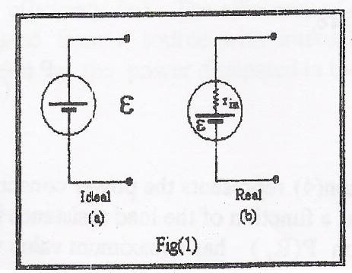
A voltage source is characterized by its electromotive force and the maximum value of the current it can deliver to a short circuit. An ideal voltage source is the one in which the internal resistance is zero (R~O), so when it is connected to a short circuit it should, according to Ohm’s law $\left(I=\frac{V}{R}\right)$, be able to provide an almost infinite current. But in real circuit a voltage source connected to a short circuit can’t neither maintain its (emf) as a voltage difference across its terminals nor can it provide the circuit with unlimited current, and that’s because there is some kind of resistance inside the voltage source which is called internal resistance (r_{in}) as shown in fig.1.
Any circuit component that consumes electrical power to produce useful work is called a load and its resistance is called load resistance (R_{L}).
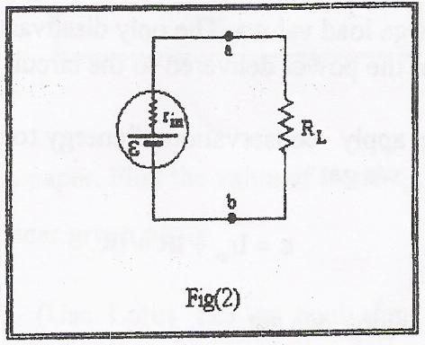
In the simple series circuit shown in fig.2 the current is:
$I=\frac{ε}{R_{l}+r_{\text{in}}}$
and the voltage difference between its terminals is:
$V_{\text{RL}}=\frac{ε}{(R_{L}+r_{\text{in}})}R_{L}$
If (R_{L}) is comparable to (r_{in}) then (V_{RL}) is smaller than (ε), and so a considerable amount of power is consumed inside the source and converted to unuseful heat energy. And in this case the source is said to be loaded and this is what is known as the loading problem. In practical circuits we usually want to avoid loading the source, therefore, choosing ($R_{L}≥\text{10}R_{\text{in}}$) is recommended.
In fig.2 the power consumed in the load resistor is given by:
$P=I^{2}R_{L}$
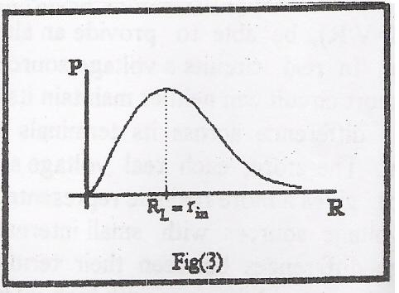
Therefore,
$P=\frac{ε^{2}R_{L}}{(R_{L}+r_{\text{in}})^{2}}$
the last equation shows the power consumed in the load as a function of the load resistance itself. And this function has a maximum value which can be obtained by setting $\left(\frac{\text{dP}}{{\text{dR}}_{L}}=0\right)$as in fig.3 and this gives:
R_{L}=r_{in}
as the condition for transferring maximum power to the load resistance. This choice of load resistance is called impedance matching.
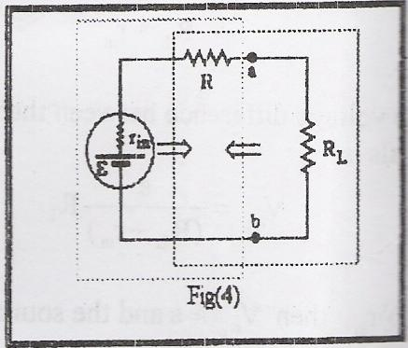
As in the internal resistance of voltage sources is usually small (a few Ohms), in practical circuits an additional resistor is connected in series with the source as shown in fig.4 in order to produce the maximum power transfer condition for large values of (R_{L}). While this additional resistance appears to (R_{L}) as an additional internal resistance, it is seen by the source as an additional load resistance. Consequently, this resistance helps in avoiding loading problems and fulfilling the condition of impedance matching for large load values. The only disadvantage is that this additional resistance consumes part of the power delivered to the circuit by the source.
Now if we apply conservation of energy to the circuit in fig.4, we get:
$ε={\text{Ir}}_{\text{in}}+\text{IR}+{\text{IR}}_{L}$
and rearranging we get:

$$\frac{1}{I}=R_{L}\frac{1}{ε}+\frac{r_{\text{in}}+R}{ε}$$
A plot of ($\frac{1}{I}$vs. RL) gives a straight line with $\left(\frac{1}{ε}\right)$ as its slope and $\left(\frac{r_{\text{in}}+R}{ε}\right)$ as its y-intercept.
And now if we apply the condition of maximum power transfer to the load resistance of the same circuit we get:
R_{L} = R + r_{in}
A useful concept to use with power is that of efficiency (η). The efficiency of a component with impedance (resistance) (R_{L}) operated from a source with internal resistance (r_{in}) is the power dissipated in (R_{L}) divided by the power dissipated in the circuit. Therefore:

$η\left(R_{L}\right)=\frac{I^{2}R_{L}}{I^{2}\left(R_{L}+r_{\text{in}}\right)}$

$⇒$ $η\left(R_{L}\right)=\frac{R_{L}}{R_{L}+r_{\text{in}}}$
Data:

I(mA) | R_{L}(kΩ) | 1/I(Ma⁻¹) | P(mWatt)

Calculations:

Using $\left(\frac{1}{I}\text{vs}\text{.}R_{L}\right)$ graph we can find the value of ε and r_{in}, like that:
The slope of the line = $\frac{1}{ε}$
Slope = 0.105
$ε=\frac{1}{0\text{.}\text{105}}=9\text{.}5$ volts
y-intercept =$\frac{r_{\text{in}}+R}{ε}$
0.1104 = $\frac{r_{\text{in}}+R}{9\text{.}5}$ $⇒R_{\text{in}}=r_{\text{in}}+R$
R_{in}=1.0488 kΩ ≈ 1049Ω
The value of r_{in}=R_{in}-R , and we know that R=1 kΩ ,
r_{in}=1.049-1=0.049 kΩ = 49 Ω

From the graph of P_{RL} on semi-log paper we can find the value of R_{L} that satisfies the condition for transferring maximum power to the load resistance. P_{RL} has a maximum value when R_{L}=1000Ω.

Analysis of results:

Theoretically the value of R_{in}=R_{L} at the maximum power point. As we saw from the result of the $\frac{1}{I}$ vs. R_{L} graph on the linear graph paper the value of R_{in} was 1049Ω, and this value is somehow near to the value that we got using the graph of P vs. R_{L} which was 1000 Ω. And the difference between the two results is due to some systematic and random errors that may have occurred in the experiment. The graph of P vs. R_{L} gives us that the max. value of the power when R_{L}=1000 Ω , and we know that we get the max. power when R_{L}=R_{in} .



Physics Department

Physics 112

Experiment No.2
Source Internal Resistance, Loading Problems

And Circuit Impedance Matching

Student’s Name:

Student’s No.:

Partner’s Name:

Partner’s No.:

Section: 6

Date: /2/2005

Instructor: Dr. ISMAEL BADRAN

