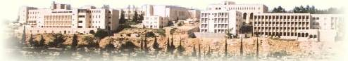

Physics Laboratory 112

Experiment # 03
Network Analysis 1
The Superposition Principle and Kirchhoff's Laws

Name: JIHAD WAHDAN
Student ID: 1071899

Partner's Name: MAHMOUD SROUR
Partner's ID: 107

Section: 5

Instructor: Dr. ISMAEL BADRAN

Abstract:

The aim of the experiment :is to analysis the current which passes in circuits component and to prove experimentally the Superposition principle (SPP) and Kirchhoff’s laws(loop theorem and the junction theorem).

The method used: by using digital multimeter t

