

Physics Department

Physics 112

Experiment No.3

Network Analysis 1

The Superposition Principle And Kirchoff’s Laws

Student’s Name: Mudar Abed Rabbo

Student’s No.: 1041433

Partner’s Name: Khairallah Amous

Partner’s No.: 1040132

Section: 6

Date: 2/10/2005

Instructor: Dr. Ziyad Izzat
Abstract:

The aim of the experiment: is to prove experimentally the superposition principle (SPP) and Kirchoff’s laws (loop theorem and junction theorem).
The method used: is by directly measuring the currents and the voltage differences through the carbon resistors using digital multi-meter.
The main result:
Kirchoff’s Results:
I₁ = 3.14 mA V₁ = 3.12 volt
I₂ = 1.25 mA V₂ = 2.66 volt
I₃ = 1.87 mA V₃ = 8.64 volt
SPP’s Results:
I₃₁ = 1.52 mA
I₃₂ = 0.35 mA

Theoretically: I₁ =3.17 mA
I₂ =1.29 mA
I₃ =1.53 mA
I₃₁ =1.53 mA
I₃₂ =0.35 mA
I₃ = I₃₁ + I₃₂
I₃ = 1.88 mA

Theory:

Applying Ohm’s law and the simple parallel and series connection rules on electric networks is of no particular help, because electric networks consists of many circuit components connected in a complicated way.
Some of the laws that we can use in such cases are; Kirchoff’s law and the superposition principle.

Kirchoff’s law:
- Loop theorem: it stats that: “The algebraic sum of the voltage drops and electromotive forces (emf’s) in a closed electric circuit is always zero.” And that means that the power generated by voltage sources is totally consumed through the closed circuit.
$\sum_{i}{V_{i}}=0$,
or$\sum_{k}{ε_{k}=\sum_{j}{I_{j}R_{j}}}$,
where we have accounted for the opposite signs of voltage drops and emf’s.
- Junction theorem: it stats that: “The algebraic sum of currents passing through any circuit junction is always zero.” Symbolically,
$\sum_{j}{I_{j}}=0$
where the currents entering a junction have opposite signs to those leaving it.

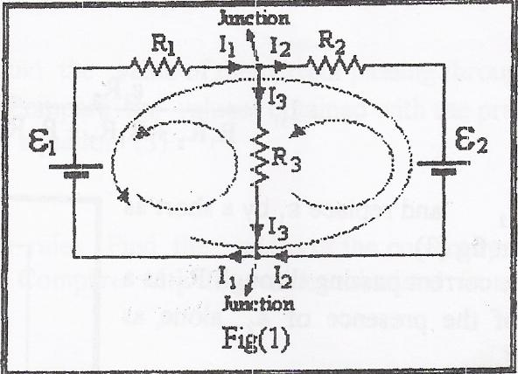
If we took the circuit shown in fig.1 as an example, we will find that applying the previous laws on it gives the following:
- There is two junctions in the circuit and applying the junction theorem both will give us the same equation:
$I_{1}+I_{2}−I_{3}=0$
- Three circuit loops exist, but only two independent equations could be formed:
$ε_{1}=I_{1}R_{1}+I_{3}R_{3}$
$ε_{2}=I_{2}R_{2}+I_{3}R_{3}$
the third equation which is from the large loop is the sum of the previous two equations. Solving these three linear equations with three unknowns is straight forward and gives the values of the currents passing through the three resistors.

The Superposition Principle (SPP):
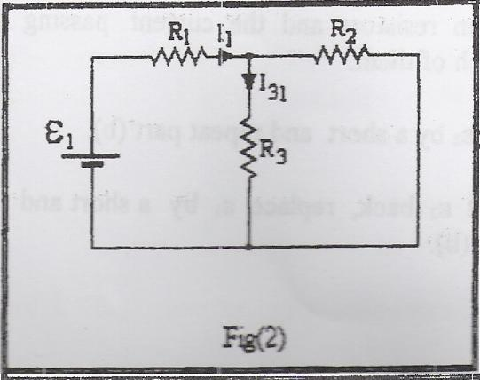
If circuit equations are linear, then the mathematical superposition principle is applicable. And it stats that: “The response (a desired current or voltage) at any point in a linear circuit having more than one source can be obtained as the sum of the responses caused by each of the independent sources acting alone.”
For example if we want to find the current passing through the third resistor we can follow the following steps:
- Keep ε₁ and replace ε₂ with a short circuit as in fig.2.
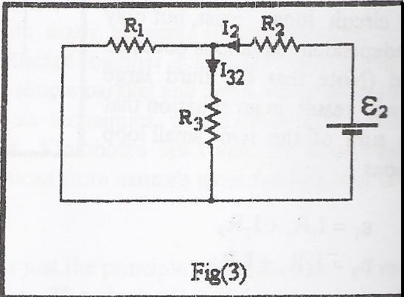
- Find the current passing through R₃ as a result of the presence of ε₁ alone, as follows:
$I_{1}=\frac{ε_{1}}{R_{1}+\left(R_{2}||R_{3}\right)}$,
and $I_{\text{31}}R_{3}=\left(I_{1}−I_{\text{31}}\right)R_{2}$.
Thus, $I_{\text{31}}=\frac{ε_{1}R_{2}}{R_{1}R_{2}+R_{1}R_{3}+R_{2}R_{3}}$
- Keep ε₂ and replace ε₁ by a short as shown in fig.3 .
- Find the current passing through R₃ as a result of the presence of ε₂ alone as follows:
$I_{2}=\frac{ε_{2}}{R_{2}+\left(R_{1}||R_{3}\right)}$,
and $I_{\text{32}}R_{3}=\left(I_{2}−I_{\text{32}}\right)R_{1}$.
Those give: $I_{\text{32}}=\frac{ε_{2}R_{1}}{R_{1}R_{2}+R_{2}R_{3}+R_{1}R_{3}}$
- Add both currents to find the total current passing through R₃.
$$I_{3}=I_{\text{31}}+I_{\text{32}}$$

Data:
R₁= 1 , R₂= 2.2 , R₃=4.7
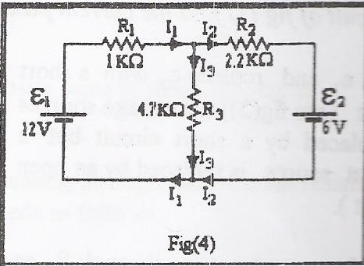
The measurements which we took from the multi-meter (ε₁=12 v , ε₂=6 v):
I₁ = 3.14 mA
V₁ = 3.12 volt

I₂ = 1.25 mA
V₂ = 2.66 volt

I₃ = 1.87 mA
V₃ = 8.64 volt

(SSP) :
I₃₁ = 1.52 mA , I₃₂ = 0.35 mA
Calculations:

Following Kirchoff’s junction theorem on the circuit shown in fig.1 we get:
$I_{1}=I_{2}+I_{3}$ ………… eq. 1-1

Using the loop theorem we get the following equations:
$$\text{12}=I_{1}+4\text{.}7I_{3}$$
$$6=4\text{.}7I_{3}−2\text{.}2I_{2}$$
Substituting by eq. 1-1 and following simple mathematical rules we get:
$\text{12}=I_{2}+I_{3}+4\text{.}7I_{3}$…………eq. 1-2
$⇓$
$$\left(5\text{.}7I_{3}+I_{2}=\text{12}\right)×2\text{.}2$$
$$4\text{.}7I_{3}−2\text{.}2I_{2}=6$$
$⇓$
$$\text{26}\text{.}4=2\text{.}2I_{2}+\text{12}\text{.}\text{54}I_{3}$$
$$6=4\text{.}7I_{3}−2\text{.}2I_{2}$$
$⇓$
$$\text{32}\text{.}4=\text{17}\text{.}\text{24}I_{3}$$
$I_{3}=1\text{.}\text{88}$ mA
Substituting the value of I₃ in eq. 1-2 we can find the value of I₂:
$$5\text{.}7I_{3}+I_{2}=\text{12}$$
$I_{2}=1\text{.}\text{29}$ mA
Using the values of currents that we found and substituting them in eq. 1-1 we can find the value of I₁:
$I_{1}=3\text{.}\text{17}$ mA

Now applying ohm’s law for each resistor independently we will get:
$V_{1}=R_{1}I_{1}$ $V_{2}=R_{2}I_{2}$ $V_{3}=R_{3}I_{3}$
V₁ = 3.17 volt V₂ = 2.8 volt V₃ = 8.8 volt

The values for I₁ , I₂ , I₃ (Theoretically):
I₁ = 3.17 mA V₁ = 3.17 volt
I₂ = 1.29 mA V₂ = 2.8 volt
I₃ = 1.88 mA V₃ = 8.8 volt

Now if we look at the circuit shown in fig.2 we will find that it is a simple circuit on which we can use ohm’s law.( as shown in the theory ( SuperPostion Principle)).
ε₁ = 12 volt R₁ = 1 kΩ R₃ = 4.7 kΩ
ε₂ = 6 volt R₂ = 2.2 kΩ
we get the following values:
$I_{\text{31}}=\frac{ε_{1}R_{2}}{R_{1}R_{2}+R_{1}R_{3}+R_{2}R_{3}}$$=1\text{.}\text{53}$ mA
$I_{\text{32}}=\frac{ε_{2}R_{1}}{R_{1}R_{2}+R_{2}R_{3}+R_{1}R_{3}}$$=0\text{.}\text{35}$ mA

The values for I₃₁ , I₃₂ (Theoretically):
I₃₁ = 1.53 mA
I₃₂ = 0.35 mA

Theoretically: I₃ = I₃₁ + I₃₂
I₃ = 1.88 mA

 | Experimentally | Theoretically
I₁ | 3.14 | 3.17
I₂ | 1.25 | 1.29
I₃ | 1.87 | 1.88
V₁ | 3.12 | 3.17
V₂ | 2.66 | 2.8
V₃ | 8.64 | 8.8
I₃₁ | 1.52 | 1.53
I₃₂ | 0.35 | 0.35

Analysis of results:
As we saw previously, using SPP we found that the sum of the current passing through R₃ when each source is acting alone equals the value of the current that passes through R₃ when the two sources act together. And the experimental values are around the theoretical ones.
And also as we found using Kirchoff’s laws, the values that we’ve got theoretically are around the experimental values.
The two methods which we used to get I₃ , have given us the same values for it.
And finally there were some errors, which were occurred because we ignored the resistance of the equipments (the wires and the multi-meter), and this affect our result.

