

Electrical Engineering Department

ENEE 212

Experiment #. 2
Shorts And Opens Electrical Circuits

Section:

Date:

Instructor:
Abstract:

The aim of the experiment: is to examine and prove experimentally Thevenin’s and Norton’s techniques and compare the results with Kirchoff’s laws.
The method used: is by using the equivalent circuit of Thevenin and Norton techniques.
The main results:

Theory:
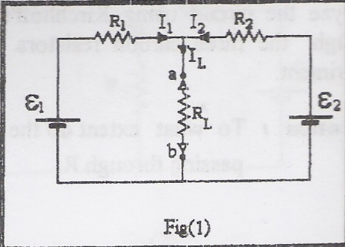
Dealing with fairly complicated networks, requires adequate methods such as the equivalent circuit techniques of Thevenin and Norton.
Thevenin’s theorem states that: “any network of resistors and supplies having two output terminals as in fig.1 can be replaced by a series combination of a voltage source (ε_{eq}) and a resistor (R_{eq}), as in fig.2.
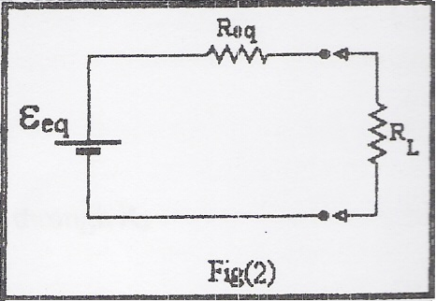
Norton and Thevenin’s techniques are especially important in obtaining the current passing through and the voltage across any one resistor (R_{L}) in complicated networks.
As an example if we took the circuit shown in fig.1 we can find the value of the current passing through (R_{L}) using Norton’s and Thevenin's techniques and the values that we will have will be equal to those of Kirchoff:

Thevenin’s:
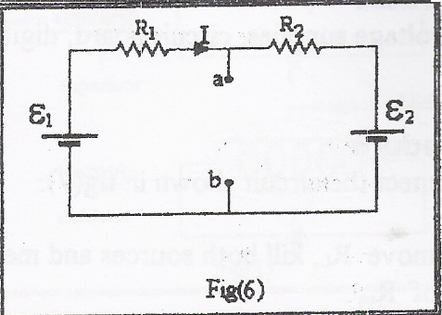
- Remove R_{L}, kill both sources as in fig.4, and you will get:
$R_{\text{eq}}=R_{1}||R_{2}=\frac{R_{1}R_{2}}{R_{1}+R_{2}}$
- Remove R_{L}, return both sources back to the circuit as in fig.6 and calculate ε_{eq} as follows:
Using Kirchoff's loop theorem we get:
$\begin{aligned}ε_{1}−ε_{2}=I\left(R_{1}+R_{2}\right), \\ ε_{\text{eq}}=ε_{1}−\text{IR},\end{aligned}$
eliminating I between the two equations, yields:
$ε_{\text{eq}}=ε_{1}−\frac{\left(ε_{1}−ε_{2}\right)R_{1}}{R_{1}+R_{2}}$
- Construct Thevenin's equivalent as in fig.2 using the calculated values of ε_{eq} and R_{eq}. Now, you can find the current passing through R_{L} as follows:
$I_{R_{L}}=\frac{ε_{\text{eq}}}{R_{\text{eq}}+R_{L}}$

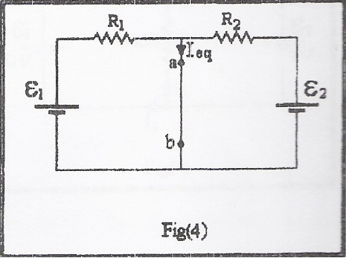
Norton’s:
- Replace R_{L} with a short circuit (a wire) as in fig.4, and calculate I_{eq} as follows:
$\begin{aligned}I_{\text{eq}}=I_{1}+I_{2}, \\ I_{\text{eq}}=\frac{ε_{1}}{R_{1}}+\frac{ε_{2}}{R_{2}}\end{aligned}$
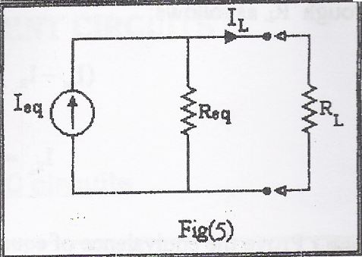
- Construct Norton’s equivalent circuit, fig.5, and calculate the current passing through R_{L} as follows:
$\left(I_{\text{eq}}−I_{R_{L}}\right)R_{\text{eq}}=I_{R_{L}}R_{L},$
$I_{R_{L}}=\frac{I_{\text{eq}}R_{\text{eq}}}{R_{\text{eq}}+R_{L}}$
Data:

ε₁ = volt
ε₂ = volt
Thevenin:
ε_{eq} =
R_{eq} =
I_{RL} =
Norton:
I_{eq} =
R_{eq} =
I_{RL} =
Thevenin’s circuit :

Norton’s circuit:

Calculations:
Thevenin’s:
To find R_{eq}:
$$\begin{aligned}R_{\text{eq}}=\frac{R_{1}R_{2}}{R_{1}+R_{2}}= \\ \end{aligned}$$
Now in the circuit shown in fig.6 if we want to find ε_{eq} we must use Kirchoff’s loop theorem:
$$\begin{aligned}ε_{\text{eq}}=ε_{1}−\frac{\left(ε_{1}−ε_{2}\right)R_{1}}{R_{1}+R_{2}} \\ \\ \end{aligned}$$
And in the circuit shown in fig.2 we can find the current passing through R_{L} as follows:
$$I_{R_{L}}=\frac{ε_{\text{eq}}}{R_{\text{eq}}+R_{L}}=$$
۩ $\begin{aligned}I_{\text{eq}}=\frac{ε_{\text{eq}}}{R_{\text{eq}}}= \\ \end{aligned}$

Norton’s:
In the circuit shown in fig.4 we can find I_{eq} like that:
$$\begin{aligned}I_{\text{eq}}=\frac{ε_{1}}{R_{1}}+\frac{ε_{2}}{R_{2}} \\ \\ \end{aligned}$$
And in the circuit shown in fig.5 we can calculate the current passing through R_{L} as follows:
$$I_{R_{L}}=\frac{I_{\text{eq}}R_{\text{eq}}}{R_{\text{eq}}+R_{L}}=$$

