بسم الله الرحمن الرحيم



Physics Laboratory 112

Experiment # 06

Damped Oscillations

Name: Majd abo Ayhour
Student ID: 1041384

Partner's Name: Mohammed Arar
Partner's ID: 1040813

Section: 3

Instructor: Dr. Wa'el Al Qara'n

Date: July 31th, 2006

Abstract:
1-The aim of the experiment:
in this Experiment we will deal with the (CRO) and the signal generator in making damping during the three different damping stages, It aims to find the maximum level for (R) to stay in Over damping stage, and found t_{1/2} for Over damping, Critical damping and Under damping for voltage.

2-Main results:

Underdamping:
t1/2 _{Exp}=4.8x10-5 sec.
t1/2 _{Theo}=5.38x10-5 sec
δ _{Exp}=$\text{14440}\text{.}\text{56}$.
δ _{Theo}= $\text{13050}$.

Criticaldamping:
t1/2 _{Exp} = t1/2 = 0.7x10-4 sec
δ _{Exp}= $\text{9902}\text{.}1$

Overdamping:

t1/2 _{Exp} = 0.15x50µs=7.5x10-6
δ _{Exp}= $\text{9242}$.

Theory:
in this Experiment we have three cases of damping, we make circuit as shown in fig (1) for the three cases and change the resister for each case The charge on the capacitor variables by this equation : $Q(t)=A_{1}e^{λ_{+}t}+A_{2}e^{λ_{−}t}$. Where A₁ and A₂ are constants
$λ_{+}=−\frac{R}{\text{2L}}+\sqrt{(\frac{R}{\text{2L}})^{2}−\frac{1}{\text{LC}}}$. $λ_{−}=−\frac{R}{\text{2L}}−\sqrt{(\frac{R}{\text{2L}})^{2}−\frac{1}{\text{LC}}}$

Case 1: Over damping
If $(\frac{R}{\text{2L}})^{2}>\frac{1}{\text{LC}}$, then both terms of Q(t) decay exponentially with time, and the voltage across the capacitor is said to be over-damping.

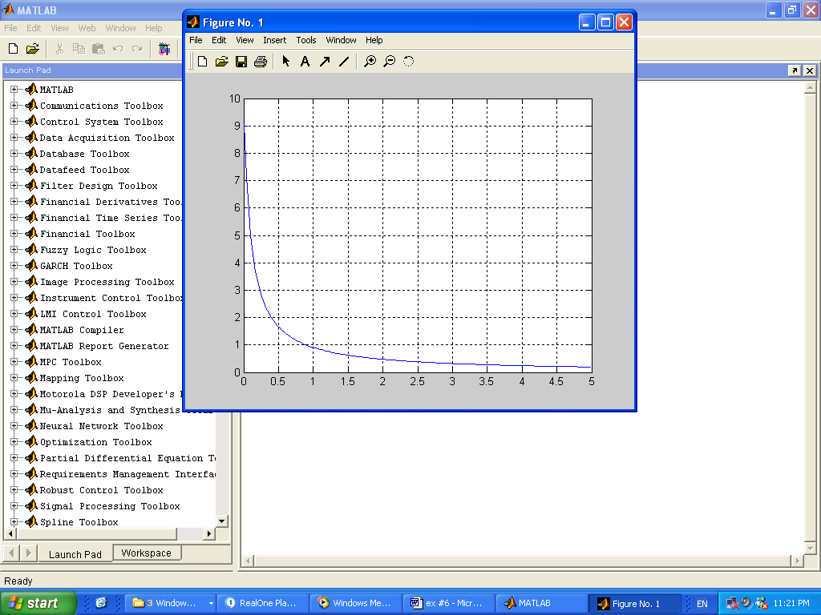
Fig(2)

Case 2: Critical damping
If$(\frac{R}{\text{2L}})^{2}=\frac{1}{\text{LC}}$, then $λ_{+}$ = $λ$₋ = -$\frac{R}{\text{2L}}$, and Q(t) = ${\text{Ae}}^{−\frac{R}{\text{2L}}t}+{\text{Bte}}^{−\frac{R}{\text{2L}}t}$

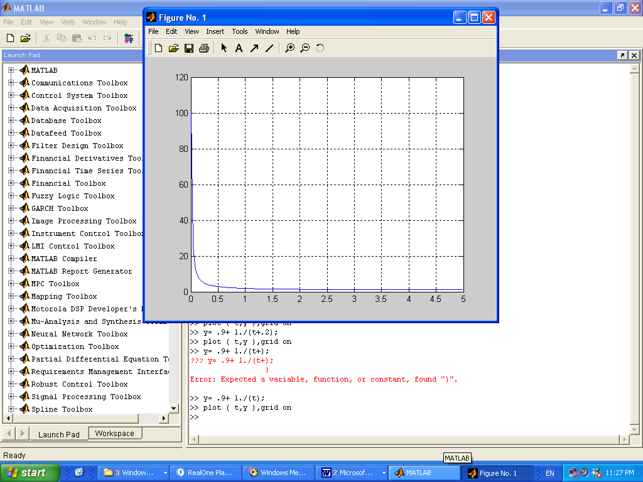
.
Fig(3)

Both the charge on the capacitor plates, and consequently the voltage across them decay exponentially with time, and the voltage across the capacitor is said to be critical-damping.

Case 3: Under damping
If $(\frac{R}{\text{2L}})^{2}<\frac{1}{\text{LC}}$, then the term under the square root becomes negative, and Q(t) = $Qe^{−\text{δt}}\text{cos}(ω^{'}t+θ_{0})$ where $δ=\frac{R}{\text{2L}}$ and $ω^{'}=\sqrt{\frac{1}{\text{LC}}−(\frac{R}{2L})^{2}}$.
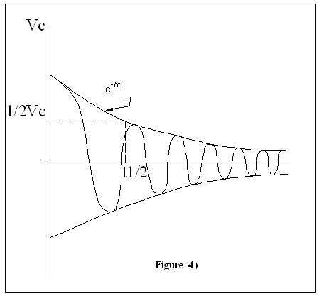fig4
The time at which the amplitude falls to its half is called t_{1/2}. Which is given by$t_{\text{1/2}}=\frac{\text{2L}}{R}\text{ln2}$.

Procedure:
We create circuit as shown in fig (1),with variable (R) :
1- For Under damping-> R=200 Ω
2- For Critical damping-> R=1808 Ω
3- For Over damping -> R=10000 Ω

Then we found t1/2 for each case by taking the value Vc_{1/2}=1/2* Vc_{max} from the screen of (CRO) then we Estimate t_{1/2} from the graph.

We Repeat this Procedure for three cases .

Data & Calculations:
C=0.01µ
L=10mH
Internal R for inductor =61 Ω

Underdamping:
t_{1/2} (when the variable resistance equals 200Ω) =0.95x50µs=4.8x10⁻⁵sec. (Experimentally)
(Theoretically)
At t1/2
$δ=\frac{\text{ln}2}{t_{1/2}}=\frac{\text{ln}2}{4\text{.}8×{\text{10}}^{−5}}=\text{14440}\text{.}\text{56}$ (Experimentally)

$δ=\frac{R}{2L}=\frac{\text{261}}{2×\text{10}×{\text{10}}^{−3}}=\text{13050}$ (Theoretically)

Criticadamping:
RL at which critical damping occurs ≈ 1808Ω.
Vmax=3.75 volt. V1/2=1.875volt.
At V1/2 →t1/2 = 0.7x10-4 sec. (Experimentally)
$δ=\frac{\text{ln}2}{t_{1/2}}=\frac{\text{ln}2}{7\text{.}5x{\text{10}}^{−5}}=\text{9902}\text{.}1$(Experimentally)

Overdamping:
RL at which we moved from criticaldamping to overdamping ≈10000 Ω.
Vmax=3.55 volt. V1/2=1.8volt.
→ t1/2 = 0.15x50µs=7.5x10-6(Experimentally)

$δ=\frac{\text{ln}2}{t_{1/2}}=\frac{\text{ln}2}{0\text{.}7x{\text{10}}^{−4}}=\text{9242}$(Experimentally)

Conclusions:
For the value we found for δ experimentally ($\text{14440}\text{.}\text{56}$ ) & theoretically ($\text{13050}$ ) for Underdamping case we note there is small deference between them because there is small resister doesn’t be in Calculations in wires and capacitor.
I think the theoretical result is more precise because the neglect resisters and we when calculating t_{1/2} from the CRO screen, we had to perform much estimation in counting the number of units on the screen.
We note that decay constant ($δ$) for Criticadamping (9902.1) is greater than ($δ$) for Overdamping (9242) which means that decay is faster when the circuit at the critical damping case.
We found the value of R that present the critical point (1808 Ω)
Less than this value is underdamping, more than it is overdamping.

