






Physics laboratory
Phy. 112
Experiment 6
Damped Oscillation

Muhannad Hassan Abu Ayhour 1030691
Jeries Boloutta 1030277

Sec.:1
Instructor: Dr. Wae’l Qara;en

1/ 8/ 2006

Abstract:
This experiment aims to analyise and compare the behavior of an RLC circuit during the three different damping stages. It aims to find the range of R and t_{1/2} for each of the three stages by connecting an RLC circuit with a variable resistance to a CRO from which we can obtain our readings. The main results are:
i. Under damping:
  - t_{1/2 (exp)} = 5*10⁻⁵ sec; t_{1/2 (th)} = 5.7*10⁻⁵ sec
  - Range for R_{L} [0, 1800) Ω.
  - δ _{exp} =13863 δ _{th=}12100
- Critical damping:
- t_{1/2 (exp)} = 1.5*10⁻⁵ sec.
- Value for R_{L} =1800Ω.
- δ _{exp=}46209.5
- Over damping:
- t_{1/2 (exp)} = 3.5*10⁻⁵ sec.
- Range for R_{L} [1800, ∞) Ω.
- δ _{exp=}19804.2

Apparatus:
1- Resistance decade box.
2- Inductor (10 mH)
3- Capacitor (0.1μF)
4- Signal generator.
5- Oscilloscope

Theory:
For an RLC circuit like the one connected in the Fig the charge that accumulates on the capacitor can be given by the following relation: $Q(t)=A1e^{λ+t}+A2e^{λ−t}$---eq (1), where A₁ and A₂ are both constants and:
$λ±=−\frac{R}{2L}±\sqrt{{(\frac{R}{2L})}^{2}−\frac{1}{\text{LC}}}$ --- eq (2).
When dealing with a circuit in which only R is variable we get three cases depending on R’s value:

*Underdamping:
For a very small value of R we get:${\left(R/2L\right)}^{2}<\left(1/\text{LC}\right)$. Therefore $Q(t)=Q0e^{{−\text{Rt}}/2L}\text{cos}(\sqrt{(1/{\text{LC}})−{\left(R/2L\right)}^{2}}+θ0)$ this is a sinusoidal function with exponentially decaying amplitude. We can define the half life (t_{1/2}) of the amplitude (envelope) as the value when $Q0/2=Q0e^{−\text{Rt}{1/2}/2L}⇒t1/2=\frac{(2L)\text{ln}(2)}{R}$--- eq(3). Using .this method we can even measure the overall resistance of the components of our circuit by substituting t_{1/2} as we get it from the CRO when R_{L} is set to 0.as this fig shown .

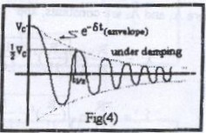

*Critical damping:
This is considered a turning point between underdamping and overdamping: here ${(R/2L)}^{2}=(1/{\text{LC}})$which means that $λ+=λ−={−R}/2L$. And the charge decays exponentially according to the relation: $Q(t)=Ae^{{−\text{Rt}}/2L}+\text{Bt}e^{{−\text{Rt}}/2L}$in which A and B are both constants.
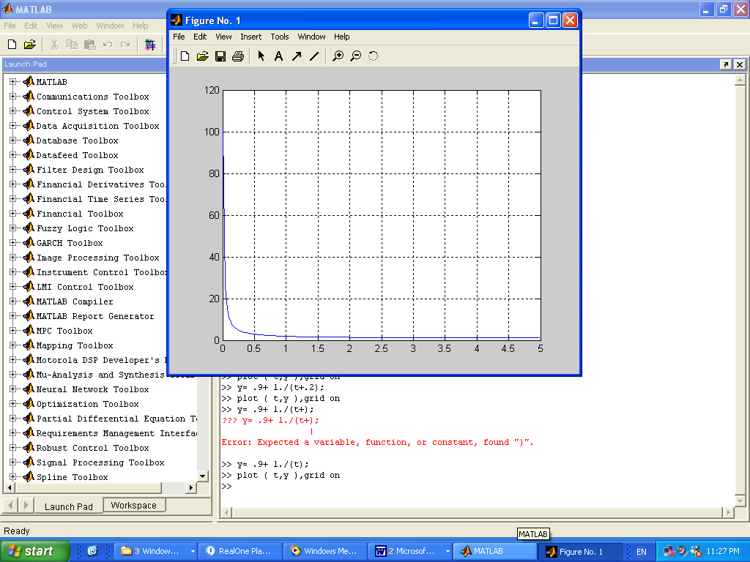

*Overdamping:
As a final stage, when the resistance is large enough: ${(R/2L)}^{2}>\left(1/\text{LC}\right)$, in this case equation (1) would apply as it is, and both terms in that equation would decay exponentially decay.

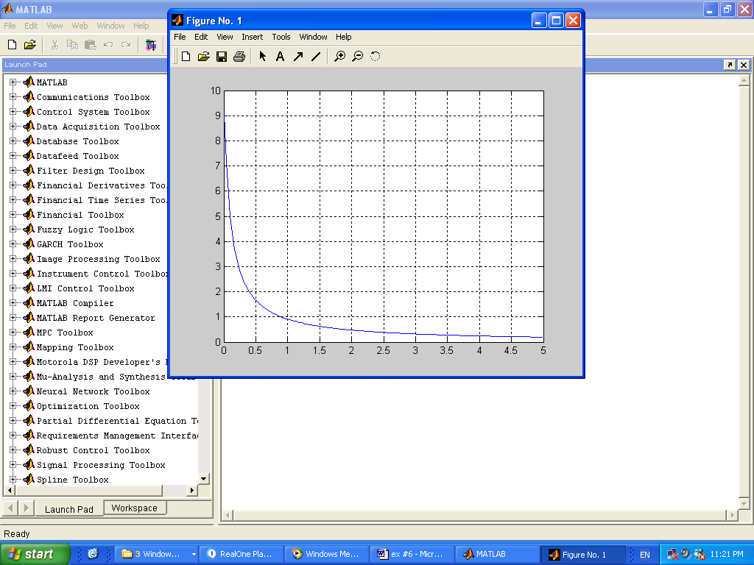

Procedure:
- We built the RLC circuit shown in the Fig. (Using a variable resistance for R) and then we connected it to the CRO which was set to work in its internal mode.
- We set the variable resistance to be zero, and we measured t_{1/2}, then using equation (3) we measured the total resistance of all the components (call this R_{comp}).
- We set the variable resistance to a small value R_{L}, then we found t_{1/2} experimentally using the CRO and theoretically using equation (3) (R in equation (3) was taken to equal R_{comp}.+R_{L})
- Next, we increased the value of the variable resistance until the sinusoidal graph on the CRO turned into that of an exponential decay. This meant that we moved from the stage of underdamping to that of critical damping.
- We then measured t_{1/2} during critical damping.
- To reach the final stage, we increased the resistance to reach the stage of overdamping. Our final step was to measure t_{1/2} for this value of R_{L} in the overdamping stage.

  - Data and Calculations :

  - $C=0\text{.}1μF$.
  - $L=\text{10}\text{mH}$.

- Underdamping:
$t1/2(\text{whenR}L=\text{200})=\frac{(2L)\text{ln}(2)}{ΣR}=\frac{(2)(\text{10}×{\text{10}}^{−3})\text{ln}(2)}{(\text{200}+\text{42})}=5\text{.}7×{\text{10}}^{−5}\text{sec}\text{.}$(Theoretically)
$t1/2$= $\text{50}×{\text{10}}^{−6}\text{sec}$ (Experimentally)
δ _{exp=} $\frac{\text{ln}(2)}{t1/2}$= 13863 δ _{th} = $\frac{R}{2L}$=12100
- Critical damping:
- R_{L} at which critical damping occurs ≈ 1800Ω
- $t1/2$= $1\text{.}5×{\text{10}}^{−5}\text{sec}$
- δ _{exp=} 46209.5

- Overdamping:
- $t1/2$=3.5*10⁻⁵ sec
- δ _{exp=} 19804.2
- Theory. Where$λ±=−\frac{R}{2L}±\sqrt{{(\frac{R}{2L})}^{2}−\frac{1}{\text{LC}}}$. By substituting R = (R_{L}+R_{comp.}) = (1800+42) = 1842Ω, we get: λ₊ = -5599.1 sec⁻¹, λ₋ = -957101sec⁻¹

  - Analysis:
By analyzing the graphs, data and the numerical results we can see that:
- For the underdamping stage, the range of R_{L} is [0, 1800) Ω.
- Critical damping occurs at R_{L} = 1800 Ω.
- For the overdamping stage, the range of R_{L} is approximately [1800, ∞) Ω.
- t_{1/2} found experimentally for the underdamping stage is close somehow to that found by theory within an order of about 10⁻⁵ sec.
- The values of R_{L}, obtained experimentally and by theory, at which we move from the underdamping to the critical damping stage closely matched.
- From the decay constants we calculated above for the critical and overdamping stages, it is not very easy to conclude where the decaying occurs faster. But by comparing the graphs we got on the CRO for both stages ,we can see that in the critical damping stage we get a steeper graph which means that decaying occurs at a faster rate. Additionally, we can come to the same conclusion by looking at section IV Data; there we can see that t_{1/2} in the critical damping stage is less than that in the overdamping stage and t_{1/2} is inversely proportional to the decay rate.

  - Conclusion:
i. Under damping:
  - t_{1/2 (exp)} = 5*10⁻⁵ sec; t_{1/2 (th)} = 5.7*10⁻⁵ sec
  - Range for R_{L} [0, 1800) Ω.
δ _{exp=} $\frac{\text{ln}(2)}{t1/2}$= 13863 δ _{th} = $\frac{R}{2L}$=12100

- Critical damping:
- t_{1/2 (exp)} = 1.5*10⁻⁵ sec.
- or R_{L=} 1800Ω.
Value f δ _{exp=} 46209.5

- Over damping:
- t_{1/2 (exp)} = 3.5*10⁻⁵ sec.
- Range for R_{L} [1800, ∞) Ω.
- δ _{exp=} 19804.2
We can conclude that for each of the three damping stages occurs at a different range of R: it begins with the underdamping stage for small values of R, then at a specific value of R we reach the critical damping stag, finally, we get to the overdamping stage for all larger values of R. The RLC circuit behaves in a very different way in each stage.
When calculating t1/2 for underdamping, the values obtained for t1/2 experimentally and theoretically differed by a small amount , To obtain the value of R_{L} at which we move from one stage to another we had to change the value of the variable resistance until we got, what we think is the correct graph. So it was a matter of human judgment which means precision was somewhat compromised.
Finally, in this experiment, unlike previous ones, we have taken into consideration the resistance of other components of the circuit which means that we were able to reduce eliminate a source of error that was present in previous experiments.

