
BIRZEIT UNIVERSITY
PHYSICS DEPARTMENT
LAB 112
_______________________________________EXPERIMENT 7_______
*Impedance and Reactance*

*Student Name: mohammad modallal
*Student ID: 1120174

*Partner's Name: Ahmad Dar Khalil
*Partner's ID : 11201

*Section: 13

*Instructor: Dr.Ismael Badran

*Date: 23/3/2013

Abstract : ♣

♦ The aim of the experiment: is to determine the phase difference between the voltages of components which are inductor, resister and capacitor in an AC powered RLC circuit. Then to calculate the frequency at which the phase shift is zero. And to find the characteristics from VR, VC and VL graphs.

♦The method used: by adjusting the CRO on the internal mode and using the time divisions on it to analyze our circuit in finding the phases (Φ ). Then by using the external mode and changing the frequency of the input wave in order to take our data to draw the graph of (f vs. Φ). So we can find the frequency.

♦ The main results:

Between Vin and VR)=0 rad ) Φ
Between Vin and VC)= -π/2 rad ) Φ
Between Vin and VL)= π/2 rad ) Φ
Between VL and VC)= π rad ) Φ
Between VL and VR)= π/2 rad ) Φ
Between VC and VR)= π/2 rad) Φ

The frequency when Φ is zero= 5.5 kHz
Calculations ♣

R=1k Ω ,L=10Mh,C=0.1µf) (

* From the graph paper we find these : using that (T) equals 4 in all calculations ◊
Between VL and VC)=2π∆t/T=2* π*2/4= π rad ) Φ

Between VL and VR)=2 π*1/4= π/2 rad ) Φ

Between VC and VR)=2 π*1/4= π/2 rad) Φ

Between Vin and VR)= 2π∆t/T =0 rad(∆t=0) ) Φ

Between Vin and VC)= 2π∆t/T =- π/2 rad(∆t=-1) ) Φ
Between Vin and VL)= 2π∆t/T =π/2 rad(∆t=1) ) Φ

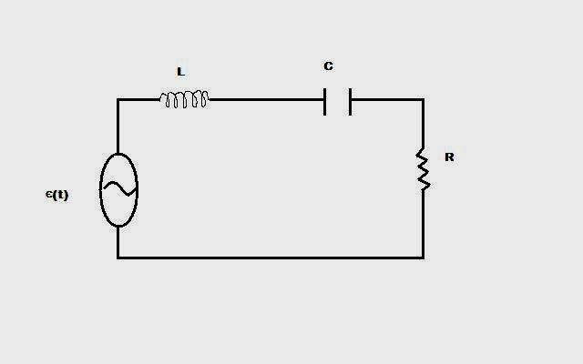 1fig

From the graph of the phase with the frequency we find: *

•The frequency when the phase shift is zero =5500 HZ (exp)

•The frequency when the phase shift is zero but the theoretically one:
f=1/2 π(LC)^{1/2 =} 5040 HZ

figure 2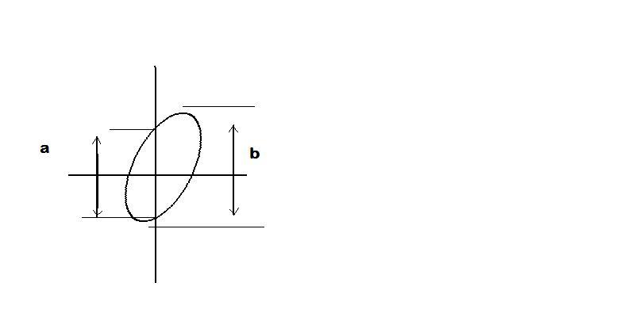

♣Results and conclusion:

♦ as we saw, the frequency when the phase is zero equals 5.5 kHz according to our experiment. However ,the theoretical value according to the values of (L,C) is 5.04 Hz. There is a small difference between the two values which refers to some errors in taking the data. We can say that our experiment agree somehow with the theoretical values .

♦the questions:

a)the drawing is shown in the next paper. As we see we can conclude some differences between(VL,VC,VR with Vin).(Vin vs.VR ) both are cosine relations. However , (Vin,VL) are cos and sin . while (Vin,VC) are cos and –sin.

b) the graph is represented in the semi log paper. The frequency when the phase shift zero is 5.5 kHz according to our experiment.

♣ Data sheet

Physics 112 – Experiment Seven
Impedance and Reactance

C = 0.1µF
L= 10 mH
R= 1 KΩ

Frequancy (KHz) | a | b | Ф = sin⁻¹(a/b)
0.1 | 4.2 | 4.2 | 90
0.3 | 4.1 | 4.2 | 77.5
0.5 | 4.0 | 4.2 | 72.2
0.7 | 3.9 | 4.2 | 68.2
1.0 | 3.3 | 4.2 | 51.8
3.0 | 1 | 4.2 | 13.7
4.0 | 0.6 | 4.2 | 8.2
4.5 | 0.4 | 4.2 | 5.4
5.0 | 0.2 | 4.2 | 2.7
5.5 | 0 | 4.2 | 0
6.0 | 0.2 | 4.2 | 2.7-
7.0 | 0.6 | 4.2 | 8.2-
10.0 | 1.4 | 4.2 | 19.4-
30.0 | 3.6 | 4.2 | 59-
50.0 | 4.0 | 4.2 | 72.2-
70.0 | 4.1 | 4.2 | 77.5-
100.0 | 4.2 | 4.2 | 90-

