


Physics Department
Physics 112
Experiment No.8

**Damped Oscillations**

Student's Name : ALmutasem bellah omar
ID : 1090349

Partner's Name : jihad abdullah
ID : 1090349

Instructor : Dr. Ghassan andoni

Section : 5

Date : 15/03/2010

**Abstract:

- The aim of the experiment : is to find out t ½ experimentally and compare it with the value calculated from component values.

- The method used is: by measuring the voltage difference across the capacitor’s plates using the CRO.

- The main results are :

**Theory :
The charge of the capacitor plates and the voltage across the capacitor in the Dc power RLC circuit and are described using the following solution for Q(t) :
Q(t) = A1 eê+t +A2eê-t
Where A1 & A2 are constant , and
e1 =-R/L + √(R/2l)^2 – 1/lc
e2= -R/L - √(R/2l)^2 – 1/lc

for this solution three interesting cases emerges:

Case (1) : Over Damping

Where (R/2L)^2 > 1/Lc

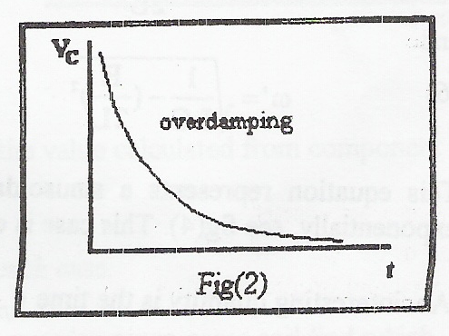

Case (2) : Critical Damping:

Where (R/2L)^2 = 1/Lc

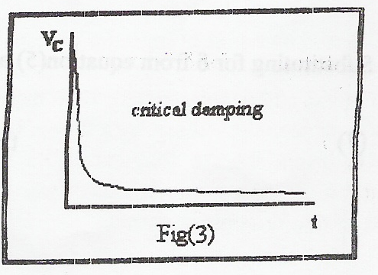

Case (3) : Under damping

Where (R/2L)^2 < 1/Lc
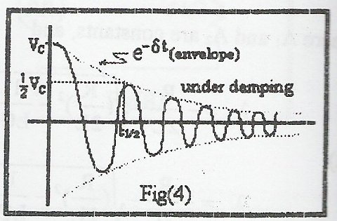

Therefore, we only introduce the solution:
Q(t) = Q. e^$t cos ( w’t + θ )
Where $ = R/2l
And w’ = √ 1/lc - (R/2l)^2
An interesting Quantity is the value of the time after which the amplitude Q(t) = e^$t falls to half its initial value Q0 , or
Q0 /2 = e^$t/2
Where t ½ = 2l ln 2/ R
And so the voltage will be :
V c = Q(t) / C

**Procedure:
  - The circuit was connected as shown in the fig.
  - The voltage was displayed across the capacitor on the oscilloscope screen.
  - The value of R was changed to obtain the three damping cases, recorded R in each case
  - Each case was drawn on a linear graph.

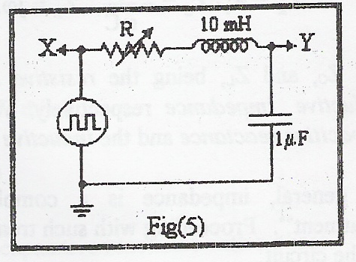
**Calculations :
……………………………………………………………………………………………………………………………………………………………………………………………………………………………………………………………………………………………………………………………………………………………………………………………………………………………………………………………………
……………………………………………………………………………………………………………………………………………………………………………………………………………………………………………………………………………………………………………………………………………………………………………………………………………………………………………………………………
……………………………………………………………………………………………………………………………………………………………………………………………………………………………………………………………………………………………………………………………………………………………………………………………………………………………………………………………………
……………………………………………………………………………………………………………………………………………………………………………………………………………………………………………………………………………………………………………………………………………………………………………………………………………………………………………………………………
……………………………………………………………………………………………………………………………………………………………………………………………………………………………………………………………………………………………………………………………………………………………………………………………………………………………………………………………………

**Conclusion:
……………………………………………………………………………………………………………………………………………………………………………………………………………………………………………………………………………………………………………………………………………………………………………………………………………………………………………………………………
……………………………………………………………………………………………………………………………………………………………………………………………………………………………………………………………………………………………………………………………………………………………………………………………………………………………………………………………………
……………………………………………………………………………………………………………………………………………………………………………………………………………………………………………………………………………………………………………………………………………………………………………………………………………………………………………………………………
……………………………………………………………………………………………………………………………………………………………………………………………………………………………………………………………………………………………………………………………………………………………………………………………………………………………………………………………………
……………………………………………………………………………………………………………………………………………………………………………………………………………………………………………………………………………………………………………………………………………………………………………………………………………………………………………………………………

