Contents

Subject | Page
Abstract | 2
Theory & definitions | 2
Apparatus | 4
Procedure | 4
Data | 4
Computations | 4
Conclusion | 7

Abstract

Aim : is to study RC circuits used as filters , examining the characteristics of both types high and low pass filters . In addition , to study the relation between the input and output voltages of such filters .

Method used : Plotting a graph of the attenuation factor , A vs. the frequency & finding ω_{-3dB} from the plot , after collecting the required data by the aid of the oscilloscope .

Results :

Practically :
Low pass ω_{-3dB} = 44.6 krad/s
High pass ω_{-3dB} = 54 krad/s

Theoretically :
ω_{-3dB} = 1/RC = 45.5 krad/s

Theory

Filters are classified into three types : high pass , low pass & band pass filters :

Low pass RC filters :
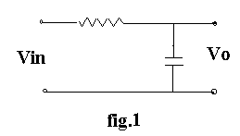
For the circuit shown in fig.* the relation between the input & output voltage is as follows :

Vout = A*Vin
Where , The attenuation factor , A is determined as follows :

A = Vout/Vin
= 1/( 1+ ω²C²R² )^{1/2}
= 1/[(1 + (ω/ω_{-3dB})2 ]^{1/2}
where , ω_{-3dB} = 1/RC
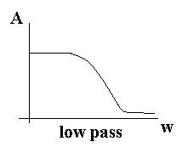

If this kind of filters are functioning in the highly attenuated region then the relation between the output and input voltage is determined as follows :

V_{out}(t) = (1/RC)∫V_{in}(t)dt

High pass RC filters :
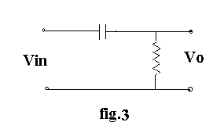
For the circuit shown in fig.* the attenuation factor , A is determined as follows :

A = 1/[(1 + (ω_{-3dB} /ω)2 ]^{1/2}
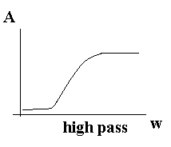
If this kind of filters are functioning in the highly attenuated region then the relation between the output and input voltage is determined as follows :

V_{out}(t) = RC(dV_{in}(t)/dt)

Apparatus

- 1 KΩ resistor .
- Capacitor ( .022 μF )
- Signal generator .
- Oscilloscope .

Procedure

- Connect a circuit as shown in fig.1
- For some different frequencies , both the input and output voltages are measured by the aid of the oscilloscope .
- The previous step is repeated with the circuit shown in figure.3.
- For the circuit shown in fig.1 use the various types of wave functions of the input voltage and the function of the output voltage is noticed .
- The previous step is repeated with the circuit shown in figure.3

Data & Calculations

Table 1 : Data of Vin , Vout with ƒ and A for low pass filters :

ƒ | V_{R} | A
1.00 | 10.5 | 1
3.00 | 10 | .952
7.00 | 7.5 | .714
9.00 | 6.5 | .62
10.00 | 6 | .57
20.00 | 4.5 | .43
30.00 | 3 | .28
50.00 | 1.75 | .166
100.00 | 1 | .095

Table 2 : Data of Vin , Vout with ƒ and A for high filters :

ƒ | V_{R} | A
1.00 | 1.75 | 0.166
3.00 | 3.75 | 0.357
7.00 | 6.50 | 0.620
9.00 | 7.50 | 0.714
10.00 | 8.00 | 0.760
20.00 | 8.50 | 0.810
30.00 | 9.50 | 0.900
50.00 | 9.75 | 0.930
100.00 | 10.00 | 0.950

Calculation of ω_{-3dB} :

Practically :
Low pass ω_{-3dB} = 7.1*2*π = 44.6 krad/s
High pass ω_{-3dB} = 8.6*2*π = 54 krad/s

Theoretically :
ω_{-3dB} = 1/RC = 1/[(1000)*(0.022*10^-6)] = 45.5 krad/s

Observations of the output wave forms with respect to various types of input wave forms :

Conclusion

In summary the results of the test where as follows :

Practically :
Low pass ω_{-3dB} = 44.6 krad/s
High pass ω_{-3dB} = 54 krad/s

Theoretically :
ω_{-3dB} = 1/RC = 45.5 krad/s

Mainly , it is clear that the practical results are almost close to the theoretical values . In the other hand , the output wave forms with respect to various types of input wave forms were following the theoretical formulas . The slight differences that are existed between the theoretical and practical variables could be justified by the difficulty to record the exact required value from the screen of the oscilloscope , where the thickness of the line describing the behavior of the current or voltage is plenty thick , which in terms makes the mission seems hardly to be done .

Another reason could be the presence of some excess resistance in the elements that are not taken exactly into consideration & in the calculations and in terms , badly effects the results .

