


Physics Department
Physics 112
Experiment No.9

Impedance and Reactance

Student's Name : Mohannad Saidi
ID : 1110689

Partner's Name : Hala Nahhal
ID : 1111512

Instructor : Dr. Ziad Izzat

Section : 4

Abstract:

- The aim of the experiment is :to find out the frequency at which the phase difference equals zero, and compare it with the theoretical one. And also to find out the phase differences between$V_{L}$, $V_{\text{in}}$ and $V_{C}$ in an AC-powered RLC circuit.

- The method used is: by using the CRO to find the phase shift between the driving voltage and the current, $V_{C}$ and $V_{L}$.

- The main results are :

Theory :
In the RLC circuit shown in figure1 the current is :
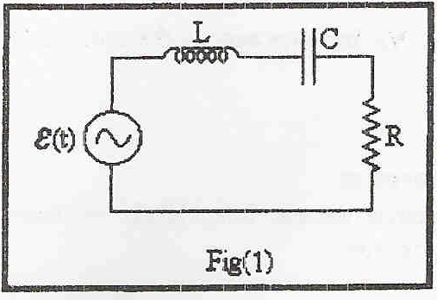
$$I(t)=\frac{ε(t)}{Z_{\text{eq}}}$$
Where
$$\begin{aligned}Z_{\text{eq}}=Z_{R}+Z_{C}+Z_{L} \\ Z_{R}=R (\text{the} \text{resistive} \text{impedance}) \\ Z_{C}=−\frac{j}{ωC} (\text{the} \text{capaci}\text{tan}\text{ce} \text{impedance}) \\ Z_{L}=jωL (\text{the} \text{inductive} \text{impedance})\end{aligned}$$
While:
$\frac{1}{ωC}$ is the capacitance reactance and $ωL$ is the inductive reactance.
We Solve the equation of the current :
$$ε(t)=ε_{0}\text{Cos}(ωt)$$
$$\begin{aligned}I(t)=\frac{ε_{0}e^{jωL}}{R+j(ωL−1/{ωC})})(\frac{R−j(ωL−1/{ωC})}{R−j(ωL−1/{ωC})}=\frac{R−j(ωL−1/{ωC})ε_{0}e^{jωL}}{R^{2}+(ωL−1/{ωC})^{2}} \\ \frac{\sqrt{R^{2}+(ωL−1/{ωC})}ε_{0}e^{j(ωL+ϕ)}}{R^{2}+(ωL−1/{ωC})^{2}}=\frac{ε_{0}}{\sqrt{R^{2}+(ωL−1/{ωC})}}e^{j(ωL+ϕ)}\end{aligned}$$
=$\frac{ε_{0}}{\sqrt{R^{2}+(ωL−1/{ωC})}}\text{Cos}(ωt+ϕ)=I_{0}\text{Cos}(ωt+ϕ)$
Where:
$$ϕ={\text{tan}}^{−1}(\frac{1/{ωC}−ωL}{R})$$
$$I_{0}=\frac{ε_{0}}{\sqrt{R^{2}+(ωL−1/{ωC})}}$$

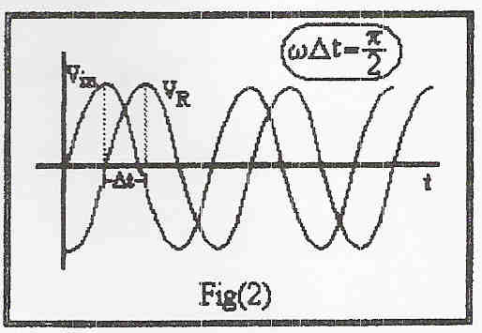
The phase shift between the current and the voltage is given by $φ=ωΔt$ see fig 2.

The voltage a cross the inductor is given by:
$$V_{L}=L\frac{\text{dI}(t)}{\text{dt}}=−ω{\text{LI}}_{0}\text{Sin}(ωt+φ)$$
This equation shows that the voltage of the
inductor is just the inductive impedance
multiplied by the current with a phase shift=$Π/2$ .
The voltage across the capacitor is given by :
$$V_{R}=\text{RI}(t)={\text{RI}}_{0}\text{Cos}(ωt+φ)$$
And here $V_{R}$is the current multiplied by the resistance..
According to the voltage across the capacitor :
$$V_{C}=\frac{1}{C}\int{I(t)\text{dt}=\frac{1}{C}\int{I_{0}\text{Cos}(ωt+φ)\text{dt}=\frac{I_{0}}{ωC}\text{Sin}(ωt+φ)}}$$
Which is the current multiplied by the capacitive reactance with a phase shift of $Π/2$ introduced.
To find the phase shift between two
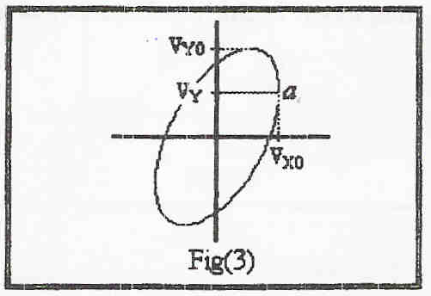
harmonic functions using the oscilloscope
we set the oscilloscope to the x-y mode
and connect the functions to the X-channel
and Y-Channel , to have a shape like that
shown in fig 3 .
Let $V_{x}=V_{x0}\text{Cos}(ωt)$ and $V_{y}=V_{y0}\text{Cos}(ωt+φ)$where $φ$is the phase shift between the two functions .
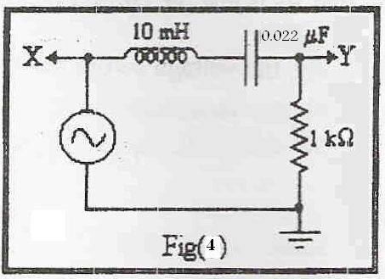
$ωt=0$at point a shown in fig3 where Vx has its maximum value ,hence:
$V_{Y}=V_{Y0}\text{Cos}(φ)$➔$φ={\text{Cos}}^{−1}(\frac{V_{Y}}{V_{Y0}})$

Procedure:
  - The circuit was connected as shown in the fig 4.
  - The phase shift was found between the driving
Voltage and the current for different frequencies .
  - Each pair of VR, VC & VL was displayed on oscilloscope screen. And measured the phase shift between each pair of them.

Data sheet:

Frequency (KHz) | T | Ф = 2pi*f*t
0.1 | 240 | 0.15
0.3 | 760 | 1.43
0.5 | 400 | 1.256
0.7 | 260 | 1.14
1.0 | 150 | 0.94
3.0 | 16 | 0.30
4.0 | 8 | 0.20
4.5 | 4 | 0.11
5.0 | 0 | 0
5.5 | 4 | 0.14
6.0 | 5.5 | 0.21
7.0 | 6 | 0.26
10.0 | 7.6 | 0.47
30.0 | 8 | 1.5
50.0 | 5.6 | 1.76
70.0 | 3.4 | 1.50
100.0 | 2.5 | 1.57

Calculations:

Phase difference is zero at resonant frequency =f0.

F0 = w/2pi
= 1/(2pi (LC)^1/2)
= 1 / 2pi((10*10^-3)(0.1 * 10^-6))^1/2

= 5 KHz

Angle between (Vl and VR) = 1.57 Rad.

Angle between (VC and VR) = 1.507 Rad.

Conclusion:

1 )The phase shift changes in a sinusoidal manner with frequency; it is zero at a certain frequency known to be the resonant frequency .

2) the voltage across inductor and the capacitor are ahead of that across the resistance or behind it by $π/2=1\text{.}\text{57}\text{rads}\text{.}$ in the RLC circuit.

As usual the error percentage and the lake of accuracy of the equipment we’ve used are the main reason of the deference between the results in the experiment and the theoretical results.

AC-powered
As Sin(x)=cos(x+$Π/2)$
The phase shifts between the current and the voltages across the circuit elements is related to $φ$ which is a function of $ω$

