If an experiment works, something has gone wrong.

Birzeit University
Physics Department
Physics 112

Experiment No.6

DAMPED OSCILLATIONS

Student’s Name: Ammar T. Ammar
Student’s No.: 1040385

Section: 7

Date: 16/4/2005
Instructor: Dr. Ziyad Izzat

 2005
Copy left reversed

Abstract:
The aim of the experiment: is to study the phenomenon of damping in a RCL circuit, and determine t_{1/2} of the damped oscillation, critical, over damping for an RLC circuit and the constant of decay, using the CRO connected to that circuit. Another aim is to distinguish between the three types of damping,

The method used: by using the oscilloscope connected to the RLC circuit, to see how the potential difference changes as a function of time.

Main results:

Theory:
The phenomenon of damped oscillations can be regarded as the equivalent of energy loss due to the frictional force in mechanics.

The charge on the capacitor in the circuit given in figure1 is given by the equation $Q(t)=A_{1}e^{λ_{+}t}+A_{2}e^{λ_{−}t}$, where A1 and A2 are constants, and
$λ_{+}=−\frac{R}{\text{2L}}+\sqrt{(\frac{R}{\text{2L}})^{2}−\frac{1}{\text{LC}}}$ and $λ_{−}=−\frac{R}{\text{2L}}−\sqrt{(\frac{R}{\text{2L}})^{2}−\frac{1}{\text{LC}}}$.

For this solution three interesting cases emerge:
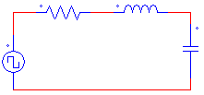

Case 1: Over damping
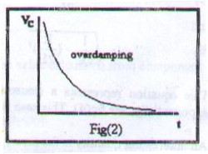
If $(\frac{R}{\text{2L}})^{2}>\frac{1}{\text{LC}}$, then both terms of Q(t) decay exponentially with time, and the voltage across the capacitor is said to be over-damping.
Figure 1

Case 2: Critical damping
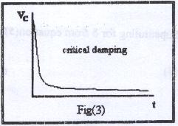
If $(\frac{R}{\text{2L}})^{2}=\frac{1}{\text{LC}}$, then + = - = -$\frac{R}{\text{2L}}$, and Q(t) = ${\text{Ae}}^{−\frac{R}{\text{2L}}t}+{\text{Bte}}^{−\frac{R}{\text{2L}}t}$. Both the charge on the capacitor plates, and consequently the voltage across them decay exponentially with time, and the voltage across the capacitor is said to be critical-damping.

Case 3: Under damping
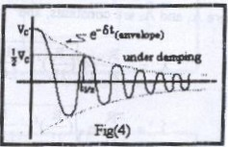
If $(\frac{R}{\text{2L}})^{2}<\frac{1}{\text{LC}}$, then the term under the square root becomes negative, and Q(t) = $Qe^{−\text{δt}}\text{cos}(ω^{'}t+θ_{0})$ where $δ=\frac{R}{\text{2L}}$ and $ω^{'}=\sqrt{\frac{1}{\text{LC}}−(\frac{R}{2L})^{2}}$.
The time at which the amplitude falls to its half is called t1/2. Which is given by $t_{\text{1/2}}=\frac{\text{2L}}{R}\text{ln2}$.

Procedure:
- 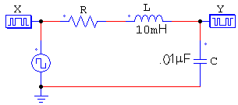Connect the circuit in figure 2
- Display the voltage across the capacitor on the CRO.
- Change the value of R to obtain over damping case; record R.
Figure 2
- Estimate t1/2 from the graph.
- Repeat the steps 3-5 to obtain the critical damping and the under damping.

Data:

After performing the experiment the following data were obtained:

Case 1: Under damping
$$R<\text{1800}Ω$$
t_{1/2}(practical) = 1.3*10⁻⁵s
t_{1/2}(theoretical) = 2L*ln2/R = 1.1*10⁻⁵ s

Case 2: Critical damping
$R=\text{1800}Ω$ (practical)
t_{1/2} = 10⁻⁵s
λ = ln2/t_{1/2} = ln2/ (10⁻⁵) = 63900s⁻¹

Case 3: Over damping
t_{1/2}(s) = 7*10⁻⁵s
λ = ln2/t_{1/2} = ln2/ (8*10⁻⁶) = 86643.39 s⁻¹

Results and conclusions:
Case 1: Under damping
$$R<\text{1800}Ω$$
t_{1/2}(practical) = 1.3*10⁻⁵s
t_{1/2}(theoretical) = 2L*ln2/R = 1.1*10⁻⁵ s

Case 2: Critical damping
$R=\text{1800}Ω$ (Practical)
t_{1/2} = 10⁻⁵s
λ = ln2/t_{1/2} = ln2/ (10⁻⁵) = 63900s⁻¹

Case 3: Over damping
t_{1/2}(s) = 7*10⁻⁵s
λ = ln2/t_{1/2} = ln2/ (8*10⁻⁶) = 86643.39 s⁻¹

After performing the experiment we come to the following conclusions:

For the under damping case; it is clear that the measured value of t1/2 is acceptable compared with the one calculated using the component values, since one should consider the fact that the scale of the CRO is small and so it is not precise.

From the other hand, one should notice the high decay constant () of the critical damping case when compared to that of the over damping case, which means that decay is faster when the circuit at the critical damping case.

The value of R is the factor on which the case of the circuit depends, when the value of R is greater than 1800Ω, the circuit is in the over damping case, when it is nearly 1800Ω it is in the critical damping stage, if it goes down, it enters the under damping case.

