

BIRZEIT UNIVERSITY
Physics Department

Physics 111

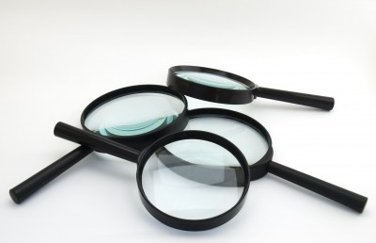

Experiment No. 5

Focal Length of a Convex Lens
………………………………………………………………………………………

Student’s Name: Lara Sami . Student’s No.: 1120139

Partner’s Name: Weam Mikkawi Partners’ No. : 1120442

Instructor: Ziad Sa'eed Section No.: 4 M

Date:5/11/2012

- Abstract:

- The aim of the experiment:
To find the value of the focal length of a convex lens.
- The method used:
by measuring the distance between the lens and the board which the object's reflection will appear on, and the distance between the lens and the illuminated object
- The main results are:

f = 16.48 ± 0.15 cm
- Theory:

When an object is placed at a distance u from a thin lens then an inverted image of the object is formed on the other side of the lens. The object's distance u and the image's distance v are related by : $\frac{1}{f}=\frac{1}{u}+\frac{1}{v}$ , where f is the focal length of the lens.
Any convex lens makes a reflection of an object which is put in front of it. For example, when an object is placed at distance (u) cm from a convex lens, an inverted image will be reflected on a board at distance (v) cm.
which is shown in the figure.
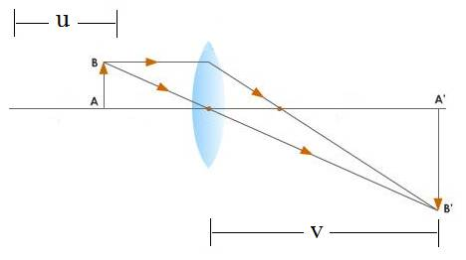
The equation that relates u and v is : $\frac{1}{f}=\frac{1}{u}+\frac{1}{v}$ , where f is the focal length of the lens defined as the distance from the lens to the point where the rays coming for infinity converge. We can rewrite the equation in another form : $\frac{1}{v}=\frac{−1}{u}+\frac{1}{f}$ . so it's obvious that the graph of $\frac{1}{v}\text{Vs}\text{.}\frac{1}{u}$ is a straight line with a slope = -1.
We can find the x-axis intercept simply by making $\frac{1}{v}=0$➔ $\frac{1}{f}=\frac{1}{u}+0$➔$\text{fx}=u$. And to find the y-axis intercept we make $\frac{1}{u}=0$➔$\frac{1}{f}=\frac{1}{v}+0$➔$\text{fy}=v$. Theoretically $\text{fy}=\text{fx}$, but experimentally $\text{fy}$maybe different from $\text{fx}$because of errors .
The focal length of the lens can be found using $f=\frac{(\text{fx}+\text{fy})}{2}$, and to find the uncertainty using $Δf=f^{2}\left(\frac{Δu}{{\bar{u}}^{2}}+\frac{Δv}{{\bar{v}}^{2}}\right)$
- Procedure:

At first, light source with exposed object, convex lens with holder, meter stick and a screen were all brought. Then the meter stick was fixed on the table, after that the lens, the illuminated object and the screen were all setup in the same straight line. Then the illuminated object was put nearly 40 cm away from the lens, and then the screen was moved until the clearest image appeared on it. After that the measurements of u and v were taken and written down in the tables. And then the lens was moved further from the object and the measurements were taken again, and this was repeated 6 times, at the end the values of $\frac{1}{u},\frac{1}{v},\left(\frac{1}{\bar{u}}\right),\left(\frac{1}{\bar{v}}\right),\bar{u}$and $\bar{v}$were calculated and written down in the tables.
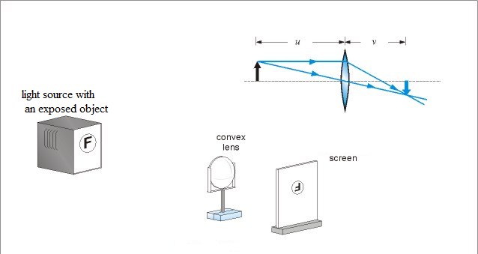
- Data:

NO. | 1 | 2 | 3 | 4 | 5 | 6 | AVERAGE
U(cm) | 80. | 70. | 60. | 50. | 40. | 30. | 55
V(cm) | 21.2 | 21.6 | 22.6 | 24.5 | 27.6 | 36.2 | 25.6
1/u cm⁻¹ | 0.012 | 0.014 | 0.017 | 0.020 | 0.025 | 0.033 | 0.020
1/V cm⁻¹ | 0.0472 | 0.0463 | 0.0442 | 0.0408 | 0.0362 | 0.0276 | 0.0403

ΔU ≈ 0.3 ΔV ≈ 0.3
- Calculations:

From graph; X-axis intercept = 62.5× 10⁻³ cm⁻¹

Y-axis intercept = 59× 10⁻³ cm⁻¹

$f_{1}$= $\frac{1}{0\text{.}\text{059}}=\text{16}\text{.}\text{95}\text{cm}$ $f_{2}$ =$\frac{1}{0\text{.}\text{0625}}=\text{16}\text{.}\text{00}\text{cm}$

$\overset{−}{f}$= $\frac{f1+f2}{2}=\text{16}\text{.}\text{48}\text{cm}$

Calculate Δf;

$Δf=f^{2}\left(\frac{Δu}{{\bar{u}}^{2}}+\frac{Δv}{{\bar{v}}^{2}}\right)$=$\text{16}\text{.}{\text{48}}^{2}\left(\frac{0\text{.}3}{{\text{55}}^{2}}+\frac{0\text{.}3}{\text{25}\text{.}6^{2}}\right)=0\text{.}\text{15}\text{cm}$

Δf=0.15 cm

f = 16.48 ± 0.15 cm

Results and conclusion:

f = 16.48 ± 0.15 cm

the true value of the focal length of the convex lens
f = 16.40 cm while my result is f = 16.48 cm.
Discrepancy (D) = |16.40 – 16.48| = 0.08 cm.
and it must be < 2Δf
0.08 < 0.30 so my result is accepted .
There are some systematic errors such as :
Maybe the illuminated object wasn't put on (0 cm) accurately and this affected the taken measurements thus the results (u, v, f). Also it's so difficult to form a one to one obvious image, so this affected v and so the result.

NOTE: The letter appearing on our lens was B

