`
BIRZEIT UNIVERSITY
Physics Department

Physics 111

Experiment No. 8
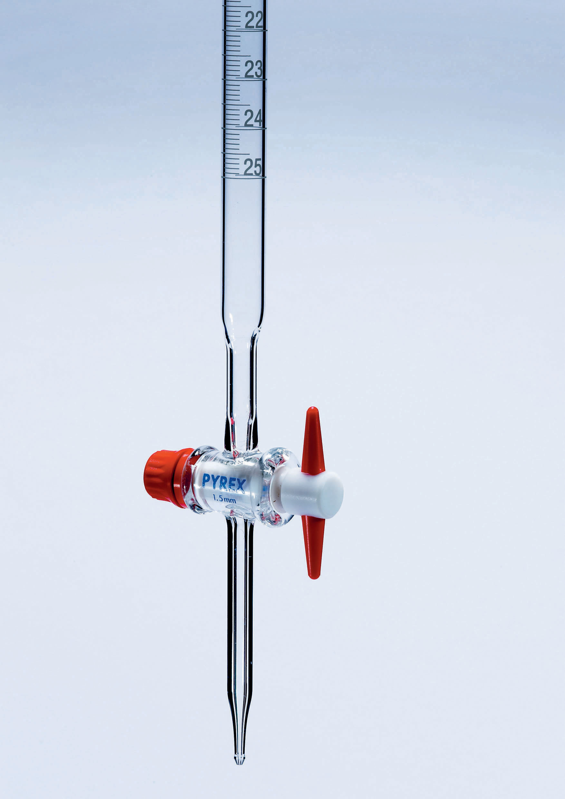

Half-Life of a Draining Water Column ………………………………………………………………………………………
Student’s Name: Lara Sami . Student’s No.: 1120139

Partner’s Name: Weam Mikkawi Partners’ No. : 1120442

Instructor: Ziad Sa'eed Section No.: 4 M

Date:26/11/2012
- Abstract:

- The aim of the experiment:

To find the half-life of the draining of a draining water column.
2)The method used:
by measuring the height at burette at different times.

3)The main results are:

t_{½}= 63.5 ± 1.2 (h vs. t graph)

t_{½}= 58 (Ln (h) vs. t graph)

- Theory:
If we consider the burette at t=0, the tube contains water to height h₀, when the value is opened, the water will start draining out of the tube, and that called "draying of the water column". So, the rate of the decay of the water column proportional to its height : $\frac{−\text{dh}}{\text{dt}}∝h(t)$. As a result $\frac{−\text{dh}}{\text{dt}}=λh(t)$(where λ is a constant). If we multiplied the previous equation by dt and divided by h(t) we'll get : $\frac{\text{dh}}{t}=−λh(t)$. Then if we integrate both sides of the equation, we'll get :
$\int{\frac{\text{gh}}{h}=\int{λd(t)→\text{ln}h(t)−\text{ln}h_{0}}=−λt}$$\text{or}\frac{\text{ln}h(t)}{h_{0}}=−λt→h(t)=h_{0}e^{−λt}$ (where the equation give the height of the water h(t) at any time t, λ is the decay constant).

We can obtain a relation between t_{1/2} and λ :
$$\frac{h_{0}}{2}=h_{0}e^{−λt}→−\text{ln}(2)=−{λt}_{1/2}→t_{1/2}=\frac{\text{ln}(2)}{λ}=\frac{0\text{.}\text{693}}{λ}$$

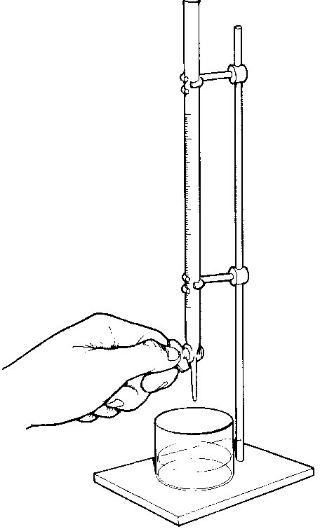

- Procedure:
In our experiment the total burette length h₀ was measured in burette units, h0 = 50 unites +D (in burette units), and the distance D was measured in units of cm then it was converted to burette units. Then, the burette was filled with water using the funnel. Also, the value was adjusted such the water was drained in about 2.5 minutes. The adjustment was made just one time. After that, the reading of the burette in the first 16 times was measured every 5 seconds and then by 10 seconds, and a finger tip was used to close the opening of the burette after each measurement. Finally, the burette was filled again with water to the same initial height. Then, step 2 was repeated again for two more times. At the end the measurements were written down in the table.

- Data:

Total burette length h₀ = in burette units (u)

Time  (sec.) | Burette reading (u) |  | $$\bar{b}$$ | h =  h₀-$\bar{b}$ | Ln (h)
 | b₁ | B₂
0 | 0 | 0 | 0 | 50.00 | 3.912
10 | 3.90 | 3.40 | 3.650 | 46.35 | 3.836
20 | 7.80 | 7.50 | 7.650 | 42.35 | 3.746
30 | 11.8 | 11.3 | 11.55 | 38.45 | 3.649
40 | 15.9 | 15.1 | 15.50 | 34.50 | 3.541
50 | 19.5 | 19.0 | 19.25 | 30.75 | 3.426
60 | 22.4 | 22.6 | 22.50 | 27.50 | 3.314
70 | 26.3 | 26.2 | 26.25 | 23.75 | 3.168
80 | 29.0 | 28.5 | 28.75 | 21.25 | 3.056
90 | 32.1 | 31.0 | 31.55 | 18.45 | 2.915
100 | 34.2 | 34.5 | 34.35 | 15.65 | 2.750
110 | 37.3 | 37.5 | 37.40 | 12.60 | 2.534
120 | 39.9 | 39.6 | 39.75 | 10.25 | 2.327
130 | 42.2 | 42.3 | 42.25 | 7.750 | 2.048
140 | 44.5 | 44.8 | 44.65 | 5.350 | 1.677
150 | 46.6 | 46.7 | 46.65 | 3.350 | 1.209

- Calculations:

- From h vs. t graph paper (Obtain 6 values for t_{½} )

t_{½} (sec) | 68 | 65 | 64 | 63 | 61 | 60
The average value of t_{½} is:

t_{½=} 63.5 s

Δt_{½} = σ_{m}(t_{½_}) =1.2 s

2) From ln (h) vs. t graph:

Slope = ـــ λ =-0.0126

t_{½} = 55

- Results and conclusion:

t_{½}= 63.5 ± 1.2 (h vs. t graph)

t_{½}= 58 (Ln (h) vs. t graph)

Discrepancy : |58 – 63.5| > 2.4 ➔5.5 > 2.4 so my result is not accepted.
There were many systematic errors in our experiment. Such as when we took the measurements of the burette we closed the small hole at the bottom of the burette with the tip of our finger. Also, we didn't take the measurements after 10 seconds exactly each time also burette wasn’t very clean so that there were some bubbles .
Also the graphs weren’t very accurate

