
Physics Department
Physics 112

Prelab.9
Preliminary Laboratory Questions sheet

IMPEDANCE AND REACTANCE
Name: AL-mutasem bellah Omar
St no.:1090349

- The resistive reactance of the resistor is R. What is the capacitive reactance,and the inductive reactance.
The capacitive reactance is The inductive reactance
- The frequency of a wave is 5000 HZ. What is the angular frequency ω of the wave.
- Draw two sinusoidal waves with phase shift equal zero.

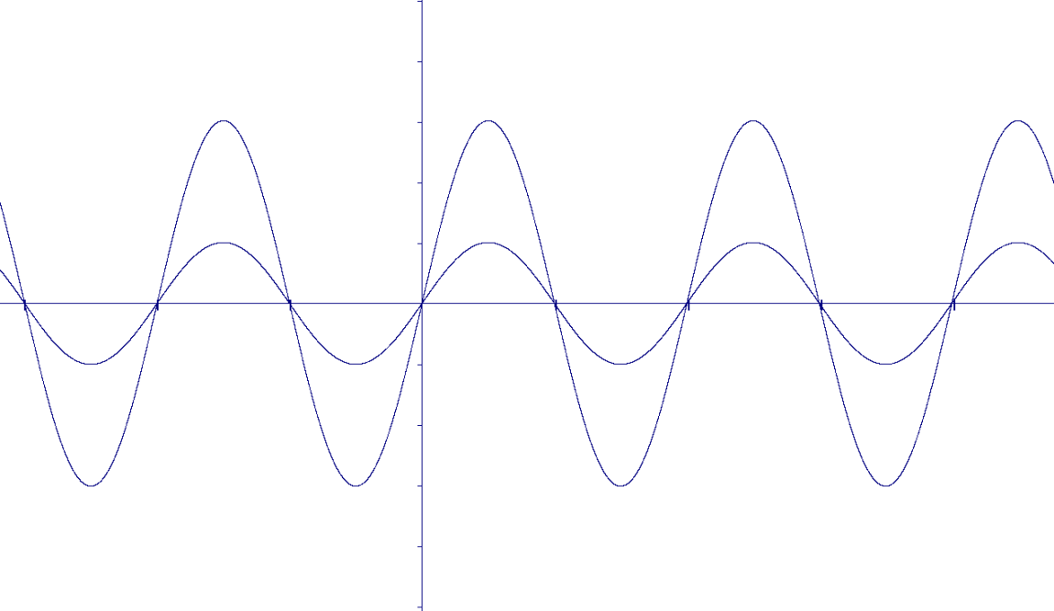

- Suppose that the angular frequency(ω) of the signal generator is 10000 rad/s. calculate the phase shift between the voltage on the resistor and the input voltage. in an –RLC series circuit with R=1 KΩ, L=10 mH , C=0.1 µF.
When the phase shift is zero between the current and the driving voltage in the RLC series circuit in the previous question? What is the current at this
