

**PHYSICS 132**

**Homework # 4 2nd. Semester 2015-16**

**NAME: STUDENT ID#:**

1. A coaxial cable consists of a 2.0-mm-diameter inner conductor and outer conductor with interior diameter 1.0 cm. A 100-mA current flows down the inner conductor. The thickness of the walls of the outer conductor is 0.5-mm. A200-mA current flows back along the outer conductor. Find the magnetic field strength (a) 0.50 mm, (b) 5.0 mm, (c) 1.2 cm, and (d) 2.0 cm from the cable axis.
$$R=1 mm=1×{10}^{-3} m$$

$$R_{in}=0.5 cm=0.5×{10}^{-2} m$$

$$R_{out}=0.55 cm=0.55×{10}^{-2} m$$

2. $r=0.50 mm=0.5 ×{10}^{-3} m$ (see figure1)

$$\oint{\vec{B}.d\vec{s}}=μ_{°}I_{enc}$$

$$\oint{B.ds\cos{0}}=μ_{°}I_{enc}$$

$B\left(2πr\right)=μ_{°}I_{enc}$…………………...…………………………………………….(1)

Note: I take the + in the outward direction

The current density $\left(J\right)$ is constant (uniform current), thus

$I_{enc}=JA_{enc}$, where $A_{enc}$: the area enclosed by Amperian loop

$$I_{enc}=J\left(πr^{2}\right)$$

$$I_{enc}=\frac{I_{1}}{πR^{2}}\left(πr^{2}\right)$$

$I_{enc}=\frac{r^{2}}{R^{2}}I_{1}$ substituting this in (1)

$$B\left(2πr\right)=μ_{°}\frac{r^{2}}{R^{2}}I_{1}$$

$$B=\frac{μ_{°}rI_{1}}{2πR^{2}}=\frac{\left(4π×{10}^{-7}\right)*\left(0.5×{10}^{-3}\right)*\left(100×{10}^{-3}\right)}{2π{\left(1×{10}^{-3}\right)}^{2}}=1×{10}^{-5} T$$

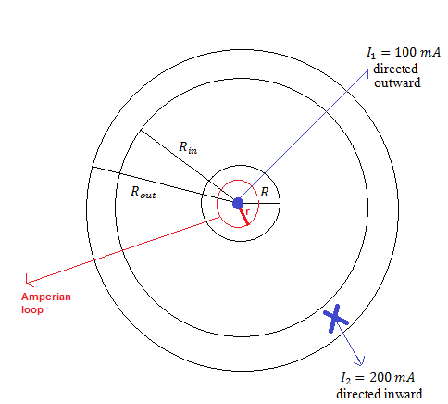

Figure1

1. $r=5 mm=5 ×{10}^{-3} m$ (see Figure2)

Note here $r=R_{in}$

$$\oint{\vec{B}.d\vec{s}}=μ_{°}I_{enc}$$

$$\oint{B.ds\cos{0}}=μ_{°}I_{enc}$$

$$B\left(2πr\right)=μ_{°}I_{enc}$$

$$B\left(2πr\right)=μ_{°}I_{1}$$

$$B=\frac{μ_{°}I_{1}}{2πr}=\frac{\left(4π×{10}^{-7}\right)*\left(100×{10}^{-3}\right)}{2π\left(5×{10}^{-3}\right)}=0.4×{10}^{-5} T$$

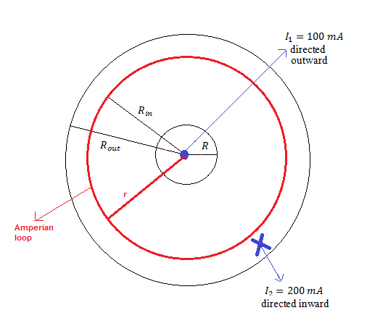

Figure2

1. $r=1.2 cm=1.2 ×{10}^{-2} m$ (see Figure3)

$$\oint{\vec{B}.d\vec{s}}=μ_{°}I_{enc}$$

$$\oint{B.ds\cos{180}}=μ_{°}\left(I_{1}-I_{2}\right)$$

Note here $I_{enc}$ directed inward

$$-B\left(2πr\right)=μ_{°}\left(I_{1}-I_{2}\right)$$

$$B\left(2πr\right)=μ_{°}\left(I_{2}-I_{1}\right)$$

$B=\frac{μ_{°}\left(I_{2}-I_{1}\right)}{2πr}=\frac{\left(4π×{10}^{-7}\right)*\left(200×{10}^{-3}-100×{10}^{-3}\right)}{2π\left(1.2×{10}^{-2}\right)}=0.167×{10}^{-5} T$

$r=2 cm=2 ×{10}^{-2} m$

Same as in ©

$B=\frac{μ_{°}I_{1}}{2πr}=\frac{\left(4π×{10}^{-7}\right)*\left(200×{10}^{-3}-100×{10}^{-3}\right)}{2π\left(2×{10}^{-2}\right)}=0.1×{10}^{-5} T$

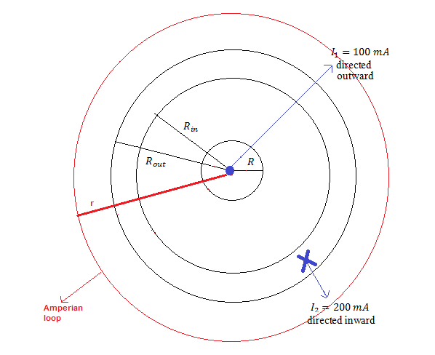

Figure3

1. An electric motor contains a 300-turn circular coil 5 cm in diameter in a uniform magnetic field $\vec{B}=2\hat{i} T$. If a $100 A$ current passes through the coil, it rotates so that angle between the plan of the coil and the magnetic field is ${30}^{°}$.

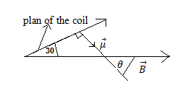

1. What’s the magnitude of the coil’s dipole moment?
$$μ=NIA=NIπR^{2}=300*100*π*\left({0.025}^{2}\right)=58.9 A.m^{2}$$

2. What is the potential energy of the magnetic dipole?

$\vec{μ}$ perpendicular to the plan of the coil

Note that the angle between $\vec{μ}$ and $\vec{B}$: $θ=90-30=60$

$$U=-\vec{μ}.\vec{B}=-μB\cos{θ}=-58.9*2*\cos{60}=-58.9 J$$

1. What is the magnitude of the torque bone by the magnetic field on the coil?

$$τ=μB\sin{θ}=58.9*2*\sin{60}=102 N.m$$