13) A uniform electric field is increasing at $1.5 (V/m)/μs$. Find the displacement current through a $1 {cm}^{2}$ area perpendicular to the field.

$$I_{d}=ϵ_{°}\left|\frac{dΦ_{E}}{dt}\right|$$

$$I_{d}=ϵ_{°}\left|\frac{d}{dt}\left(\vec{E}.\vec{A}\right)\right|$$

$$I_{d}=ϵ_{°}\frac{d}{dt}\left(EA\right)$$

$$I_{d}=ϵ_{°}A\frac{dE}{dt}$$

$$I_{d}=\left(8.85×{10}^{-12}\right)*\left(1×{10}^{-4}\right)*\left(1.5×{10}^{6}\right)=1.3×{10}^{-9}=1.3 nA$$

Note: I find only the magnitude of

34. A parallel-plate capacitor has circular plates with radius 50 cm and spacing 1.0 mm. A uniform electric field between the plates is changing at the rate of 1.0 MV/m.s. Find the magnetic field between the plates (a) on the symmetry axis, (b) 15 cm from the axis, and (c) 150 cm from the axis.

using Ampere’s law with Maxwell correction

$$\int{\vec{B}.d\vec{s}}=μ_{°}I_{°}+μ_{°}ϵ_{°}\frac{dΦ_{E}}{dt}$$

Note: here no steady current, so $I_{°}=0$. Thus,

$$\int{\vec{B}.d\vec{s}}=μ_{°}ϵ_{°}\frac{dΦ_{E}}{dt}$$

$$\int{Bds}\cos{0}=μ_{°}ϵ_{°}\frac{dΦ_{E}}{dt}$$

$$B\left(2πr\right)=μ_{°}ϵ_{°}\frac{dΦ_{E}}{dt}$$

$$B\left(2πr\right)=μ_{°}ϵ_{°}\frac{d}{dt}\left(\vec{E}.\vec{A}\right)$$

$$B\left(2πr\right)=μ_{°}ϵ_{°}\frac{d}{dt}\left(EA\cos{0}\right)$$

$$B\left(2πr\right)=μ_{°}ϵ_{°}A\frac{dE}{dt}$$

For $r<R$

$$B\left(2πr\right)=μ_{°}ϵ_{°}\left(πr^{2}\right)\frac{dE}{dt}$$

$B=\frac{μ_{°}ϵ_{°}r}{2}\frac{dE}{dt}$ (1)

For $r>R$

$$B\left(2πr\right)=μ_{°}ϵ_{°}\left(πR^{2}\right)\frac{dE}{dt}$$

$B=\frac{μ_{°}ϵ_{°}R^{2}}{2r}\frac{dE}{dt}$ (2)

1. on the symmetry axis (r = 0)

Note here $r<R$. Thus, using eq. (1) above we get

$$B = 0$$

1. 15 cm from the axis (r =15 cm) (see the figure)

Note here $r<R$. Thus, using eq. (1) above we get

$$B=\frac{μ_{°}ϵ_{°}r}{2}\frac{dE}{dt}$$

$$B=\frac{\left(4π×{10}^{-7}\right)*\left(8.85×{10}^{-12}\right)*\left(0.15\right)}{2}*\left(1×{10}^{6}\right)=8.34×{10}^{-13} T$$

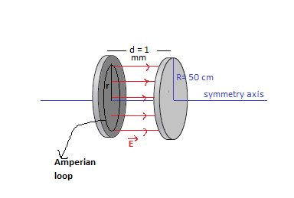

1. 150 cm from the axis (r =150 cm) (see the figure below)

Note here $r>R$. Thus, using eq. (2) above we get

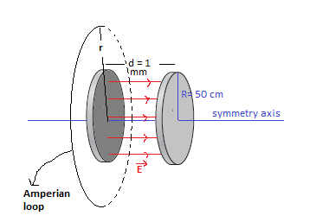

35) An electric field points into the page and occupies a circular region of radius 1.0 m, as shown in Fig. 29.14. There are no electric charges in the region, but there is a magnetic field forming closed loops pointing clockwise, as shown. The magnetic-field strength 50 cm from the center of the region is $2.0 μT$. (a) What’s the rate of change of the electric field? (b) Is the electric field increasing or decreasing?

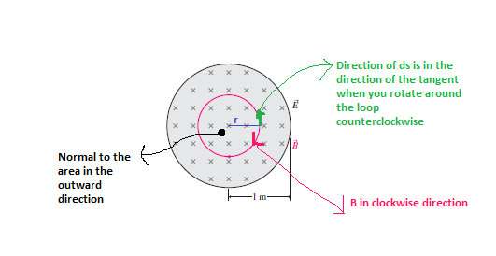

Note: you will use Ampere’s law with Maxwell’s modification

$$\oint{\vec{B}.d\vec{s}}=μ_{°}I+μ_{°}ϵ_{°}\frac{dΦ_{E}}{dt}$$

In this case $I=0$, thus

$$\oint{\vec{B}.d\vec{s}}=μ_{°}ϵ_{°}\frac{dΦ_{E}}{dt}$$

$$\oint{\vec{B}.d\vec{s}}=μ_{°}ϵ_{°}\frac{d}{dt}\left(\vec{A}.\vec{E}\right)$$

$$\oint{\vec{B}.d\vec{s}}=μ_{°}ϵ_{°}\frac{d}{dt}\left(A.E\cos{180}\right)$$

$$\oint{\vec{B}.d\vec{s}}=-Aμ_{°}ϵ_{°}\frac{dE}{dt}$$

$$\oint{B.ds\cos{180}}=-Aμ_{°}ϵ_{°}\frac{dE}{dt}$$

$$-\oint{Bds}=-Aμ_{°}ϵ_{°}\frac{dE}{dt}$$

$$B\left(2πr\right)=\left(πr^{2}\right)μ_{°}ϵ_{°}\frac{dE}{dt}$$

$$\frac{dE}{dt}=\frac{2B}{μ_{°}ϵ_{°}r}=\frac{2*\left(2×{10}^{-6}\right)}{\left(4π×{10}^{-7}\right)*\left(8.85×{10}^{-12}\right)*\left(0.5\right)}=+7.2×{10}^{11} \frac{V}{m.s}$$

Note: the + sign indicates that the electric field is increasing in the inward direction

Note here: I always take the positive in the counterclockwise direction

Also, to take the normal to area I always rotate my fingers counterclockwise, so in the case of problem 35 the normal to area is out of the page. As the electric field in directed into the page the angle between them is 180. The angle is 180 between $\vec{B}$ and $d\vec{s}$ because of the same reason (see the figure above).

46. Use the fact that sunlight intensity at Earth’s orbit is $1368 W/m^{2}$ to calculate the Sun’s total power output.

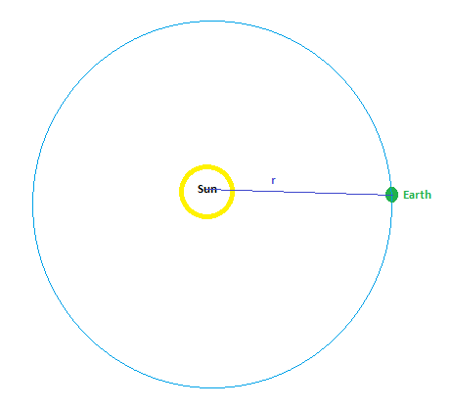

$$P=S*A$$

$$P=S*\left(4πr^{2}\right)$$

Where

$P$: total power,

$S$: sunlight intensity at Earth’s orbit.

$r$: the radius between the Sun and the Earth.

50) Find the peak electric and magnetic fields 1.5 m from a 60-W lightbulb that radiates equally in all directions.

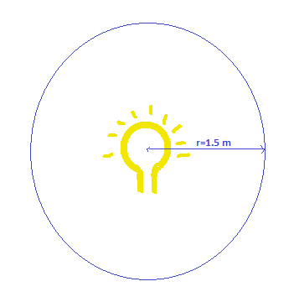

$$\overline{S}=\frac{E_{P}^{2}}{2μ_{°}c}$$

But

$$\overline{S}=\frac{P}{A}$$

Thus,

$$\frac{P}{A}=\frac{E_{P}^{2}}{2μ_{°}c}$$

$$E_{P}=\sqrt{\frac{2μ_{°}cP}{A}}=\sqrt{\frac{2μ_{°}cP}{4πr^{2}}}=\sqrt{\frac{2*\left(4π×{10}^{-7}\right)*\left(3×{10}^{8}\right)*\left(60\right)}{4π\left({1.5}^{2}\right)}}=40 \frac{V}{m}$$

$$E_{P}=cB_{P}$$

$$B_{P}=\frac{E_{P}}{c}=\frac{40}{3×{10}^{8}}=1.3×{10}^{-7} T$$