Birzeit University
Physics Department
Physics 112

Experiment No.1

Linear and non-linear Circuit Components

Student’s Name: Al-mutasem bellah Omar
Student’s No.: 1090349

Partner’s Name: Jihad Abdullah
Partner’s No.: 1090468

Section: 5

Date: 18\01\2010

Instructor: Dr. Ghassan Andoni

Abstract:

- The aim of this experiment is to check whether the electronic elements involved in this experiment are linear or non-linear conductors.
- The method used is direct measurements of: Voltage (potential difference) and electrical current through those components, then doing the proper calculations and comparisons.
- The main result is :
The resistor is a linear component, whereas the diode and the light bulb aren’t.
R=515$Ω$ R:the resistance

Theory:

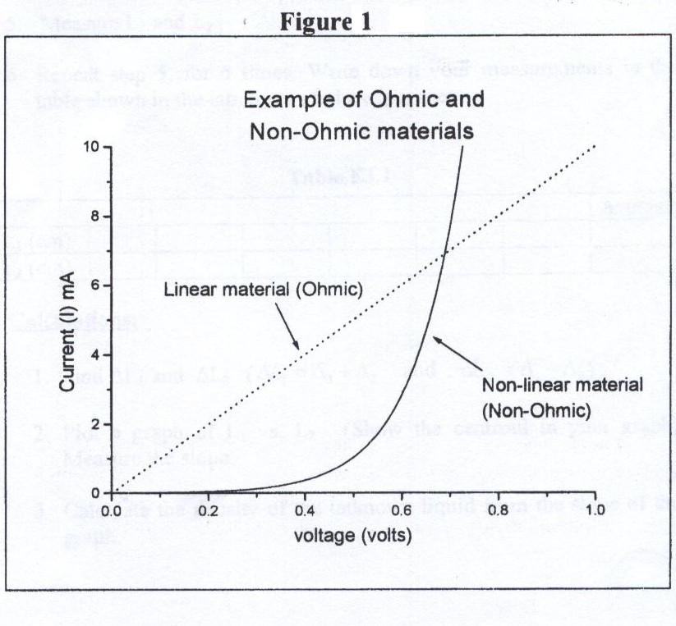
I-V characteristic is the relation between the current passing through a circuit component and the voltage difference between its terminals. And when such a relation is plotted; components that have a straight line I-V characteristic are called linear components. And the slope of this representative graph is the value (1/resistance) of the component. And since linear components’ graphs are straight lines, then this value is a constant and so is the value of the resistance. However, most resistors used in laboratory are linear carbon resistors.
On the other hand, components that don’t posses straight line I-V characteristics are called non-linear components. And example is a diode; a device frequently used in electronic circuits to provide on way current paths.
The relation between the current (I) passing through a semi conducting diode and the potential difference (V) between its terminals is usually given by the equation:
$$I=I_{0}(e^{V/K}−1)$$
Where $I_{0}$ is called the saturation current, K is a function of temperature only. Therefore a semiconducting diode has a variable resistance that depends on the value of the current passing through it.
Another example of a component that possesses non linear I-V characteristics is the light bulb, where the tungsten wire converts the electrical power to heat energy. As a result light is emitted. The resistivity and thus the resistance of the conducting material, depends on the temperature of that material according to
$$R=R_{0}\left[1+α(T−+T_{0})\right]$$
Where ($R_{0}$) is the resistance at temperature ($T_{0}$), and $α$ is the temperature coefficient of resistivity. And since the resistivity of the tungsten changes with temperature, then the resistance changes in a similar manner, causing the bulb to have non linear I-V characteristics.

Procedure:

Apparatus: DC voltage source, one carbon resistor, a silicon diode, a light bulb, a decade resistor box, connecting wires, 2 digital multi meters, and a connecting board.

- A circuit like the one shown in the figure was setup leaving the element’s place empty. And the multi-meters were used as a voltmeter and an ammeter.
- The resistance was put as the element and the readings of the ammeter and the voltmeter were taken.
- The decade resistor box was justified so as to give as different values of the voltage and current. And the new values were read.
- The previous 2 steps were repeated with the Diode, and the light bulb put as elements.
- The obtained data were entered in the tables shown below.

➔ While changing the elements, it was made sure that the electric current passing through the diode and the light bulb doesn’t exceed 30mA and 300mA respectively.

Data:

Carbon Resistor |  | Si Diode |  | Light bulb (low currents) |  | Light Bulb (high currents)
V (Volts) | I (mA) | V (Volts) | I (mA) | V (Volts) | I (mA) | V (Volts) | I (mA)
0.20 | 0.39 | 0.47 | 0.02 | 0.01 | 18.20 | 0.6 | 152.9
0.40 | 0.77 | 0.52 | 0.11 | 0.02 | 26.20 | 1.0 | 197.2
0.61 | 1.18 | 0.54 | 0.20 | 0.03 | 28.60 | 1.65 | 251
0.81 | 1.55 | 0.56 | 0.38 | 0.04 | 40.40 | 2.02 | 279
1.01 | 1.93 | 0.60 | 0.89 | 0.05 | 46.70 | 2.5 | 313
1.20 | 2.29 | 0.63 | 1.70 | 0.06 | 50.70 | 3.09 | 351
1.40 | 2.68 | 0.65 | 2.90
1.59 | 3.03 | 0.68 | 6.70
1.80 | 3.44 | 0.71 | 13.90
2.04 | 3.90 | 0.74 | 29.70

➔ Note that significant figures, in the value of the resistance, were
ignored in these tables. And that’s because the values are taken only to have an idea about the overall relation.

Calculations:
From the obtained values above, the I-V characteristics of each element can be graphed as follows:

Results and Conclusions:
After performing the experiment we come to the following conclusions:

- The value of the resistance that we got experimentally, is quite reasonable, since it comes within the range of values we obtained from the color code.R=510
- According to the three graphs obtained, we come to the conclusion that the carbon resistor is a linear material and thus obeys ohm’s law (V=IR), where as the Diode and the light bulb are non linear components, and don’t obey Ohm’s law.
- The diode is one of the most important electronic devices that helped increase the accuracy of electronic circuits, and reduce the size of them. And among it’s applications are : Radio demodulation, Logic gates , Power conversion , and Over-Voltage Protection.
- When measuring the values of the Voltage and electrical current, we are ought to avoid taking measurements near the minimum values of the grading since measurements near those end points cause us problems.
- We can increase our certainty by using finer scales on the multi meter.
- When connecting a circuit, it is preferred to connect the resistors and instruments that should be connected in series first, then connect the rest of the circuit.
- Temperature is one of the most effective factors that affect the resistance. Which changes inversely proportional with it. And from this fact came the idea of super conductors, where the temperature is decreased in order to get almost zero resistances, and therefore use the greatest amount of the electric power.

