**Physics 112 Data Sheet 4**

**Exp.#4: Network analysis 2: The Thevenin and Norton techniques**

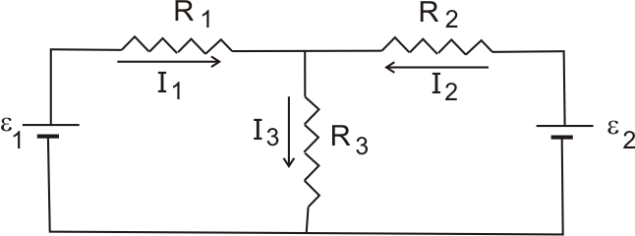

In this experiment we will use Thevenin and Norton techniques to measure I1 and I3 in the network shown in fig1:

R1= 2 kΩ, R2= 3.3 kΩ, R3= 6.2 kΩ, ε1= 10 V, ε2= 12 V.

Make use of the Preliminary Exercise to fill the theoretical values

**A) When I1= IL**

|  |  |  |
| --- | --- | --- |
| 1) | experiment | theory |
| Req1 |  |  |
| εeq1 |  |  |
| Ieq1 |  |  |

2) Construct **Thevenin** equivalent circuit:

|  |  |  |
| --- | --- | --- |
|  | experiment | theory |
| IL1 |  |  |

3) Construct **Norton** equivalent circuit

|  |  |  |
| --- | --- | --- |
|  | experiment | theory |
| IL1 |  |  |

**A) When I3= IL**

|  |  |  |
| --- | --- | --- |
| 1) | experiment | theory |
| Req3 |  |  |
| εeq3 |  |  |
| Ieq3 |  |  |

2) Construct **Thevenin** equivalent circuit:

|  |  |  |
| --- | --- | --- |
|  | experiment | theory |
| IL3 |  |  |

3) Construct **Norton** equivalent circuit:

|  |  |  |
| --- | --- | --- |
|  | experiment | theory |
| IL3 |  |  |