Physics 112
Preliminary Laboratory Questions Experiment 2
: Source , Internal Resistance, Loading Problems and Impedance Matching
Name : mo3 omar No. : 1090349

- Show that the power P developed across a resistance R is P=I²R, where I is the current flowing across the resistance.

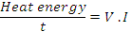

- Define the emf of a voltage source.

It is the short of electromotive force that characterize the voltage force and which is the open circuit voltage difference between its terminals and the maximum value of the current it can deliver to a short circuit .

- Define the internal resistance of a voltage source.

It is a resistance that each real voltage source is assigned with and it has a symbol .
- What is meant by;”loaded source”?.

The case in which a consider amount of power is consumed inside the source and converted to useful heat energy .

- Show how source loading is avoided?

By choosing is recommended .
- In the experiment you do not measure the actual internal resistance of the source. Why. Explain in detail.

Because and substituted in the equation :
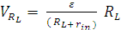
and in this case it could be neglected .

- For the circuit you use in the experiment find an expression for the power developed across the load resistance.

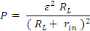
- If you vary the load resistance, when the power developed across the load resistance is maximum? Verify by using elementary calculus.

From the last equation :
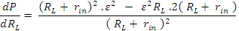
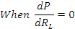

- What we call the situation reached in question 8, and why?

It is called impedance matching . Because transferring maximum power to the load resistance .

