Abstract :

The aim of experiment is to check the two theorem, the thevenin and Norton techniques . using this two theorem in this electric circuit and find ( Ieq ) ,( Eeq ) , Req ,IL , by using this theorem and then a measuring this value and compared it with the value that calculated by using theorem . the result of this experiment was :
( Ieq )= 14.9 / Req= 657 / I3= 1.85 .

THEOREM :

* Thevenins theorem states that any network of resistors and supplies having two at put terminals can we replaced by series combination of a voltage source ( Eeq ) and a resistors (Req) .
Thevenins techniques is especially important in ablating the current passing through and the voltage across any resistor ( ab)

To find the Eeq and :
- remove Rl and and calculate the voltage difference at the network terminal .
- remove Rl kill all the square with network through replacing voltage sources by short circuits and current source by open circuit and calculate equivalent resistance Req .
- Construct thevenins equivalent circuit and calculate the current passing through and the voltage drop across Rl .

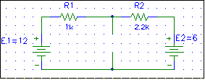
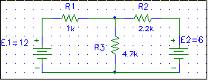
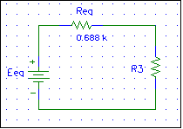

* Norton suggest similar techning that guess along the following to find Req :

- use exactly the same procedure used by thevenins to find Req .
- replace Rl by a short circuit ( wire ) and calculate the current passing through wire , call it (Ieq ) .
- construct Norton's equivalent circuit using a current source and parallel resistance , calculate the current passing through and the voltage difference across Rl . those should be the same value at tained in org network..

- using thevenins and Norton equivalent circuit techning to find the value off current :

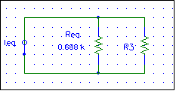
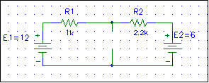

* thevenins :

Remove Rl and calculate Req = R1 ⎜⎜ R2 = R1*R2 / R1 +R2 ,
Calculate as following using kirchoffs loop :

E1- E2 = I( R1+R2)
= E1-I*R1
= E1 – (E1-E2)*R1 / R1+R2
I R2 = Eeq / Req + R2 .

* Norton's :

Ieq = I1 +I2 ============ Ieq = E1/R1 + E2/R2 .

– IRL = IRL * RL ========= IRL= Ieq * Req / Req + RL .

Apparatus :

Two voltage supplies circuit board
Digital MultiMeter three carbon resistors .

Procedure :

- connect the circuit shown in figure .
- remove R2 kill both source and measure the value of R2 .
- connect the sources back and measure ( Ieq ).
- Replace R2 by a short circuit and measure Ieq .
- Construct thevinins equivalent circuit and measure IRL .
- Connect Norton equivalent circuit .

CALCULATION ;

Theoretical value thevenins circuit :

Req = R1*R2 / R1+R2 = ( 1*2.2) * 10 / ( 1+ 2.2) *10 = 688

Eeq = E1 – ( E1-E2) *R1 / R1 +R2 = 12– (12 -6)*10 /(1+2.2)*10

= 10.13 V
IRL = I3 = Eeq / Req + R3 = 10.13/(0.688 + 4.7 )*10 = 1.88 mA

Theoretical value Norton's circuit :

Req = R1*R2 / R1+R2 = ( 1*2.2) * 10 / ( 1+ 2.2) *10 = 688

Ieq = E1/R1 +E2/R2 = 12/10 + 6/2.2*10 = 14.73 mA

I3 = Ieq* Req / Req + R3 = (14.73 * 0.688)./( 0.688 + 4.7)
= 1.88 mA

Resulted and conclusion :

After the experiment was finished we towed that the value of

Ieq = 14.9

Eeq = 10.2

Req = 657

I3 = 1.85

And this values nearly equal the values that we were by using the two theorem . but there was some after current through wire as from the machines .

