Birzeit University
Physics Department
Physics 112

Experiment No.4

NETWORK ANALYSIS II
The Thevenin and Norton techniques

Student’s Name: Almutasem bellah Omar
Student’s No.: 1090349

Partner’s Name: Jihad Abdullah
Partner’s No.: 1090468

Section: 5

Date: 08-02-2010

Instructor: Dr. Ghassan Andoni

Abstract:

The aim of the experiment: is to verify Thevenin and Norton techniques. And to find the current passing through a resistance, or the voltage between its terminals.

The method used: by comparing the value of the current passing each resistant measured using the ammeter with values we calculate using the mentioned laws. (i.e. by employing the equivalent circuit technique of Thevenin and Norton.)

Main results:

I1= …......................................... , I_{2=……………………………………. ,} I_{3 = ………………………………………..}

V_{1=……………………………..} , V_{2=…………………………………...} , V_{3=………………………………………...}

Theory:

The techniques of Thevenin and Norton are used for more complicated circuits than those for which we use Kirchhoff's Laws and the Superposition Principle.

Thevenin's Technique:
"Any network of resistors and supplies having two output terminals can be replaced by a series combination of a voltage source and a resistor ."
This means that, with Thevenin's theorem, we can calculate the current passing across any resistor in a complicated network.

Thevenin's technique is applied as the following states:

- is calculated by removing (the resistor across which passes the current we want to calculate) and connected a voltmeter in it’s place. The voltmeter's reading will be .
- is calculated by removing and the two voltage sources in the network, and replacing them with an ohmmeter. The ohmmeter will read the equivalent resistance to the two (or more) resistances that are in the circuit.
- Thevenin's equivalent circuit is constructed by connecting the equivalent voltage source and the equivalent resistance in series with , and then measuring the current passing through .

The measured value of the current should be the same as the value would be had it been passing through the resistance in the originally constructed circuit.

The original circuit:
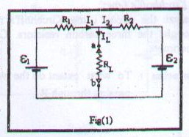

To calculate , we replace with a voltmeter:

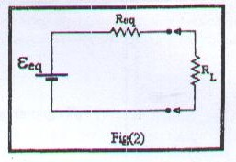
To calculate , we replace both and with shorts, and with an ohmmeter.

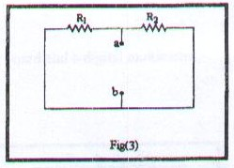

Thevenin's Circuit:
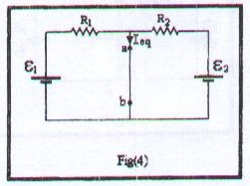

Norton Technique:

- is calculated the same way as in Thevenin Technique.
- is calculated by replacing with an ammeter.
- A current source suppliant a current with the value of is connected with a parallel , which is also connected in parallel with . The current passing through is then measured.

The current's value should be the same as it's value that was given by Thevenin Technique, Kirchhoff's Laws, the Superposition Principle and the original circuit.

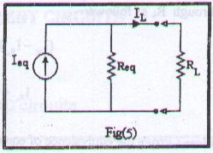

The reading of the ammeter gives the value of

Norton's Circuit:

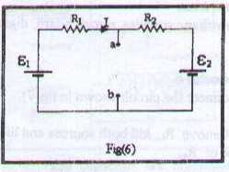

But since there are no available current source, it can be replaced by a voltage source that gives the same current as the current source would give (which is in this case).

Procedure:

- , , are calculated as mentioned above.
- Thevenin's circuit is connected, and is measured.
- Norton's circuit is connected and is measured.

Data:
After performing the experiment the following data were obtained:

Thevenin equivalent circuit |  |  | Norton equivalent circuit
When I₁=I_{L} |  |  | When I₁=I_{L}
 | Theoritical | Experimental |  | Theoritical | Experimental
R_{eq} |  |  | R_{eq}
ε_{eq} |  |  | I_{eq}
I_{L} |  |  | I_{L}
When I₂=I_{L} |  |  | When I₂=I_{L}
 | Theoritical | Experimental |  | Theoritical | Experimental
R_{eq} |  |  | R_{eq}
ε_{eq} |  |  | I_{eq}
I_{L} |  |  | I_{L}
When I₃=I_{L} |  |  | When I₃=I_{L}
 | Theoritical | Experimental |  | Theoritical | Experimental
R_{eq} |  |  | R_{eq}
ε_{eq} |  |  | I_{eq}
I_{L} |  |  | I_{L}

Data Analysis:

The theoretical values of $I$:

From Thevenin's circuit:
1-when I₁=I_{L}

2- When I₂=I_{L}

3- when I₃=I_{L}
$R_{\text{eq}}=R_{1}||R_{2}=\frac{R_{1}R_{2}}{R_{1}+R_{2}}$=
$ε_{\text{eq}}=ε_{1}−\frac{\left(ε_{1}−ε_{2}\right)R_{1}}{R_{1}+R_{2}}$=
$$I_{3}=\frac{ε_{\text{eq}}}{R_{\text{eq}}+R_{3}}$$

From Norton's circuit:
1-when I₁=I_{L}

2- When I₂=I_{L}

3- when I₃=I_{L}

$$\begin{aligned}I_{\text{eq}}=I_{1}+I_{2}, \\ I_{\text{eq}}=\frac{ε_{1}}{R_{1}}+\frac{ε_{2}}{R_{2}}\end{aligned}$$
$$I_{3}=\frac{I_{\text{eq}}R_{\text{eq}}}{R_{\text{eq}}+R_{3}}$$

Results and conclusions:

Theoretically:

Thevenin's : I1= …......................................... , I_{2=……………………………………. ,} I_{3 = ………..}

Norton’s :I1= …......................................... , I_{2=……………………………………. ,} I_{3 = ……………..}

Experimentally

From Thevenin's circuit : I1= …......................................... , I_{2=……………………………………. ,} I₃ ₌

From Norton's circuit: I1= …......................................... , I_{2=……………………………………. ,} I₃ ₌

After performing the experiment we come to the following conclusions:

- By comparing the values of the electric current obtained from the theoretically by solving the current Thevinin’s and Norton’s techniques, and the values obtained from the experiment we find that these techniques fit almost perfectly with a slight discrepancy that fall within the experimental error range. Which is not something strange since they are based on the natural laws of electricity.
- Results seem to be very close to the values in experiment #3 (we have used the same circuit). And that shows the application for Thevenin and Norton techniques.
- Thevinin’s and Norton’s techniques are among the circuit analyzing methods used with complicated circuits, when we have voltage sources connected in parallel, that is to say when Ohm’s law is not applicable anymore.
- The difference in the values obtained and the theoretical ones are due to some kind of errors concerning the precision of the used apparatus, and maybe some systematic errors while setting the circuit. However, such errors don’t affect our conclusion that our verification of the circuit has worked.

