
Physics Department
Physics 112
Name : Almutasem bellah omar number : 1090349
Prelab.8
Experiment8: Damped Oscillations
Question 1: Consider a DC-powered series RLC circuit, write down a general expression for the charge on the capacitor as a function of time. (Define symbols you use). Comment on this function whether it is decreasing or increasing with time. Differentiate for the various values of R. You have to charge and discharge i.e to use a square wave.
In this circuit , by a DC supply , using Kirchoff's loop theorem :
because
Then , the result of the solution for charge is:
Where and are constants , and :
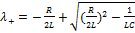 , 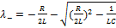

- When :
the charge and the voltage decay exponentially with time and the voltage across the capacitor is over damped .
- When
in this case under the square root is zero then:
the charge of the capacitor plates and the voltage across the capacitor plates take the following form:
. (where A and B are constants)
The critical damping is a boundary between the under damping and the over damping and in this case the charge and the voltage across the capacitor decay exponentially with time.
if and so the term under the square
root become negative which make the charge on the
capacitor as:

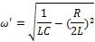
As we can see in figure4 that that this equation has a sinusoidal wave with an amplitude that decay exponentially with time and this is the under damping process.

Question 2: The table below shows the values of R, L, and C in four different DC-powered series RLC circuits. Fill out the table accordingly.

Circuit values | Damping case | Sketch of the plot of the V_{C} vs. t
R= 1kΩ, L= 10mH, C= 1μF | over damping | 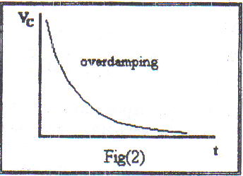
R= 0.1kΩ, L= 10mH, C= 0.1μF | Under damping
R= 1kΩ, L= 10mH, C= 0.001μF | Under damping
R= 2kΩ, L= 10mH, C= 0.01μF | Critical damping | 