**Birzeit University**

**Physics Department**

**Physics 112**

Experiment No.6

Capacitors and Inductors

**Student’s Name:** Hala Mohammed **Student’s No.:**1210312

**Partner’s Name:** Dana Hafitha **Partner’s No.:**1211234

**Section:** 9

**Date:** 2\08\2022

**Instructor:** Dr.Khalid Eid

**Abstract:**

We found out the time constant in RC, RL , and LC circuits by finding the time at which the voltage across a component reaches either 0.63Є during charge build up or 0.37Є during decay.

also we found (ω 0 ) by measuring the frequency of the circuit which corresponds to the maximum amplitude and then calculating ω 0 .

**Introduction:**

**1-RC – circuit :**

Charging a capacitor:

During the positive half period of the square wave, the charge in the simple RC circuit shown in Fig(7) builds up on the capacitor plates according to the following formula:

RC is usually called the time constant (τ) of the RC circuit. t has the unit of time (sec) and is measure of how fast the voltage across the capacitor rises. When t= τ

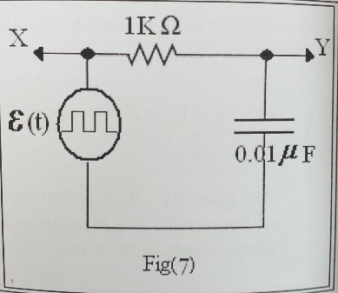

**2-** **RL circuits:**

In Fig(8), the current passing through the circuit rises with the according to the following equation:

The quantity L/R is called the time constant (τ) of the circuit; it is measure of how fast the current rises in the circuit. When t= τ

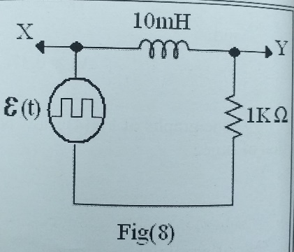

**3- LC circuits:**

In the circuit of Fig(9), the voltage across the capacitor plates is described through the following equation:

Where,Vc0 is the amplitude (constant)

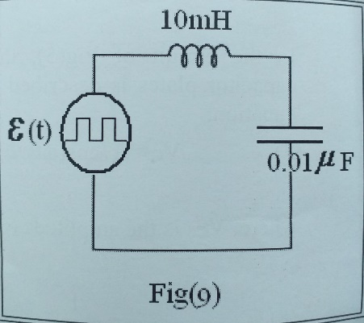

**Results & Conclusion:**

In our experiment, the values we obtained for τ and ω experimentally closely

matched those which we theoretically predicted.

Of course, there are some errors in our result, and this is due to the components used and measuring instruments.

Q1:

Q2: