**Birzeit University**

**Physics Department**

**Physics 112**

Experiment No.7

Damped Oscillations

**Student’s Name:** Hala Mohammed **Student’s No.:**1210312

**Partner’s Name:** Rawan  **Partner’s No.:**1200129

Dana 1200031

**Section:** 9

**Date:** 6\08\2022

**Instructor:** Dr.Khalid Eid

**Abstract:**

we found the maximum level for (R) to stay in Over damping stage, and found

t 1/2 for Over damping, Critical damping and Under damping for voltage.

**Introduction:**

**1-Over-damping :**

If

Then , both terms in equation decay exponentially with time and the voltage across the capacitor is said to be over-damped.

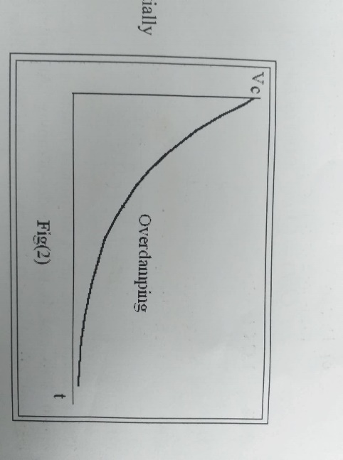

**2-** **Critical damping:**

The charge on the capacitor plates, and consequently the voltage across the capacitor plates take the following form:

Again the charge on the capacitor plates , and consequently the voltage across them , decay exponentially with time.

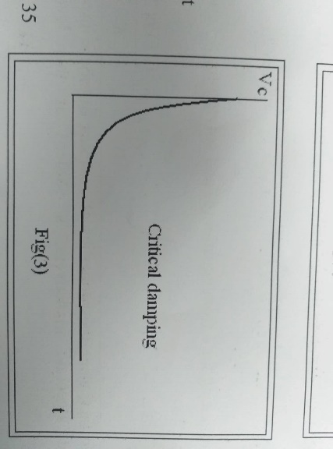

**3- Under damping:**

If

This equation represents a sinusoidal function with an amplitude that is decaying exponentially.

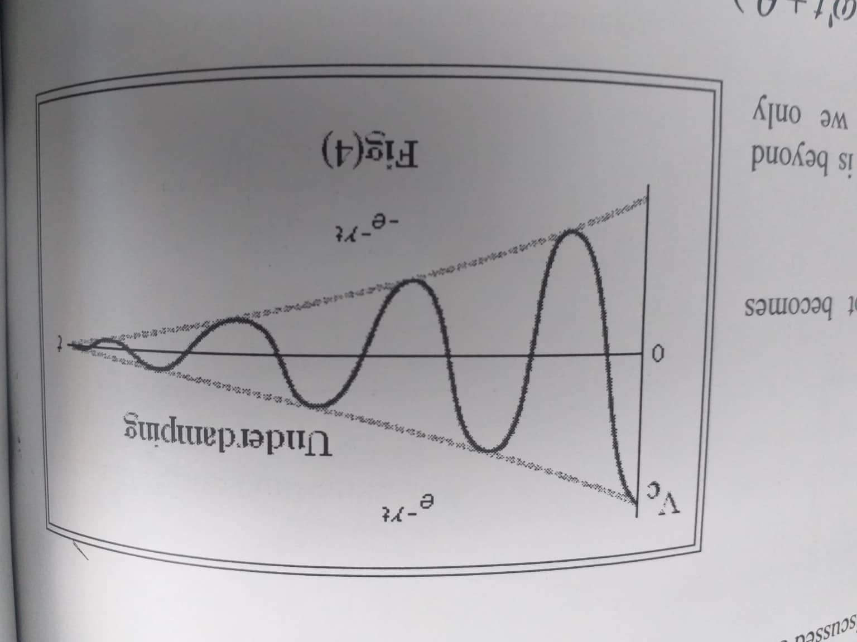

**Results & Conclusion:**

We found that for each of the three damping stages occurs at a different range of R: it begins with the underdamping stage for small values of R, then at a specific value of R we reach the critical damping stag, finally, we get to the overdamping stage for all larger values of R.

and we calculated t1/2 and f for underdamping, the values obtained for t1/2 and f experimentally and theoretically differed by a very small amount because of errors