**Birzeit University**

**Physics Department**

**Physics 112**

Experiment No.10

Filters

**Student’s Name:** Hala Mohammed **Student’s No.:**1210312

**Partner’s Name:** Ilaf Omar  **Partner’s No.:**1210816

**Section:** 9

**Date:** 18\08\2022

**Instructor:** Dr. Khalid Eid

**Abstract:**

we found angular frequency (ω -3dB ), which acts as the border between high and low attenuation for filters by using the CRO to see the plot of the capacitance’s voltage vs. time and get the value of the voltage **.**

**Introduction:**

A filter is an electrical circuit that allows signals with a defined frequency range to pass while blocking others with different frequency ranges. Filters are useful units in many electrical and electronic devices such as radio, TV, etc.

There are three types of filters:

**1- Low-pass RC filter**

Using the generalized Ohm’s law we can obtain the output voltage, V out, as a function of the input voltage, Vin.

**V out(t)=V in(t)/1+j** **w RC**

And the attenuation factor takes the following form:

**A=1/(1+(w/w-3dB) ^2) ^0.5**

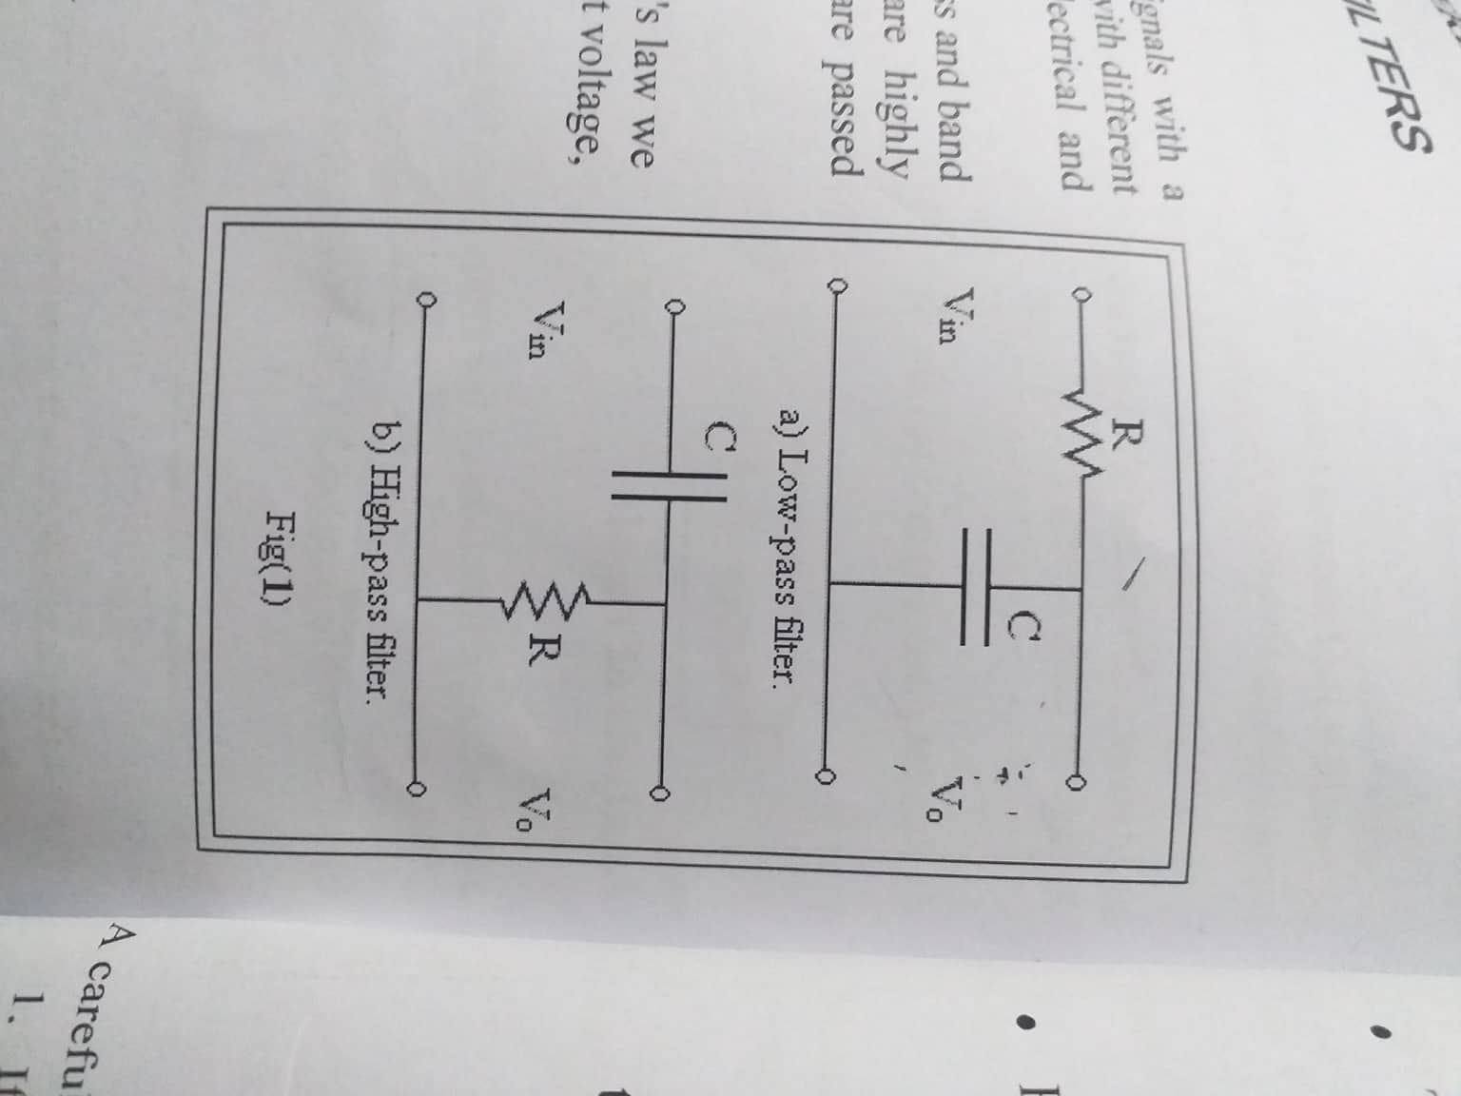

**2- High-pass RC filter**

The attenuation factor.A can be deduced using exactly the same procedure used in case of the low-pass filter , this gives:

**A=1/(1+(w/w-3dB) ^2) ^0.5**



**Differentiators and Integrators**

If a low-pass filter is functioning in the highly attenuated region, Where

w >> w-3dB then V out is extremely small and

**V R(t)=V in(t) – V out(t) ~= V in (t)**

On the other hand,

**I(t)=d Q(t)/dt = C dv c(t)/dt = C dv out(t)/dt**

The output voltage is just integral of the input voltage. Under such conditions this circuit acts as integrator.

If an RC high-pass filter is functioning in the highly attenuated region where

w << w-3dB then V out is extremely small and

**V c(t)=V in(t) – V out(t) ~= V in (t)**

On the other hand,

**I(t)=d Q(t)/dt = C dv c(t)/dt = C dv in(t)/dt**

The output voltage is just the derivative of the input voltage. Under such conditions this circuit acts as a differentiator.

**Graphs:**

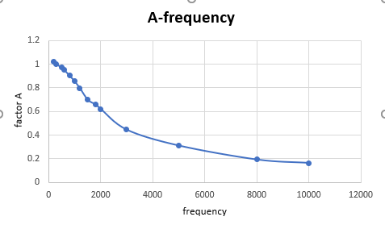

**Attenuation factor A as a function of frequency for Low-pass filter**

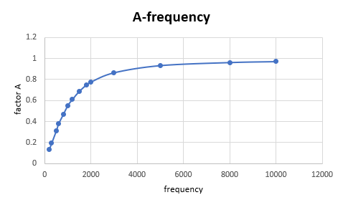

**Attenuation factor A as a function of frequency for High-pass filter**

**Calculations:**

1-ω -3dB Theoretically: 1/RC = 10000 rad/sec

2-ω -3dB from the graph of A vs. ω for the low pass filter = ω which corresponds to (A=0.707) ≈ 10.4*10^3 rad/sec.

3-ω -3dB from the graph of A vs. ω for the high pass filter = ω which corresponds to (A=0.707) ≈ 10.6*10^3 rad/sec

**Results & Conclusion:**

As we can see from the results that we’ve got, the high-pass filter acts as a differentiator and the low-pass filter acts as an integrator.

The results we have experimentally is near the once we have Theoretically but there are some errors.