**Birzeit University**

**Physics Department**

**Physics 112**

Experiment No.8

Impedance and Reactance

**Student’s Name:** Hala Mohammed **Student’s No.:**1210312

**Partner’s Name:** Dana Hafitha **Partner’s No.:**1211234

**Section:** 9

**Date:** 9\08\2022

**Instructor:** Dr.Khalid Eid

**Abstract:**

we measured the impedance and the reactance of the circuit .

And it was noticed the difference and the between V R , V C and V L graphs, and measured the phase shift between each of them and the driving voltage.

**Introduction:**

In the AC-powered RLC circuit , the current is given by

I(t) = E(t)/Zeq

Where

Zeq=ZR+Zc+ZL

With

ZR=R, Zc = -j/wc , ZL = jwL

ZR ,Zc,ZL being the resistive impedance , the capacitive impedance and the inductive impedance respectively.

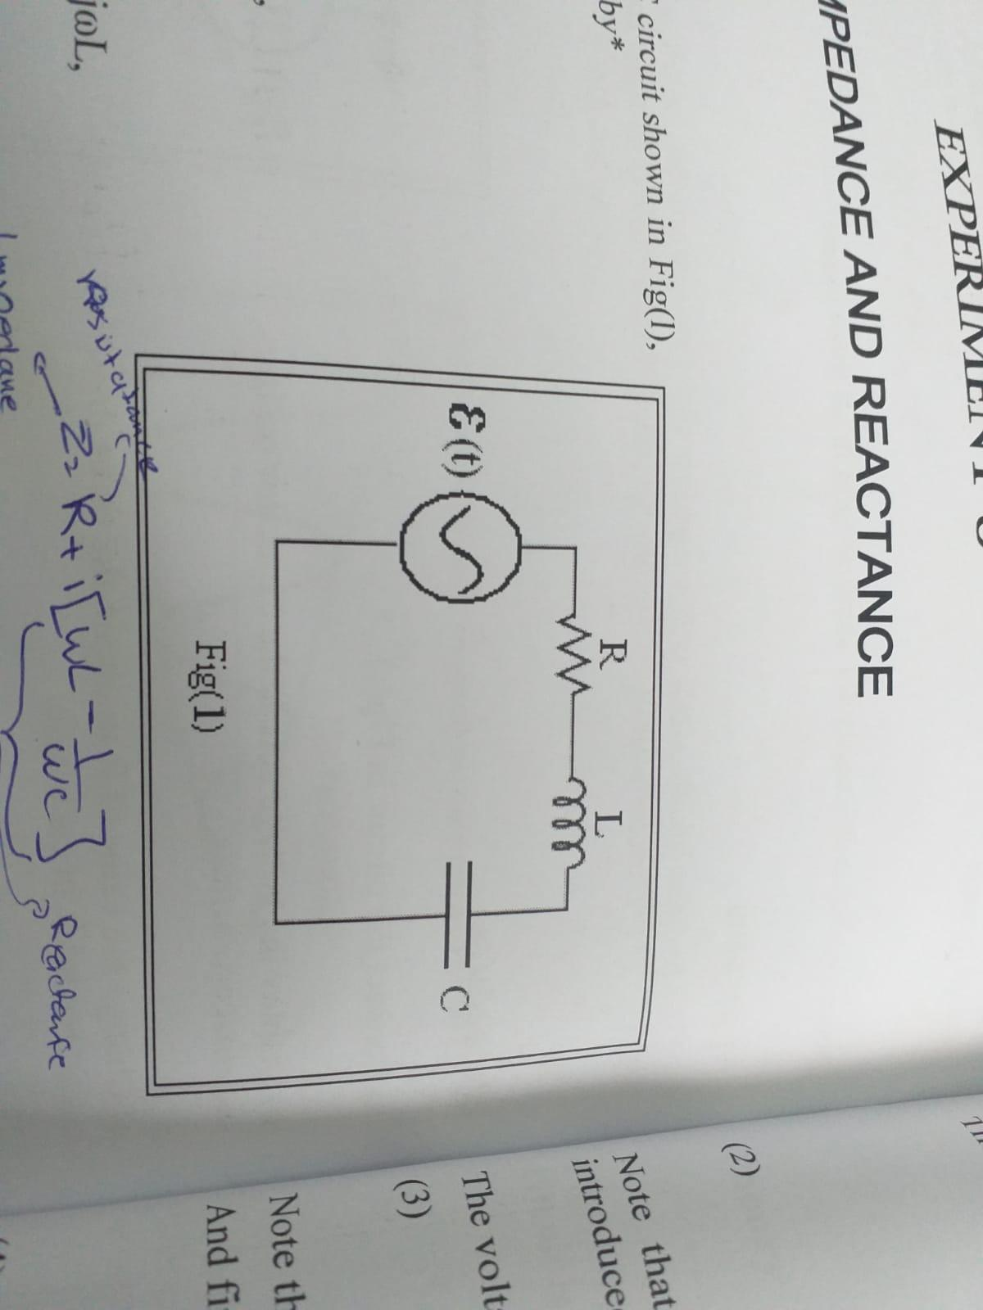

In general , impedance is a complex numbers that needs special mathematical treatment.

Proceeding with such treatment we get the following value for the current in the circuit:

I(t)=I0 cos (wt + Ф)

**\*\*** The phase shifts between the current and the voltages across the different circuit elements in Fig(1) are related to Ф which is a function of w **\*\***

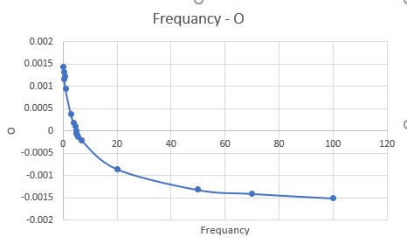

**The graph shows the change Ф with the Frequency**

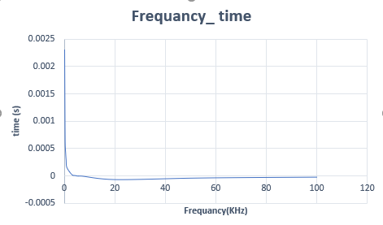

**The graph shows the change of time with the Frequency**

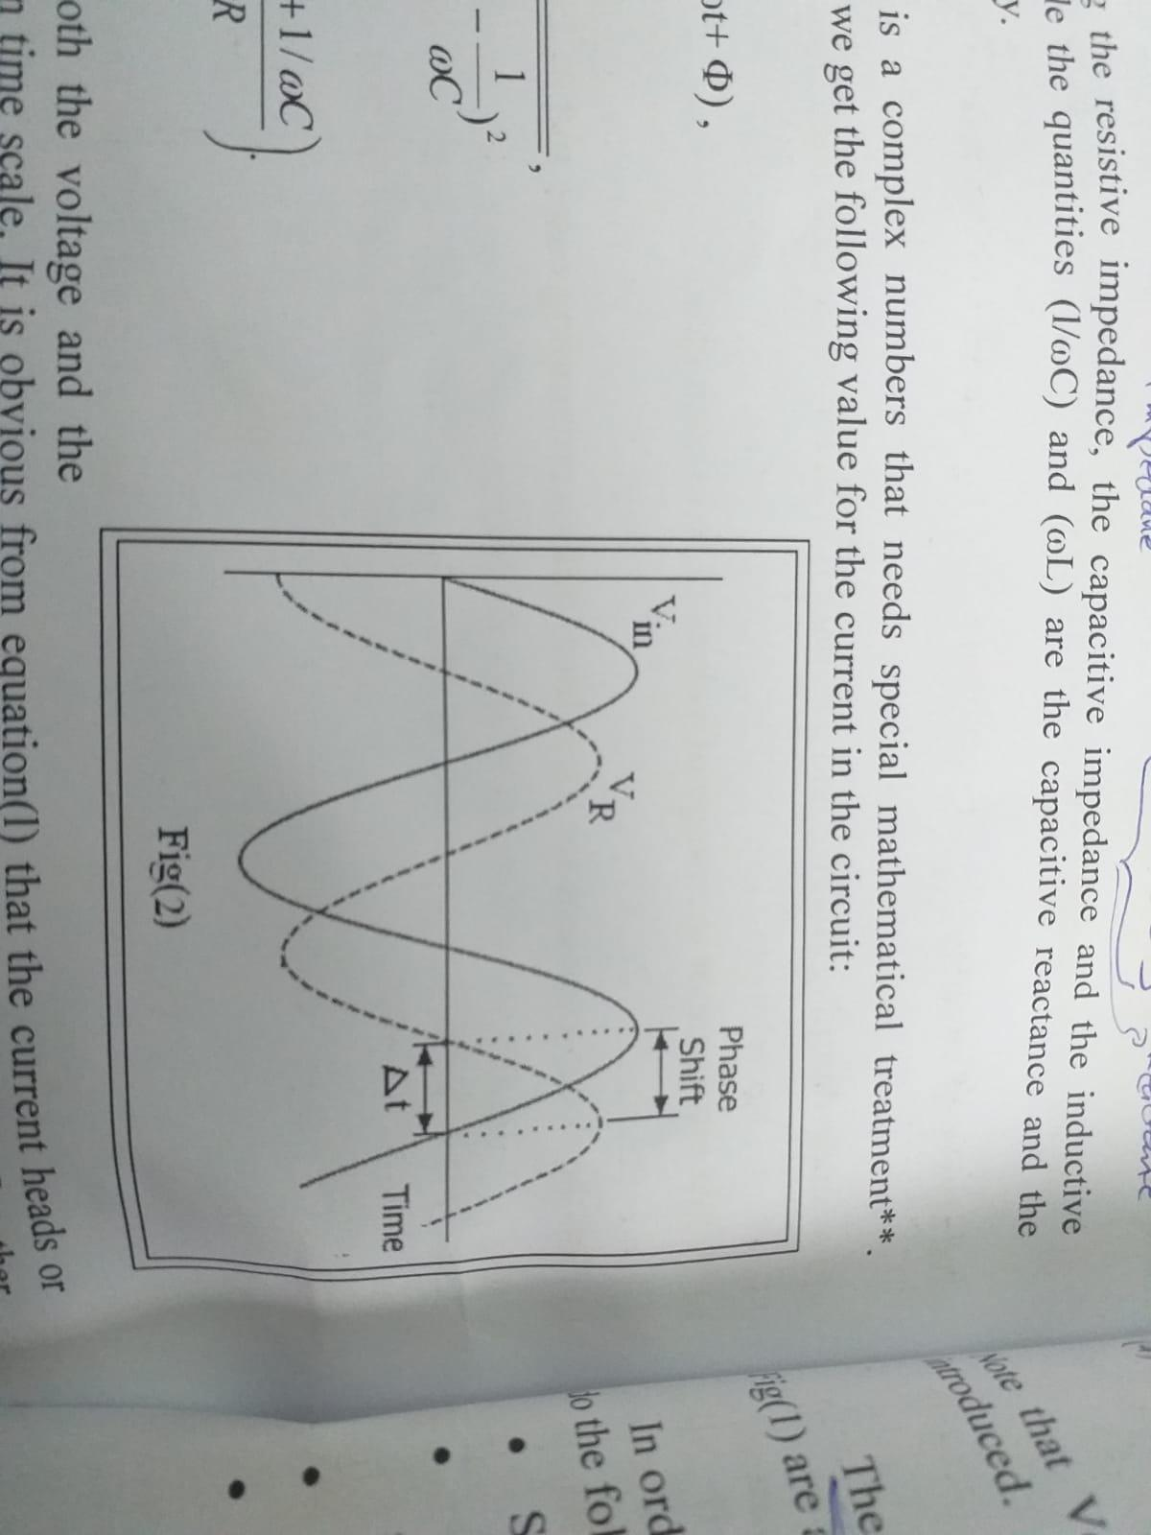

**The graph shows the similarities and differences between VR ,Vc and VL**

**Results & Conclusion:**

We notice that the phase shift becomes zero when the frequency becomes 4.8 KHz. We found also that in an RLC circuit, the voltage across inductor and the capacitor are ahead of that across the resistance or behind (one is ahead and the other is behind: they do not overlap).