**Birzeit University**

**Physics Department**

**Physics 112**

Experiment No.9

RESONACE

**Student’s Name:** Hala Mohammed **Student’s No.:**1210312

**Section:** 9

**Date:** 18\08\2022

**Instructor:** Dr.Khalid Eid

**Abstract:**

We found out the resonance frequency of the RLC circuit by using the CRO to find out the voltage changes due to the change of frequency.

**Introduction:**

Consider the AC- powered RLC. The amplitude of the current passing through the circuit given by :

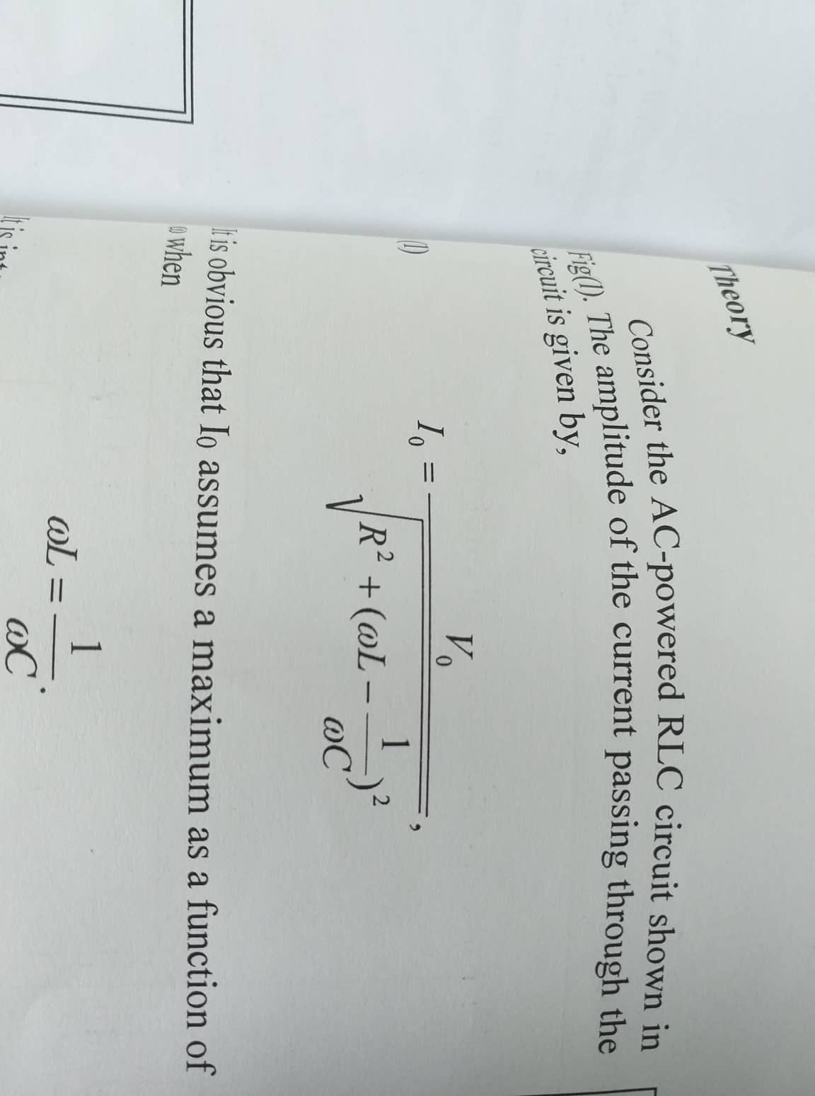

The current in the circuit assumes its maximum value when the driving voltage frequency equals the natural frequency of RLC circuit. This phenomenon is called resonace.

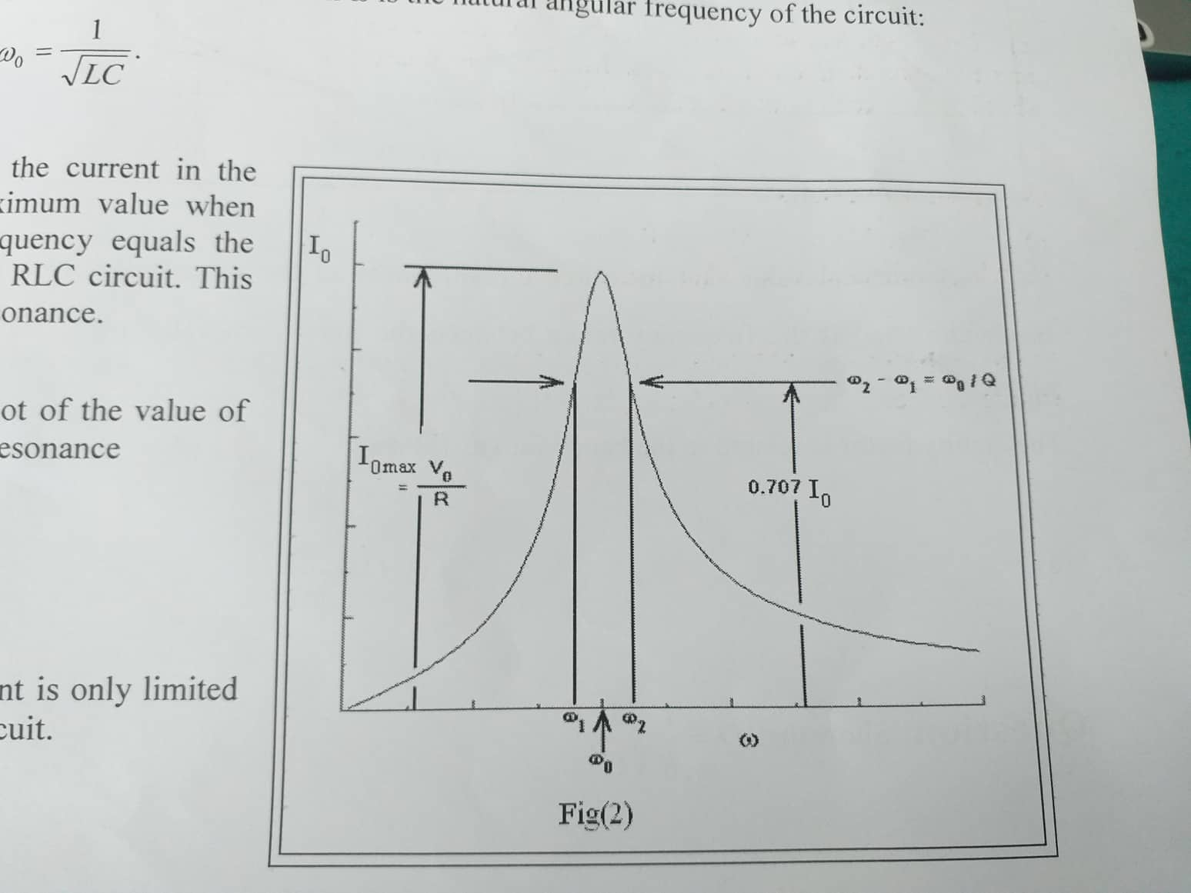

The Quality Factor

A measure of the resonance curve is a quantity called the quality factor (Q) which is defined as

**Q=w L/R**

The fig shows a plot of resonance curve for different combinations of R,L and C.

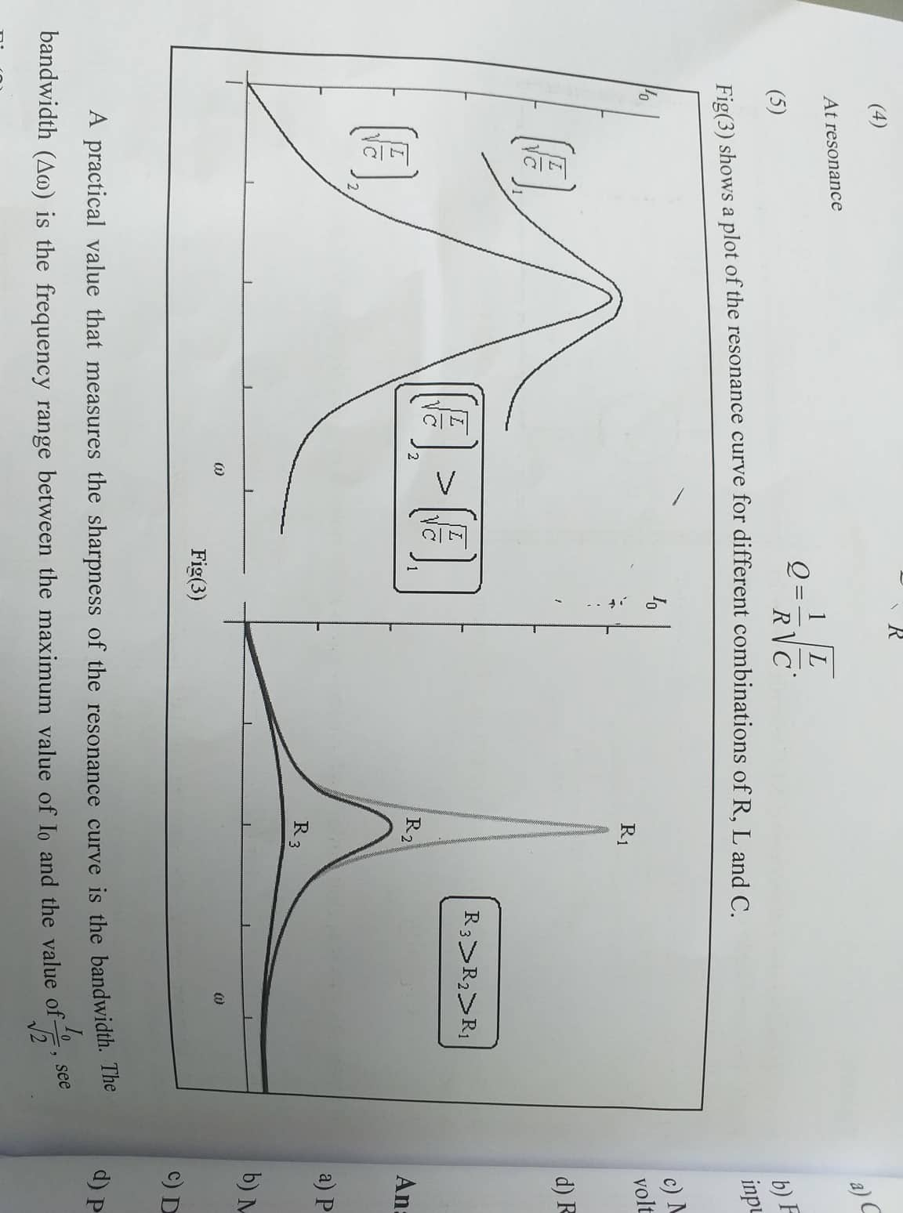

A practical value that measure the sharpness of the resonance curve is the bandwidth.

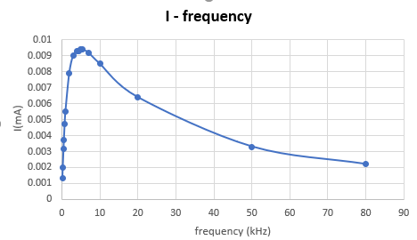

**I as a function of the frequency for 1K OHM R**

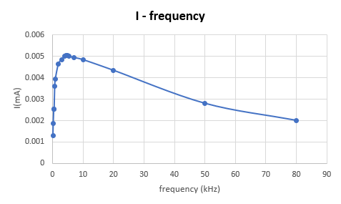

**I as a function of the frequency for 2K OHM R**

**Calculations:**

**First case R=1kΩ:**

The quality factor:

Q=0.32 (Theoretically)

**second case R=2kΩ:**

The quality factor:

Q= 158.0 (Theoretically)

**The angular resonance frequency:**

W = 31.62 K rad / sec (Theoretically)

**Conclusion:**

We found that current in an RLC circuit has reaches a maximum when the

driving voltage frequency is equal to the resonant frequency. We can also conclude that the greater the resistance in an RLC circuit, the small the quality factor.