Unit 4 L

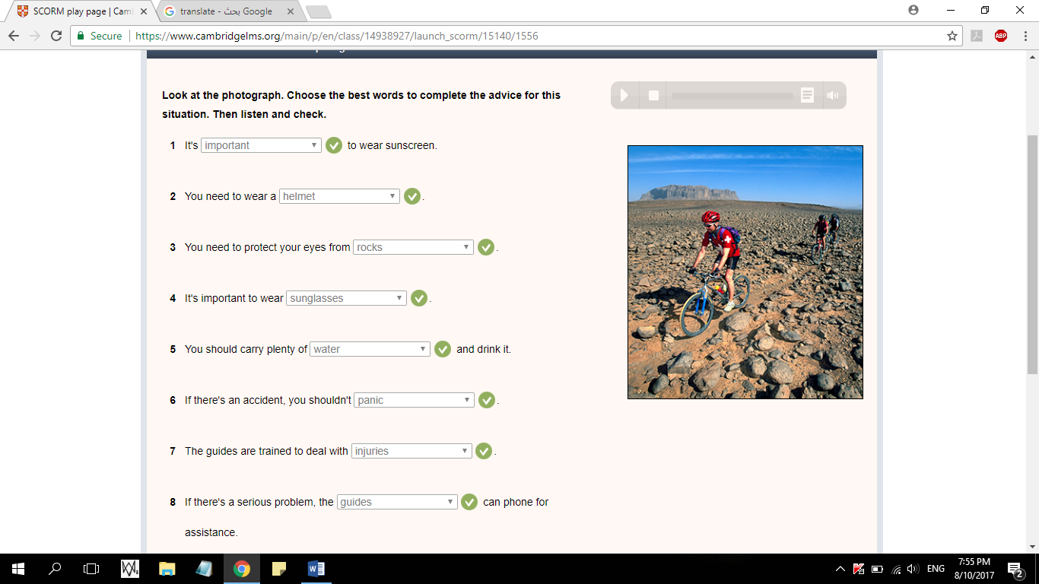

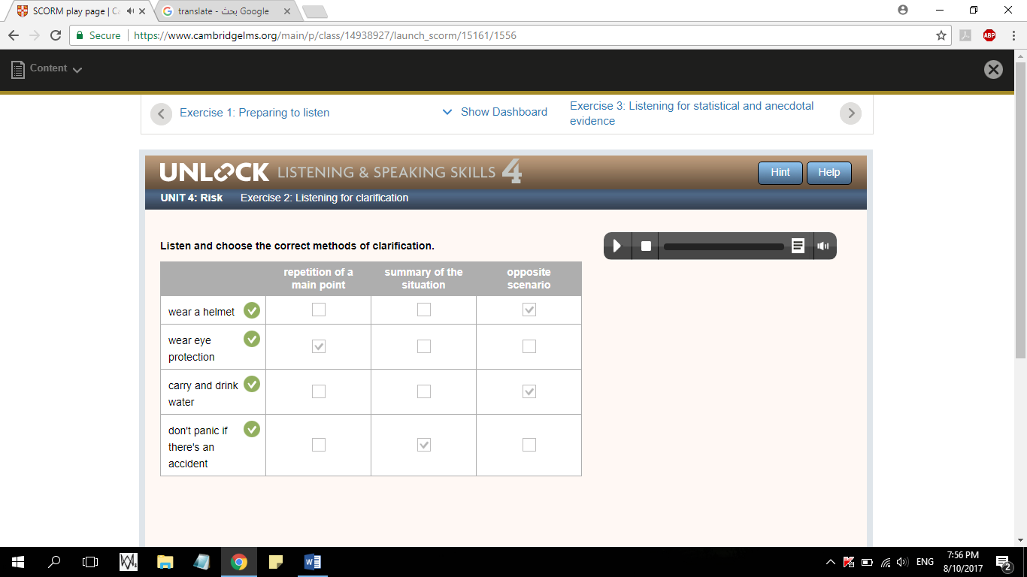

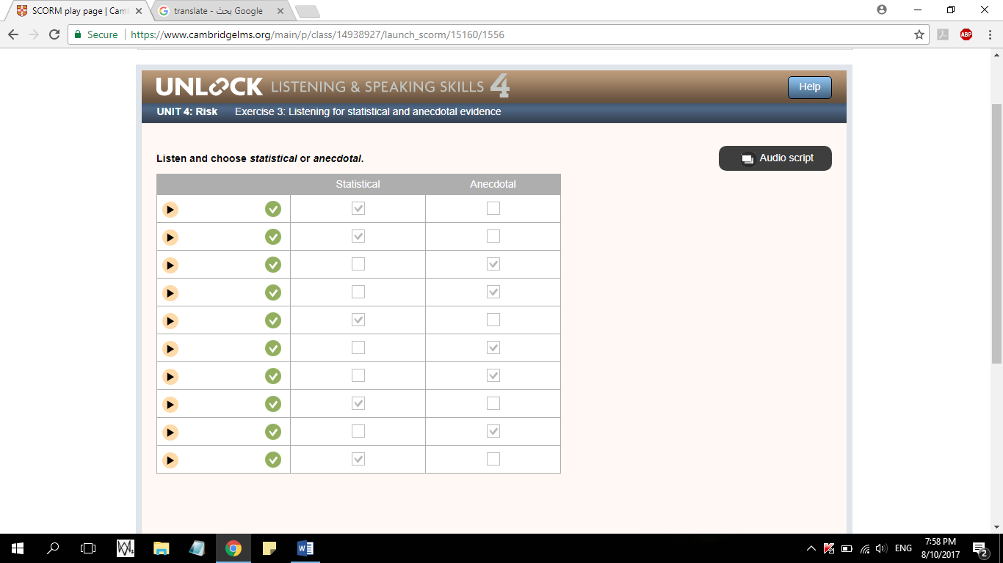

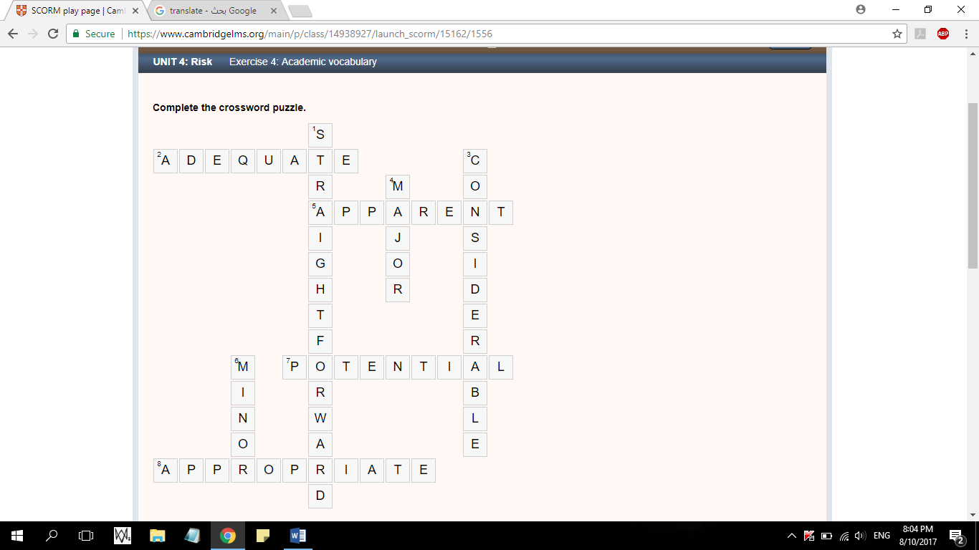

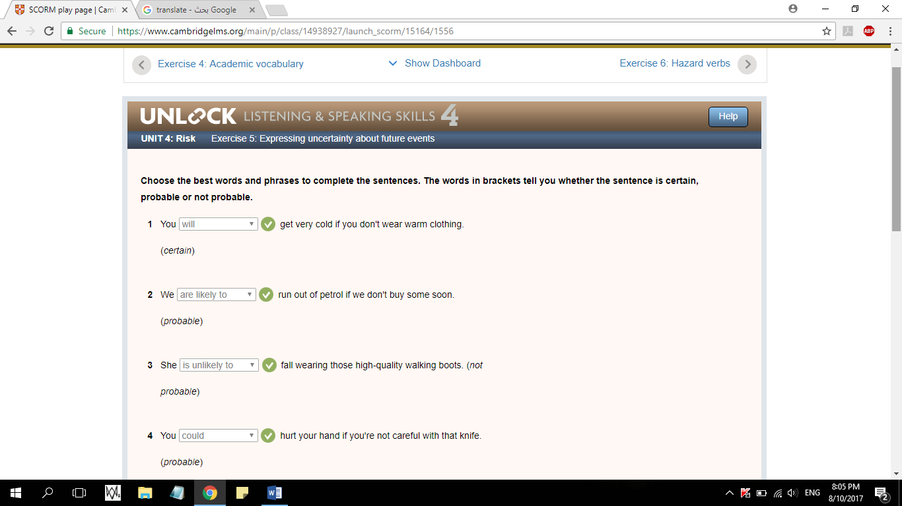

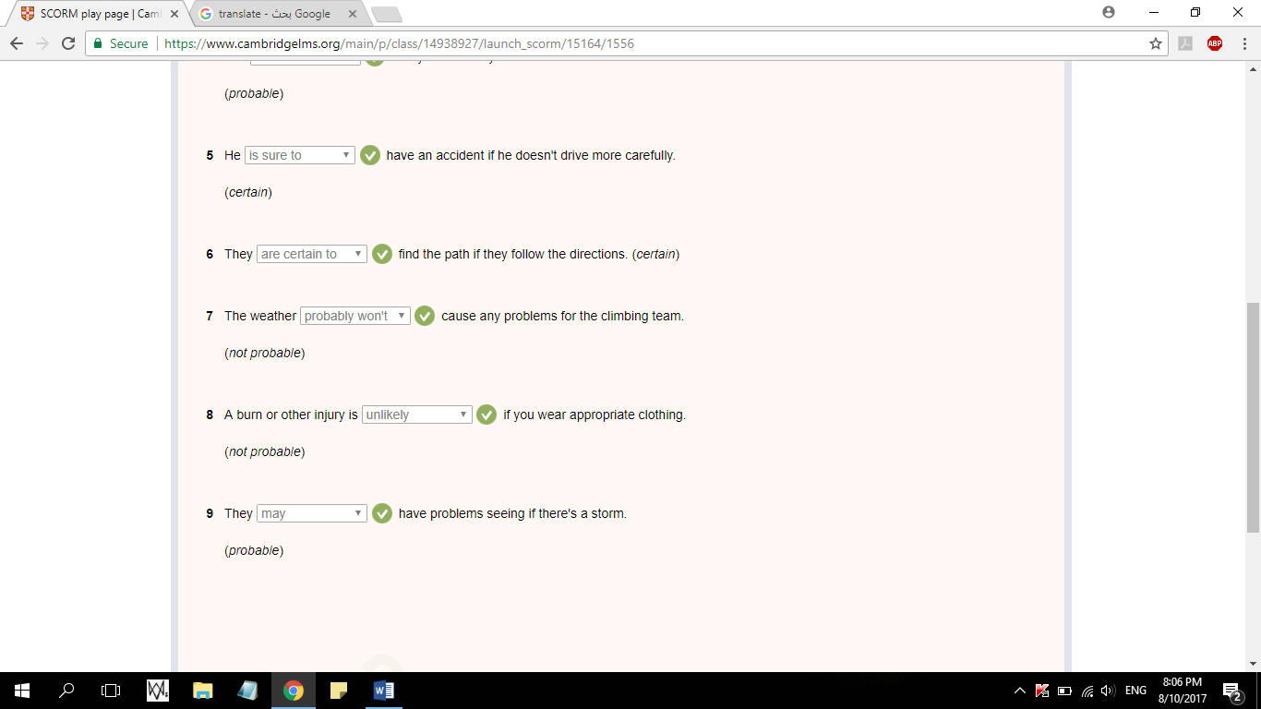

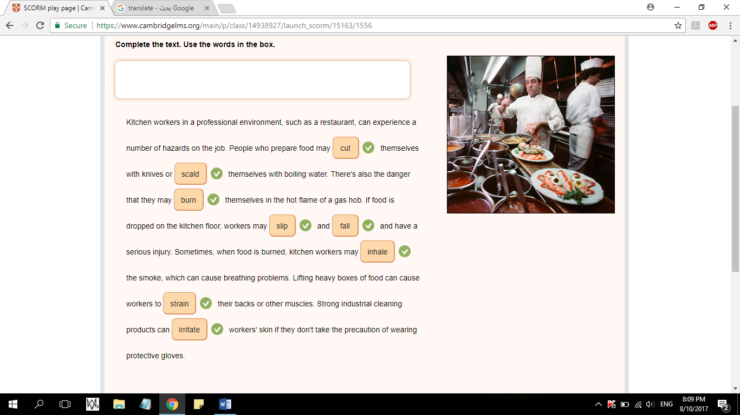

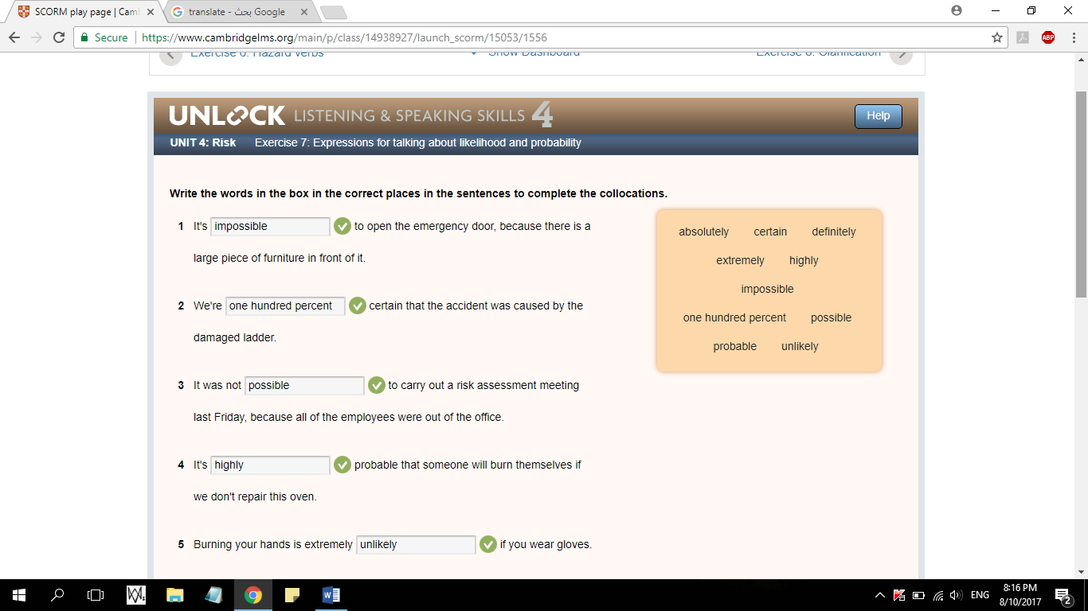

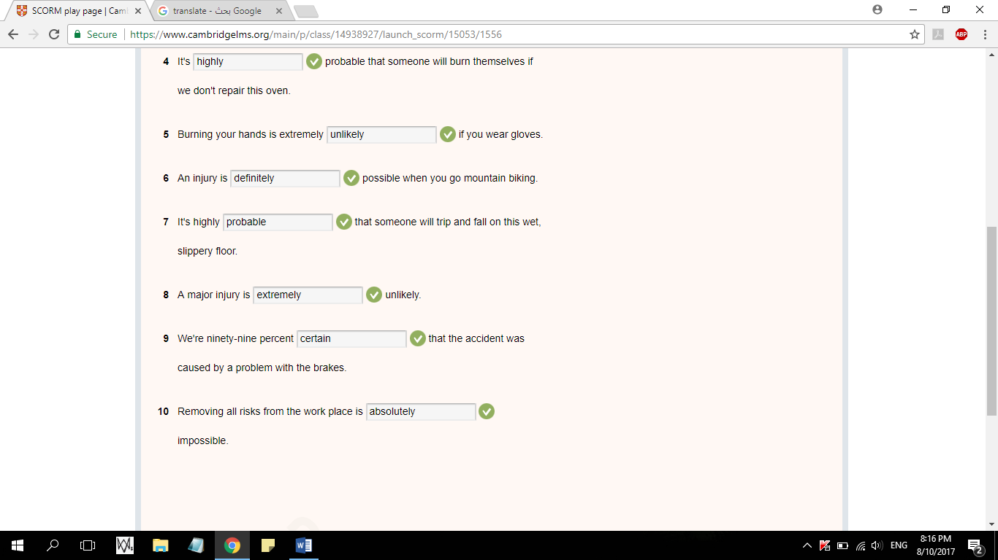

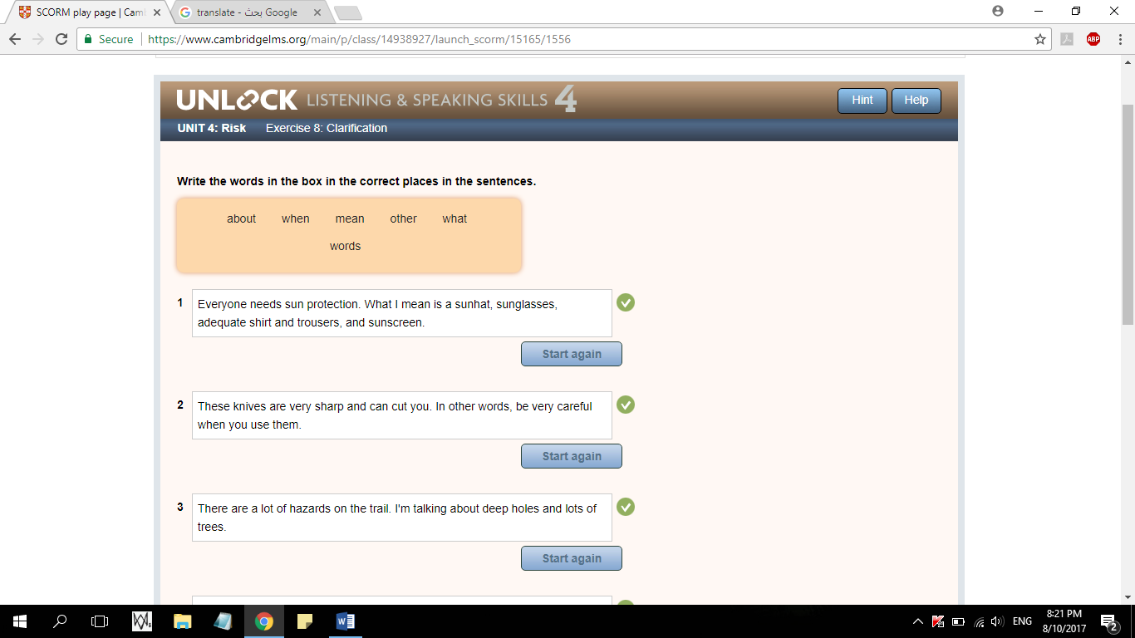

1-Everyone needs sun protection. What I mean is a sunhat, sunglasses, adequate shirt and trousers, and sunscreen.

2-These knives are very sharp and can cut you. In other words, be very careful when you use them.

3- There are a lot of hazards on the trail. I'm talking about deep holes and lots of trees.

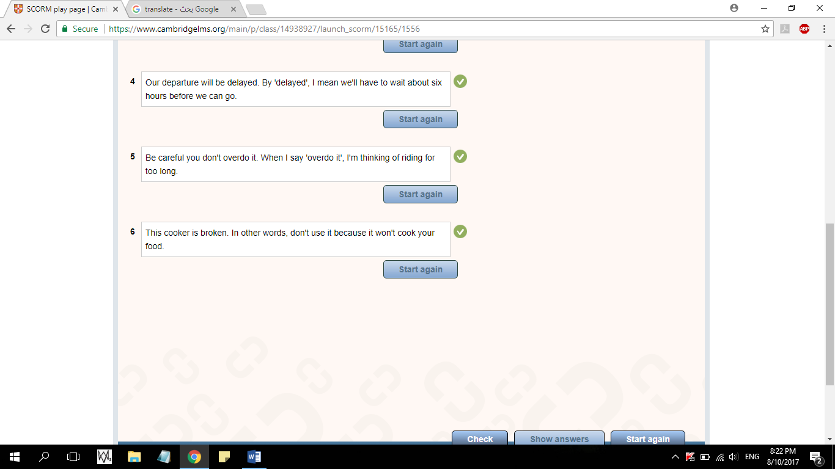

4- Our departure will be delayed. By 'delayed', I mean we'll have to wait about six hours before we can go.

5- Be careful you don't overdo it. When I say 'overdo it', I'm thinking of riding for too long.

6- This cooker is broken. In other words, don't use it because it won't cook your food.

