Huda Okab 1193133

Business chapter 1 (Notes)

* What is business?

Business is an organization the provides goods or services to earn profits.

I

Difference between a business’s revenues and expenses.

* What are the benefits of business?
* They produce most of the good and services we consume today.
* They give jobs to the unemployed.
* They create most new innovations and provide a vast range of opportunities for new businesses.
* They support charity and provide community leadership.
* What are the types of business environments?

Domestic business environment: is the environment in which a firm conducts its operations and derives its revenues.

Global business environment: encompasses the international forces that affect a business and includes international trade agreements, international economic conditions, and political unrest.

Technological environment: encompasses all the ways by which firms create value for their constituents and includes human knowledge, work methods, physical equipment, electronics, and telecommunications.

Political- legal environment: is the relationship between business and government.

Sociocultural environment: includes the customs, mores, values, and demographic characteristics of the society in which an organization functions and determines the goods and services, as well as the standards of business conduct, that a society is likely to value and accept.

Economic environment: includes relevant conditions that exist in the economic system in which a company operates.

* What affects a business?

The external environment effects a business.

I

Everything outside an organizations boundary that might affect it.

* What do businesses seek?
* Businesses seek a close relationship with their customers
* Establish strong relationships with their suppliers
* Distinguish themselves from other businesses
* What is an economic system?

A nations system for appropriating its resources among citizens, individuals and organizations.

* What are the factors of production?

I

The resources that a country’s business use to produce goods or services.

There are 5 factors:

* Labor: includes the physical and intellectual contributions people make while engaged in economic production and is also called human resources.
* Capital: is the term used to describe the financial resources needed to operate a business.
* Entrepreneurs: is a person who accepts the risks and opportunities entailed in creating and operating a new business venture.
* Physical resources: tangible things that organizations use to conduct their business and include natural resources and raw materials, offices, storage and production facilities, parts and supplies, computers and peripherals.
* Information resource: are data and other information used by businesses and include market forecasts, the specialized knowledge of people, and economic data.
* What are the 4 types of economic systems?
* Planned economy: an economy in which production, investment, prices, and incomes are determined centrally by the government. (basically controlled by the government).

I

Communism: is a system in which the government own and operates all factors of production.

Socialism: the government owns and operates selected industries.

* Market economy: an economic system in which production and prices are determined by unrestricted competition between privately owned businesses.

I

Relies on capitalism (an economic and political system in which a country's trade and industry are controlled by private owners for profit, rather than by the state) and free enterprise (refers to an economy where the market determines prices, products, and services rather than the government) to create an environment in which producers and consumers are free to sell and buy what they please.

* Mixed market economy: system of resource allocation, commerce, and trade in which free markets coexist with government intervention (features characteristics of both planned and market economies)
* Privatization: the transfer of a business, industry, or service from public to private ownership and control.
* What is supply and demand?

Demand: the willingness and ability of buyers to purchase a product.

I

Law of demand: a buyer would purchase more of a product when the price drops and less when the price increases.

Supply: the willingness and ability of a producer to offer a good or service for sale.

I

Law of supply: Producers will offer (supply) more of a product for sale as its price rises and less of a product as its price drops.

* What is the supply and demand schedule?

is an assessment of the relationships among different levels of demand and supply at different price levels.

I

Supply curve: is a graph showing how many units of a product will be supplied (offered for sale) at different prices.

Demand curve: is a graph showing how many units of a product will be demanded (bought) at different prices.

* How does private enterprise and competition work in an economy?

Private enterprise; allows an individual to pursue their own interest with minimal government restrictions. Examples: private property, competition, freedom of choice, profits.

Private property right: ownerships of resources used to create wealth is in the hands of individuals.

Freedom of choice: you can sell your labor (supplies) to any employer of your choice.

Profits: a financial gain, especially the difference between the amount earned and the amount spent in buying, operating, or producing something.

Competition: two or more businesses sell the same resources or have the same customer.

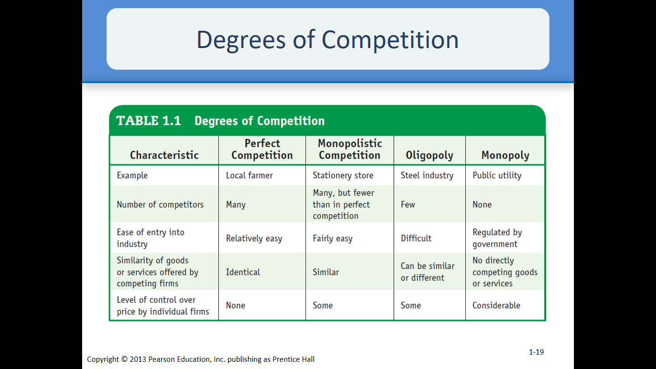

* What are the degrees of competition?

Perfect competition: is a theoretical market structure in which the following criteria are met (all firms in the industry must be small, a number of firms in the industry must be large)

Monopolistic competition: is a type of imperfect competition such that many producers sell products that are differentiated from one another and hence are not perfect substitutes.

Oligopoly: a state of limited competition, in which a market is shared by a small number of producers or sellers.

Monopoly: one producer can therefore set the price of the product.

I

Natural monopoly: industry in which one company can most efficiently supply all needed goods or services.

* What is an economic indicator?

It is the statistics that shows weather an economic system is strengthening, weakening, or remaining constant. (Helps asses the performance of an economy).

* What is economic growth, aggregate output and standard of living?

Economic growth: is an increase in the production of economic goods and services, compared from one period of time to another.

Business cycle: a pattern of short turn ups and downs in an economy.

Aggregate output: the total amount of output produced and supplied in the economy in a given period.

Standard of living: the total quantity and quality of goods and services that they can purchase with the currency used in their economic system. (the degree of wealth and material comfort available to a person or community).

* What is Growth domestic product and Growth national product?

Growth domestic product (GDP): refers to the total value of all goods and services produced with in a given period by a national economy through domestic factors of production. (measure of aggregate output).

Growth national product (GNP): refers to the total goods and services produced by a national economy within a given period regardless of where the factors of production are located.

* What are the two types of GDP?

Nominal GDP: measured in current dollars or with all components valued at current prices.

Purchasing power parity: the principles that exchange rates are set so that the prices of similar products in different countries are almost the same.

* What is productivity and what are their types?

Productivity: measure of economic growth that compares how much a system produces with the resources needed to produce it.

2 types of productivity:

Balance of trade: the economic value of all the products that a country exports minus the economic value of its imported product.

I

Positive balance trade: results when a countries exports is more than the imports.

Negative balance trade: result when countries imports are more than the exports.

National debt: the amount of money the government owes its creditors.

* Economic stability

There are five types of economic stability:

Stability: condition in which the amount of money available in an economic system and the quantity of goods and services produced in it are growing at about the same rate.

Inflation: occurs when widespread price increases occur throughout an economic system.

Unemployment: the level of joblessness among people actively seeking work in an economic system.

Recession: a period during which aggregate output, as measured by GDP, declines.

Depression: a prolonged and deep recession.

* Ways to manage the U.S economy.

Fiscal policies: policies used by a government regarding how it collects and spends revenue.

Monetary policies: policies used by a government to control the size of its money supply.

Stabilization policy: government economic policy intended to smooth out fluctuations in output and unemployment and to stabilize prices

Huda Okab 1193133

Business chapter 2 (Notes)

* What is ethics?

Ethics: beliefs of what is right and wrong, good or bad in actions that affects others.

Business ethics: refers to ethical or unethical behaviors by employees and managers in complex of their jobs.

* What is the difference between ethical and unethical behavior?

Ethical behavior: behavior that conforms to individual beliefs and social norms about what’s good and right.

Unethical behavior: behavior that conforms to individual beliefs and social norms about what’s wrong and bad.

* What is individual ethics?

Individual ethics: depends on individual’s beliefs and social concepts. It differs from person to person, situation to situation, & culture to culture. Ethical and unethical is determined by an individual and society.

* What is the law and the real world?

The law must be clear for everyone. Societies generally adopt laws that prevail ethical standards or social norms.

* Managerial ethics.

Standard behavior that guides individual managers to their work.

Types of behaviors of managerial ethics:

* Behavior towards employees: This category covers such matters as hiring and firing, wages and working conditions, and privacy and respect.
* Behavior towards the organization: Ethical issues also arise from employee behavior toward employers, especially in such areas as conflict of interest, confidentiality, and honesty.
* Behavior toward other economic agents: Ethics also comes into play in the relationship of a business and its employees with so-called primary agents of interest- mainly customers, competitor, stock holders, suppliers, dealers, and unions.
* How to asses’ ethical behavior?
* Gather the relevant factual information.
* Analyze the facts to determine the most moral values
* Make an ethical judgement based on the right and wrong of the purposed problem.
* What are the 4 ethical norms?
* Utility: the state of being useful, profitable, or beneficial
* Rights: that which is morally correct, just, or honorable
* Justice: fairness
* Caring: responsibility to others.
* What are the company’s practices and business ethics?

There are two common approaches:

* adopting written codes.
* Instituting ethics programs.
* How to adopt written codes the HP way.
* We must have trust and respect for individuals
* We focus on high level of achievement and contribution
* We conduct our businesses with uncompromising integrity
* We achieve our common objectives through team work
* We encourage flexibility and innovation
* What is social responsibility?

Refers to the overall way in which a business attempts to balance its commitments to relevant groups and individuals in its social environment.

I

Organizational stake holders: those groups, individuals, and organizations that are directly affected by the practices of an organization and who therefore have a stake in its performance.

* 5 main groups of stake holders:
* Customers: treat customers fairly and honestly
* Employees: treat employees fairly and respect their dignity and basic human needs
* Investors: Follow proper accounting procedures; provide information to shareholders about financial performance.
* Suppliers: Create mutually beneficial partnership arrangements with suppliers
* Local communities where they do business: Involvement in programs and charities
* What is the concept of accountability?

The expectation of an expanded role for business in protecting and enhancing the general welfare of society.

* Areas of social responsibility.
* Environment
* Customers
* Employees
* Investors
* Responsibility towards the environment
* Air pollution
* Water pollution
* Land pollution (toxic waste disposal, recycling)
* What is the responsibility towards customers?
* Consumer rights (consumerism): social activism dedicated to protecting the rights of consumers in their dealing with business.
* Unfair pricing: Collusion – two or more firms collaborate on such wrongful acts as price fixing and price gouging.

I

Responding to increased demand with overly steep pricing increase.

* What is green marketing?

It is the marketing of eco-friendly products and services. With the passage of time it is becoming a bigger trend.

* Examples of ways for green marketing
* Creating an eco-friendly product
* Using eco-friendly packaging
* Adopting sustainable business practices
* Focusing market efforts on messages that communicate the product of green benefits.
* What are the elements of green marketing?
* Production process
* Product modification
* Carbon offsets
* Packing reduction
* Sustainability
* What are the consumer bill of right?
* Consumers have the rights to safe products
* Consumers have the right to be informed about the products
* They have the right to be heard
* They have the right to choose what they buy
* Right to be educated about purchases
* Right to continuous services
* General background about the rights of consumers

Declared in the 1960s, by president John F Kennedy, who came up with the basic four. The consumer bill of rights backed up by numerous federal and state laws.

* What are the responsibilities towards employees?
* Zero discrimination (sex, race, religion etc…)
* Provide opportunities to balance work and social life
* Help employees maintain their job skills
* Treat terminated or laid off workers with respect and compassion
* What are the responsibilities towards investors?
* Insider trading: using confidential information to gain from the purchase or sale of stocks.
* Misrepresentation of finances
* Approaches to social responsibility (from lowest to highest)
* Obstructionist stance: involves doing as little as possible and may involve attempts to deny or cover up violations.
* Defensive stance: company meets only minimum legal requirements in its commitments to groups and individuals its social environment
* Accommodative stance: company meets only minimum legal requirements in its commitments to groups and individuals its social environment
* Proactive stance: company meets only minimum legal requirements in its commitments to groups and individuals its social environment
* Managing social responsibility programs
* company meets only minimum legal requirements in its commitments to groups and individuals its social environment.
* A committee top manager must develop a plan detailing the level of management support
* One executive must be put in charge of a firm’s agenda
* The organization must conduct occasional social audits

I

systematic analysis of a firm’s success in using funds earmarked for meeting its social responsibility goals.

* How does social responsibility affect small businesses?
* Ethical issues are questions of individual ethics.
* But in question of social responsibility they must ask themselves if they can afford a social agenda.
* The government and social responsibility, how it works with planned and market economies
* In planned economies - the government intensely controls trade exercises to guarantee that businesses back social ideals.
* In market economies- here's impressive government control of commerce to guarantee that business interface don't harm social interests.
* Businesses and government utilize a few strategies to impact each other.
* Types of regulations
* Direct regulation: The foundation of laws and rules that direct what organizations can and cannot do.
* Indirect regulation: The government can impact how organizations spend their social duty dollars by giving more prominent or lesser assess incentives.
* How does a business influence government?

There are four main methods for addressing SR:

* Personal contact
* Lobbying
* Political action committees
* Favors

Huda Okab 1193133

Business chapter 3 (Notes)

* What is a small business?
* A small business is one that's independent (not portion of a larger trade) which has generally small impact in its market.
* Small business administration (SBA) is a government office charged with helping little businesses.
* Small businesses give people the opportunity to get employed.

* Benefits of small businesses
* Job creation: little businesses have accounted for approximately 40 percent of all modern occupations in high-technology segments of the economy. They are also the 1st to hire. Many businesses start small and over time expand.
* Innovation: Major developments are as likely to come from little businesses (or people) as from huge ones. Innovations are not always new products. (new methods, new payment, new delivery models, new processes). Small Businesses create 13 times as numerous licenses per representative as huge licensing firms.
* Contributions to big businesses: Little businesses give administrations to huge businesses such as websites, distribution, data storage services and raw materials.
* What roles does a small business play in society?
* Services, retailing, construction, wholesaling, finance and insurance, manufacturing, transportation, ***the more resources required the harder the business to start***. ***Small is just a term***

Visit slide 11 for better view!

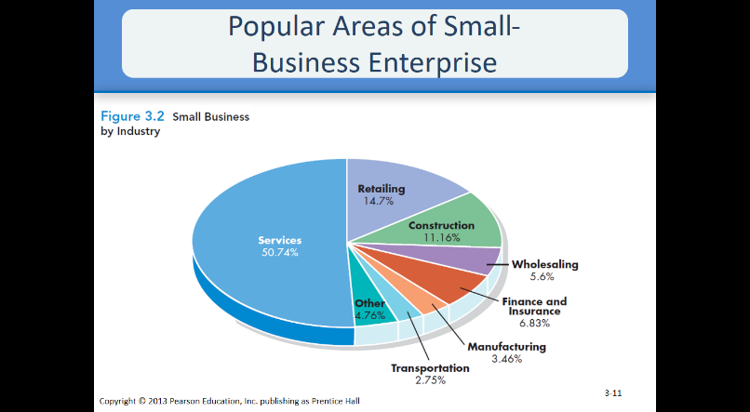

shows the distribution of all U.S. businesses employing fewer than 20 people across industry groups.

* What is the difference between entrepreneur and entrepreneurship?
* Entrepreneur: businessperson who acknowledges both the dangers and the openings included in making and working a unused commerce venture.
* Entrepreneurship: the handle of looking for commerce opening with taking all risks.
* What are the 3 goals of entrepreneurship?

1. Independence: gained from working for someone else
2. Financial security: safe and secure monetary future for themselves and their families.
3. Growth and expansion: Transforms business to a large one

* Start up and ventures are terms used for small businesses
* What are some entrepreneurial characteristics?
* Resourcefulness
* Concern for good, personal customer relations
* Goal to be their own boss, and build for their families
* Deal with risks and uncertainty (they take the risk)
* Self-dependent and enthusiastic almost their ideas
* Open minded leaders with business plans and general agreements
* How to start and operate a new business?
* The internet and social media has made life better the benefits are as follows
* More opportunities
* The ability to gather more information and asses it
* How to give a well-crafted business plan?

I

A real benefit of a business plan is the fact that in the act of preparing it, the would-be entrepreneur must develop the business idea on paper and firm up his or her thinking about how much to launch it before investing time and money on it.

* What is distinctive competencies?
* Distinctive competencies: is the aspect of commerce that the firm performs superior than competitors.
* They usually fall into 3 areas:
* The capacity to recognize unused specialties in built up markets
* The capacity to identify new markets
* The ability to move quickly to take advantage of new opportunities
* The business visionary must illustrate an understanding of the current advertise, of the qualities and shortcomings of existing firms, and of the implies by which the unused wander will compete.
* What is a business plan?
* record in which the business visionary depicts her or his commerce technique for the unused wander and illustrates how it'll be implemented
* How to craft a business plan?
* Setting goals and objectives
* Sales forecasting
* Financial planning
* Three main questions one must ask:
* What are the entrepreneur’s goals and objectives?
* What strategies will be used to obtain them?
* How will these strategies be implemented?
* What are the 3 ways to start a small business?

1. Starting from scratch
2. Franchising
3. Buying an existing business

* What is franchising and what are the benefits and draw backs of it?
* Franchising: an course of action in which a buyer (franchisee) buys the correct to offer the great or benefit of the vender (franchiser), basically like buying the entire store to your country.
* The benefits: ***Proven business opportunity, access to management expertise***
* The drawbacks: ***Startup costs, ongoing payments, management rules and restrictions***
* Questions to ask when starting from scratch
* Who and where are my customers?
* How much will those customers pay for my product?
* How much of my product can I expect to sell?
* Who are my competitors?
* Why will customers buy my product rather than the product of my competitors?
* How to finance a small business?
* Personal resources
* Loans from family and friends
* Bank loans
* Venture capital companies: the gather of little speculators who contribute cash in companies with quick development potential
* Small-Business Investment Companies (SBICs): government-regulated investment company that borrows money from the SBA to invest in or lend to a small business.
* Minority Enterprise Small-Business Investment Companies (MESBICs)
* SBA financial programs
* Small Business Development Center (SBDC): SBA program designed to consolidate information from various disciplines and make it available to small businesses.
* What are some trends of small business startups?
* Emergence of E commerce
* Which is technically a fancy name for the internet (online businesses)
* Cross overs from big businesses
* Basically people who worked at big businesses and left to start their own.
* Opportunities for minorities and women
* Basically like small women businesses
* Global opportunities
* Entrepreneurs are finding new opportunities abroad (basically outside of their home land)
* Better survival rates
* 44 percent of new start-ups can expect to survive for at least four years (big percentage)
* Why do women start businesses?

1. Gain control over their schedule
2. Saw a market opportunity and decided to pursue it
3. Basically done with “glass ceilings” (which is a term used for limits) at big companies.
4. There are also other unknown reasons

* Why does a small business fail?
* Managerial incompetence or inexperience
* A few business visionaries put as well much confidence in common sense, overestimate their claim administrative abilities, or accept that difficult work alone guarantees success.
* Neglect
* Some entrepreneurs try to launch ventures in their spare time, and others devote only limited time to new businesses. (basically not give the business the amount of time it deserves)
* Weak control systems
* Effective control systems keep a business on track and alert managers to potential trouble. If your control systems
* don’t signal impending problems, you may be in serious trouble before you spot more obvious difficulties. (when you don’t notice the problem it can be a problem)
* insufficient capital
* Some entrepreneurs are overly optimistic about how soon they’ll start earning profits. In most cases, it takes months or even years. (overly excited with high expectations)
* How does a business succeed?

1. Hard work, drive and dedication: Small-business owners must be committed to succeeding and willing to spend the time and effort to make it happen. (give all they got)
2. Market demand for product and services being provided: Careful analysis of market conditions can help small-business owners assess the probable reception of their products.
3. Managerial competence: Successful owners may acquire competence through training or experience or by drawing on the expertise of others. (trained by others to become successful)
4. Luck: people are born with this

* What are the two types of non-corporate business owner ship?
* Sole Proprietorship: business owned and usually operated by one person who is responsible for all of its debts. (basically one owner or boss)
* General partnership: business with two or more owners who share in both the operation of the firm and the financial responsibility for its debts (basically a shared business)
* Advantages and disadvantages of sole proprietorship

1. Advantages

* Freedom
* Simple to form
* Low start-up costs
* Tax benefits

1. Disadvantages

* Unlimited liability
* Limited resources
* Limited fundraising capability
* Lack of continuity
* What are advantages and disadvantages of partnerships
* Advantages
* More talent and money
* More fundraising capability
* Relatively easy to form
* Limited liability for limited partners
* Tax benefits
* Disadvantages
* Unlimited liability for general partners
* Disagreements among partners
* Lack of continuity
* Notice that the disadvantages for partnerships and sole Proprietorship are somewhat similar.

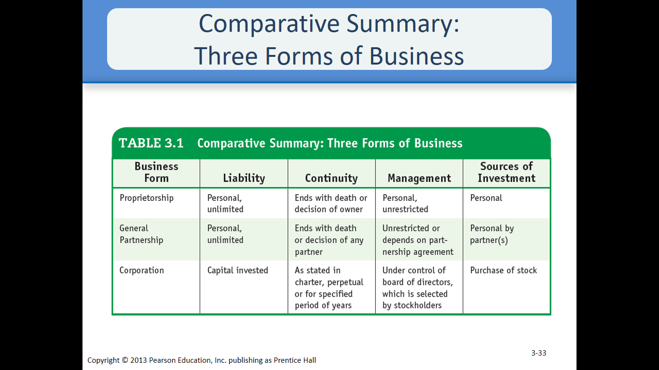

* What are the two types of alternative general partnership?
* Limited partnership
* Allows for constrained accomplices who contribute cash but are at risk for obligations as it were to the degree of their investments General (or dynamic) accomplice (or accomplices) run the business
* Master Limited Partnership
* Organization sells shares (partnership interests) to investors on public exchange; investors paid back from profits master partner has majority ownership and runs the business, minority partners have no management voice
* Cooperatives
* Combine the freedom of sole proprietorships with the financial power of corporations
* Groups of sole proprietorships or partnerships agree to work together for their common benefit
* What is the cooperate entity?
* Corporation
* business that is legally considered an entity separate from its owners and is liable for its own debts; owners’ liability extends to the limits of their investments
* advantages and disadvantages

1. Advantages

* Limited liability
* Continuity
* Stronger fundraising capability

1. Disadvantages

* Can be taken over against the will of its management
* Double taxation of profits
* Complicated and expensive to form

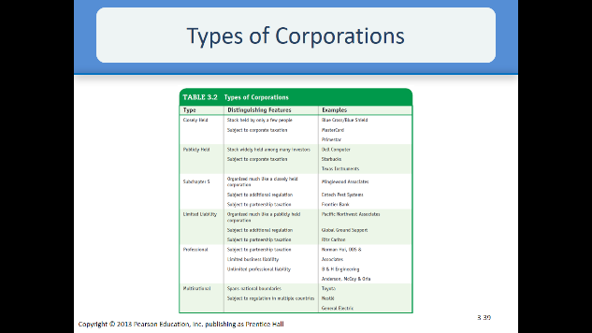

Focus on slide 39

* How to manage a corporation?
* roles of shareholders, directors, and other managers in corporate decision making and accountability.
* Corporate governance
* Stockholders (shareholders)
* owner of shares of stock in a corporation
* Board of Directors
* overseeing body of an organization that reports to its shareholders and delegates control to run its day-to-day operations whereas remaining capable for maintaining its assets
* Officers
* top management team of a corporation
* some special issues in corporate ownership
* Joint Venture – strategic alliance in which the collaboration involves joint ownership of the new venture
* Employee Stock Ownership Plan (ESOP) – arrangement in which a corporation holds its own stock in trust for its employees, who gradually receive ownership of the stock and control its voting right.
* Institutional Investor – large investor such as a mutual fund or a pension fund that purchases large blocks of corporate stock.
* Merger – the union of two corporations to form a new corporation.
* Acquisition – the purchase of one company by another
* Divestiture – strategy whereby a firm sell one or more of its business units
* Spin-Off – strategy of setting up one or more corporate units as new, independent corporations